**Your Project Title**

**Your Name Ei Shune Le Tha**

**Supervisor: Your Supervisor's Name**

**Initial Contextual Report**

**COMP1682 Final Year Project**

**Programme Title, e.g. BSc Computer Science or BSc Computing**

**Due date:**

**Word count:**

**Abstract**

This is where you succinctly describe your project, the context of and interest in your project, your approach to your project and your progress to date using somewhere between 60 and 120 words. This is much easier to write after you have written the rest of this report.

Contents

2 Introduction 4

2.1 Background 4

2.2 Aims and objectives 5

2.2.1 Aims 5

2.2.2 Objectives and Deliverables 5

2.3 Approach 8

2.3.1 Literature Review 8

2.3.2 Product Research 9

2.3.3 Feasibility Study 9

2.3.4 Requirements 9

2.3.5 Designing and Prototyping 10

2.3.6 Implementation 10

2.3.7 Evaluation and conclusion 10

3 Literature Review 10

3.1 Approach to literature searching 10

3.2 Discussion on E-learning and its platforms 11

3.2.1 What is e-learning 11

3.2.2 Brief history 12

3.2.3 Benefits of E-learning 12

3.2.4 Types of E-learning platforms that are popular in the market 12

3.2.5 Summary 14

3.3 Discussion on HCI and E-learning 15

3.3.1 What is HCI and a brief history of it 15

3.3.2 Two practices of HCI 16

3.4 Technologies 22

3.4.1 Methodologies 22

3.4.2 Programming languages 31

3.4.3 Database 37

4 Legal, Social, Ethical and Professional Issues and Considerations 41

4.1 Legal Issues that can happen at Educally 41

5 Requirements 42

5.1 Analysis of requirements 42

5.2 Comparison of systems 42

5.3 Requirements elicitation 42

5.4 Functional requirements 42

5.5 Non-functional requirements 43

6 Design 43

7 Prototype 43

7.1 Review of technology 43

8 Reflection 43

9 Bibliography 44

10 Appendices 44

# Introduction

## Background

Online course providers, also known as learning destination sites (LDS) are e-learning platforms based on web applications that offer learners with massive open courses, provided by lecturers from various fields which everyone around the globe with different interests can join them with the use of the internet anytime anywhere. Allowing people to pursue education with ease and allowing instructors to deliver lecturing contents, learning destination sites had been dominating the e-learning industry for decades.

The history of online course providers started all the way back from 1987 where the University of Phoenix launched the first ever completely online assembled institution that offers both bachelor and master degrees. As the time goes by, the advancement of technology and the evolution of Internet had elevated the capacity of online learning to its furthest extent in which there had been tons of emerged online course providers these days such as Udemy, edX, Coursera, Skill share, Udacity etc., which offer both courses from both freelance instructors and college courses. The providers offer various courses that cover up different fields with various price ranges depending on the type of course with some of them giving certificates to students upon course completion.

There are two types of online course providers on the market which are the ones that offer courses with only pre-recorded video lectures yet with standardized affordable prices and the ones that provide both live-streaming and pre-recorded courses with some of them requiring monthly paid subscriptions and some of them having heavy price ranges which is quite inconvenient for students on budget. In such case, using third-party video streaming software like Zoom or Microsoft team etc. in the hybrid way is the only solution for course instructors on the LDS to organize live streaming classes and gather students there which is quite chaotic for both students and instructors to go one place from another. Some of them provide course instructors with tools that assist them in doing statistical analysis on both their students and contents but are expensive while some of them do provide none-to-little statistical tools but for free. At this rate, learning destination sites like these are scattered and replicated all over the market that it is impossible to find an online course provider that offer both live-streaming and on-demand video classes at one place while providing statistical tools for both instructors and learners to assist in evaluating teaching and learning process.

To fulfil the above demand, a web-based course provider, named Educally will be created in this project. Educally will be an online course provider that offer both on-demand video courses and live streaming courses for both instructors and lecturers who want to play active role in learning and teaching process and for those instructors who have no time to organize real-time classes and learners who have cannot spare time to join live classes since instructors can record their lectures and students can access to them anytime they want. The prices for learners will vary from free to paid but with affordable price based on the type of class or instructor and the commission for the instructor will be inquired based on the amount of people enrolling their course, the amount of teaching content they deliver and the type of features from Educally they use while organizing their contents. Once creating an account, learners will also have access to a library like forum which will have the materials such as reference links, books etc. for every category which will be uploaded by course instructors and will be downloadable if possible. This will assist instructors in referencing for their lectures and the learners in being convenient to find the sources and materials at one place. Moreover, there will possibly be a review section for each course where students can comment and share opinions and give reviews on particular courses which will be helpful for people who are going to enrol the courses and instructors in collecting opinions and feedbacks of their students. At the end of the courses, learners will receive certificates upon course completion offered by course providers which will help them in verifying their competency and proficiency in the particular filed they have joined which will as well be beneficial in applying for job or build career based on the subjected area. This way, Educally will be profitable and beneficial for both learners and educators themselves.

In order to implement this very project, various techniques and technologies will be applied. In this case, Structured System Designed Methodology (SSADM), known as the traditional waterfall model, will be used as the implementation method for the entire project, MySql as database, PHP, Javascript, Node.js as programming languages for implementing the product respectively.

(g2, n.d.)

## Aims and objectives

### Aims

The main aim of the project is to develop a web-based course provider that will offer both on-demand and live video courses that cover a ton of fields to ever exist to every one around the globe who wants to pursue education conveniently as well as assist instructors and lecturers in reaching a greater audience while being able to organize their teaching methods. In essence, Educally will be a medium that would connect learners and lecturers with a use of the Internet. Comparing this aim with the one stated in the proposal, it is basically the same since there is nothing else to change.

### Objectives and Deliverables

#### Literature Review

1. Approach to literature searching
2. Discussion on e-learning
3. HCI for e learning
4. Technologies
   1. Methodology
      1. SSADM and DSDM definition
      2. Comparison of two methods
      3. Choosing a right development method with justification
   2. Programming language
      1. Discussion on ASP.Net
      2. Discussion on PHP
      3. Discussion on Java Script
      4. Comparison between ASP.Net and PHP
      5. Combining one of them with Java Script and Reason
   3. Database
      1. Definition of database
      2. Comparisons of DBMS used in course providers
      3. Choosing the right DBMS
5. Conclusion

**Deliverables**

* Knowledge of online course providers
* Technologies that are going to be used throughout the development

#### Product Research

1. Summary of similar systems
2. Comparing similar systems using Neilson’s Heuristic Evaluation
3. Evaluation of similar products

**Deliverables**

* Essential functions and features of a successful online course provider
* Inspiration on functions and features to be put into the system

#### Feasibility study

1. Legal, Social, Ethical, Professional issues that can occur in Educally
2. Possible Risks and how to manage them

**Deliverables**

* Confirmation on whether the project is feasible or not
* Possible risks that can occur while developing the system
* Solutions on risks

#### Requirements

1. Requirement elicitation
   1. Requirement specification
   2. Surveying certain group of people in education using questionaries
2. Analysing functional requirements
3. Analysing non-functional requirements
4. Target user analysis
5. DFD
6. Normalization
7. ERD
8. Data Dictionary

**Deliverables**

* User expectations from Educally
* High-level and low-level requirements
* The summary of process, behaviours and data holdings in Educally

#### Logical Design

1. Screen Design

**Deliverables**

* The way the data flow
* A foundation for creating a database and data to be put into it
* Context of what the interface is going to look like

Nothing has changed for this phase in contrary to the ones in the proposal.

#### Implementation and testing

1. Implementing and testing Educally with the chosen programming language
2. Testing the developed chunks

**Deliverables**

* A proposed learning destination site

#### Evaluation

1. Evaluation of the developed system
2. Future development
3. Self-reflection
4. Conclusion

**Deliverables**

* Abstract evaluation of the whole project
* Critical self-reflection on developing this whole project
* Strategies for further development of the system

Some of the sub steps in the objectives have changed in contrary to the ones proposed in the proposal. Here, first of all, literature review has been added in order to state the researched areas related to the development and to prove awareness on the existing technologies and ideas while evaluating the development of this project against the existing ones and establishing the professional approach to research. The research phase is changed to product research since some of the steps in research step from proposal such as research on technology, database, programming language etc. would be included in the literature. In this Product Research phase, comparison on 3 similar course providers will be documented. Feasibility study phase is no longer combined with research step as it was in proposal with this particular step being individual one with two sub steps as documented above. The rest stages, however wouldn’t differ that much against the ones demonstrated in the proposal.

(Greenwich, n.d.)

## Approach

SSADM, the traditional waterfall approach will be applied in this project as its thorough analysis of the system ensures all the procedures in each step are undertaken without being missed at any point while exercising the chances of misunderstanding information from the initial stages. A set of methods, practices and processes that will be undertaken in each phase of objective throughout the project are described as follows.

### Literature Review

In this first step, the overview of the sources and studies that have been researched related to this very project will be discussed first. Then, a discussion of e-learning focusing on their history and what they do would be discussed, followed by a literature review of why online course providers are important. In order to provide enjoyable visit for users of Educally, a HCI (Human Computer Interaction) aspect of e-learning will be discussed next. Then, technologies that are going to be used throughout the project will be discussed. First, SSADM and DSDM, two of the most popular software developing methods would be discussed along with the comparison between them and the justification on choosing one of them. Subsequently, a discussion on programming languages that are popular in developing web applications, PHP, ASP.Net and Java Script will be discussed and compared in order to choose a suitable one for developing Educally. Then, research on database management software that are going to be used will be made including comparisons between two DBMSs and justification on choosing one that will be used in Educally. Since Educally will be a learning destination site and focus on providing video lectures, a technology behind streaming will be discussed with two types of streaming: on-demand and live video streaming which will be provided for learners. Finally, a brief summary on what processes will be undertaken after all these literature reviews and how the influence the incoming stages will be documented.

### Product Research

In this phase, a research and comparison on similar products, more specifically, learning destination sites will be made. Here, using Neilson’s 10 general principles for interaction designs, the usability of three similar course providers: Udemy, Coursera and EdX will be evaluated and compared. From here, inspiration of usability features and functions from those sites will be obtained and include them while developing Educally to enhance user satisfaction and to meet user experience goals.

### Feasibility Study

In order to evaluate if the project is feasible or not, this phase is undertaken. In here, legal, social, ethical and professional aspects of an e-learning platform will be discussed including issues relating to those aspects that can happen in Educally. Then, potential risks that can happen during the development and after the development of Educally will be examined and the solutions to them.

### Requirements

This is the stage of brainstorming requirements to be put into Educally. Firstly, requirements from developer’s aspect including the usability features and functions inspired from researching the similar learning destination sites will be specified in order to visualize what the system must do and how it must perform. Then, certain group of people from educational field such as students, teachers and some people who are pursing education someway will be surveyed with questionaries to collect expectations of potential users of Educally. Those requirements will be categorized into functional ones and non-functional ones to distinguish which requirements are important and mandatory be put into the system and which are not. Then, target user analysis will be produced to understand who the targeted audience of Educally is. After all the requirement analysis steps, one of the behavioural UML diagrams, a Use Case Diagram will be produced in order to visualize what the system is actually going to do and different ways the users going to interact with the system.

(visual-paradigm, n.d.) (Chart, n.d.)

### Designing and Prototyping

Using the combination of 3 data modelling techniques from SSADM and some of the modelling techniques from UML, diagrams will be produced throughout this phase. First of all, using the Data Flow Modelling technique from SSADM, a dataflow diagram (DFD) will be produced in order to identify input and output of data of the system as well as what and how the data is going to be processed and where it is going to be stored. In order to identify entities and relationships between them as well as to reduce data redundancy and duplication, Normalization of the whole system is going to be produced next up. After normalization, using the Logical Data Modelling technique, an Entity Relation Diagram (ERD) will be produced to define the data structures that includes entities, attributes and relationship between the entities. After all the entities and relationships between them are sorted out, a Data Dictionary will be produced to describe metadata about attributes within the entities and to avoid data inconsistencies. One of the UML diagrams, a Class Diagram will be produced next to describe the structure of the system and details of implementations. Lastly, to visualize the interface of Educally, screen designs will be produced using prototyping tools.

(USGS, 2008)

### Implementation

This is going to be the actual development stage of this project. With the programming languages, DBMS and Streaming technologies researched and chosen in the literature review, codes for Educally will be written and the system will be created. UML designs produced above would possibly be useful while put ting functionalities in the development. The developed chunks will be tested with test logs bit by bit regularly with test logs to avoid errors piling up.

### Evaluation and conclusion

This final stage will be about evaluating the development of the system and discussion for future developments. First of all, evaluation of the entire system will be reported. Next, the possible plan for future development of the system referring to the functions or features to be put if the developed system is ever going to be continued will be produced. A critical self-reflection on developing this whole project will be demonstrated next. Lastly, the conclusion of the system will be generated. This phase will be all about the summary of the entire project and ideas for future development.

# Literature Review

## Approach to literature searching

Everything that had been researched for the project will be documented throughout this phase. First of all, discussions about E-learning platform would be made by demonstrating its history, how it became popular and why it is important for everyday life. Subsequently, out of all the genres in e-learning platform, the reason on creating an online course provider in this very project will be discussed with why they are necessary and what are lacking in the existing ones. In order to make the interface of Educally interactive and to provide enjoyable user experience, Human Computer Interaction on e-learning platform will be reviewed and discussed. Then, technologies that are going to be used throughout the development will be researched and documented. First of all, the development methodologies, more specifically, SSADM and DSDM, the most popular software development approaches will be researched, compared and one of them that is suitable for this project will be chosen with reason provided. Then, main programming languages for developing Educally, PHP and ASP.Net will be researched and compared and subsequently choosing a suitable one among them which will then be combined with JavaScript to make the web app more functionable. A database is required to store data in this particular learning destination site and therefore, two database management software (DBMS) that are mostly used in e-learning platform will be researched and compared and a suitable one among them will be chosen for Educally. Since Educally is going to focus on streaming the courses with both on-demand and live videos, a technology behind both streaming will be investigated and documented next along with how to do them and what are required to do so. After doing all the reviews and research, how everything that are investigated will be applied in the coming phases will be explained conclusively.

## Discussion on E-learning and its platforms

### What is e-learning

E-learning, also known as online learning is a learning mechanism driven by the use of electronic media which commonly involves the Internet and is made to be accessible via numerous digital devices used in everyday life such as mobile phones, computers, tablets etc. Coming in various categories such as digital courses, software, apps etc., it creates a flexible environment for everyone around the globe to purse education within one’s grasp. The materials for this learning mechanism can be typically PDF, word documents, links, websites etc. which are easily attainable in everyday life of this digital era and thus, making it easier for E-learning to be undertaken and learn new skills by one’s self at their own pace.

(Partnerships, n.d.) (Litmos, n.d.)

### Brief history

Everyone might believe that E-learning has only existed after the invention of internet. However, it has been utilized in universities way before the Internet was invented back in 1950s and 1960s with the use of slide projectors and classroom televisions. A year after the Internet was invented, 1984, a first ever completed online course provider was created by the University of Toronto and with the development of technology throughout the years, online learning has been established into something that would assist learning to be available and accessible at finger tips of everyone these days.

(Sarkar, 2020)

### Benefits of E-learning

E-learning is a phenomenal concept happened in educational factor as everyone can acquire education without limitation on where they come from or what mechanism they use on their learning process. The lessons are delivered quickly and time precision is leveraged compared to physical classrooms as time delay and procrastination that typically happen in traditional classrooms would be subtracted. Versatility is better than those traditional classes where taking revisions and unpacking lessons from missed classes are not quite simple, since people can undertake those works as much time they want without requiring much effort as well as learn new skills at their own pace with no time limitation. Most importantly, it is cost-effective since based on learners’ preferences on their learning mechanism and subjects, they can choose and join various types of classes with different subjects and obtain degrees and certificates that would be useful in their career path without actually attending the University or institute which would cost ample. E-learning is not only beneficial for learners but also for instructors and teachers as well since first of all, they can earn whether it is side income or regular income just by teaching remotely anytime anywhere they want with the Internet and Device of their choice being the only necessary equipment and additionally they have access to variety of features and functions for delivering teaching materials such as recording lessons, organizing live classes, selling and promoting their courses and so on. To sum up, online learning has become a medium that has brought learners, students, teachers, instructors and experts from various interests and fields altogether and connect them, overcoming the geographical and time boundaries. In a digital world of this 21st century, e-learning is something everyone cannot avoid and cannot deny the importance of it as it provide so much benefits for expanding one’s knowledge and education.

(World, n.d.)

### Types of E-learning platforms that are popular in the market

E-learning platforms are a collection of integrated online services that offer learners, instructors and people from educational industry with web portals that offer tools, resources and features that would assist them in interactive teaching and learning process and in monitoring the teaching and learning progress as well as opportunities to connect with other learners and students.

There are numerous e-learning platforms in the industry currently and some of the most popular types among them will be presented as following.

#### Learning Destination sites and Massive Open Online Course providers

These types of platforms allow various course creators and institutes to host and offer courses and materials instructed by them and often provide them with tools and features (which most of them require to be paid to have access to them) to assist them in creating and delivering contents to their audience. They usually come as websites and sometimes as software which users can either browse them up on the Internet or download them to have access to them. Courses in them are available in mostly two forms, which some include pre-recorded video lessons which learners can watch them and digest contents at no time restriction and some are entirely live courses, held by using third party video conferencing software for example, ZOOM for a more interactive classroom environment which users need to enrol and take the class at the specific time and both types of courses often contain course materials such as PDF books, source links, documents etc. and sometimes, interactive text assignments. Some of these platforms are free which give users access to the website once they signup but however have to choose and buy courses based on their preference while some of them give users free trials to access to the contents for a particular time period but after the free trial had finished, users have to pay monthly/yearly to still have access to those course contents. These e-learning platform types are suitable for people who want to purse education and learn new skills at their own pace as well as for people who prefer interactive learning environment due to its versatility and flexibility which increases the learning experience of learners. Udemy, Coursera, Skill share and Master Class are the examples of these types of e-learning platforms that are famous in the market. This type of e-learning platform is suitable for people who want to pursue education at their own pace as well as for those who want to interact with teachers and other learners occasionally.

#### Learning management systems

These are the platforms mainly employed in large organizations and institutes with the purpose of knowledge management, which commonly is to train people within to enhance their skills and knowledge as well as to organize, manage, analyse and distribute the resources such as documents, expertise, data etc. across the organization. Similar to LDSs and MOOCs they come in as both web app or software applications that are available and responsive on any device in but however to have access to them, the user must be the authorized person from the specific organization with secure user id or password. Unlike Learning Destination Sites, the contents and information in these are available to only people within the organization but however would contain more features and functions, that would assist administrators and instructors to effectively handle elements such as user control, contents, calendar, communication etc. than LDSs and MOOCs and the cost would vary based on the size of the organization, the deployment environment: whether the LMS is going to be cloud-based, self-hosted, software application or mobile application etc. and the type of add-ons and plug-ins the organization appends. Due to its versatility, the number of tools and features that assist users on their tasks, efficiency on knowledge management, security, scalability and multiple options on deployment, LMSs are topping the e-learning industry nowadays. Moodle, Blackboard learn and Schoology are the examples of LMSs that are popular and employed in most educational institutes. In essence, Learning Management Systems are more suitable for larger institutions and organizations with a large group of employees as they might be pricey but fair considering the fact that they would be deployed across the entire organization.

#### Online group learning

These are the types of platforms that offer learners a learning mechanism where they have to collaborate and interact with other learners during the learning process. Collaborative learning proved to be far more effective and beneficial in pursuing education than self-paced learning method since they have sessions where both learners and instructors have to share opinions, ideas and knowledge on specific topics in. These platforms are available as both web application and software applications and any user can have access to them once signed up and have access to the Internet. Most of them integrate with video conferencing third-party apps like Zoom, Microsoft team etc. to leverage the real-time communication between learners and instructors as well as tools and features for instructors to upload and deliver contents via videos, images etc, and elements such as games, quizzes, images and videos for learners to improve their learning. These types of platforms not only give physical classroom atmosphere but also help both learners and instructors improve their knowledge and learn specific experiences and skillsets of others as well as enhance their collaboration skills and learn new perspectives on different topics. There are many of these platforms in the e-learning market such as Varsity Tutors, Ed App, Slack etc. and all of them have different functionalities which users have to choose based on their preferences of learning mechanism. To sum up, this platform is for people who would want to experience the traditional classes which have real-time communication between teachers and students as well as freedom to discuss and share opinions and knowledges and collaborate in the learning process.

(Chef, n.d.) (Litmos, n.d.) (Inc., 2021)

### Summary

There are so many benefits of e-learning not only for teachers and students but also for business organizations and institutes considering the fact that this mechanism can be adopted for different purposes and factors. Having different types of platforms enables learners and instructors to obtain education and deliver learning contents based on their preferences on the ways of teaching and learning. Most importantly, e-learning is cost-effective and skills and knowledge obtained from it can be accessed for life time. To summarize without further ado, e-learning is something one cannot avoid in this digital age and something that would enhance education factor if adopted wisely.

## Discussion on HCI and E-learning

### What is HCI and a brief history of it

Human Computer Interaction (HCI) is a field of study on interaction between users and computer systems with the purpose of helping computer users improve their task performance on their everyday and working life by designing the system more user friendly and satisfactory to user’s needs. It is a combination of different subjects including behavioural science, cognitive science, ergonomics, human factors, psychology and design principles.

The journey of HCI started back in 1980s, the prime time of personal computers and desktops such as Apple Macintosh, IBM PC 5150 etc., for offices and home uses such as gaming, word processing, accounting etc., which were the basic tasks that people at that time were using the computer for and the factors HCI practitioners at the time were focusing on improving usability. The rise of the Internet and technology such as smart phones lead the general public to embrace the trendy devices that are portable and easy enough to make their computer use more efficient and drift from traditional desktops that take them more space and advanced computer-knowledge to usage. Thus, human-computer interaction started to play a vital role for a more efficient and easy use of computer systems for all types of users including the novice ones and advanced ones.

According to John M Carroll, the founder of the field of human computer interaction, these events brought HCI to expand its focus from on mere general and individual user behaviours to accessibility of social and organizational, elderly, people with different disabilities, in essence, to support the widest possible human activity and experience of all types of people. HCI had expanded from just being available on desktop applications to technology used in a myriad of fields that people face in everyday life such as learning and education, medical fields, business, art, and so on. Nowadays, HCI is covering methodologies and processes to design, develop, implement and evaluate interfaces as well as interaction designs in order to improve user experiences. This makes a pretty convincing case of HCI pursuing its long-term goal of supporting people with their everyday life by designing computer systems interactive enough to downsizes the barrier between people’s cognitive pattern of what they desire to attain and the system’s understanding of user’s expectation.

(Gawande, 2010) (Foundation, n.d.) (Kanade, 2022)

### Two practices of HCI

While HCI is a field of study on communication between human and technology, there comes two practices that fulfils the field itself as a whole, UX or UE (User experience) design and IXD (Interaction design).

#### User experience (UX or UE) design

User experience design, in short, UX or UE is the process of creating products that provide meaningful and enjoyable experiences to users with the purpose of elevating satisfaction and loyalty on the product as a whole. It focuses on not only creating usable products but also on other aspects such as efficiency, functionality, user experience i.e., pleasure or satisfaction etc. as well as user attitudes and emotions throughout the usage journey of that particular product or service. User experience designs are based on human behaviour and psychological factors rather than logical aspects as regards to the system and are dynamic i.e., it can be modified constantly based on changes of usage and user scale. Understanding the targeted user is the first step to start designing a UX design. With the proper understanding of user-base, relevant user behaviour can be generated and additionally appropriate user requirements can be specified and produced which will assist in the prototyping stage later. Choosing the appropriate prototyping method is crucial as well as it will enforce cost-efficiency and assist in feedback gathering process and reiteration stages effectively.

Don Norman, Cognitive Scientist and User Experience Architect and a cofounder of Neilson Norman group, describes UX as follows: “User experience encompasses all aspects of the end-user’s interaction with the company, its services, and its products”. Thus, designing products that provide satisfaction to user’s visit is important since user’s experience on a product is a first impression that might influence on other aspects of that particular product as well in addition to the brand itself. In order to design a product that provide enjoyable user experience, it is required to practice a set of methods and techniques to gather user’s requirements and expectations as well as to design products and services that meet those demands. A good UX design minimize the conflict between the tasks one wants to undertake and the tools that have to utilize to accomplish that task.

(Foundation, n.d.) (Guo, 2017) (LAMPRECHT, 2022) (Gupta, 2021) (Greenwich, n.d.)

#### UX in e-learning

UX in e-learning will be about all the behaviour, experience, emotions learners are going to experience throughout the visit to the platform. It will be focusing on learner’s attitude, how they feel while visiting the website as well as what they need from the website and issues faced through out the visit. With that being said, UX design for e-learning platform must be designed to provide easiness through the navigations of learning process as well as help learners to concentrate on the learning contents thoroughly and access to the contents at their own pace. Moreover, it is important to design the interface of an e-learning platform to give off conducting and motivative ambience and atmosphere as it will stimulate learner’s learning process. should be included while creating UX for e-learning platforms.

1. Consistency: This is about making important elements in the website such as navigation, layout, functions consistent in order to avoid conflicts caused by cluttering and inconsistent contents that would irritate learners
2. Clean interface: In order for learners to put their concentration on the learning process only, it is important to make the interface as clear as possible. Avoiding inserting unnecessary buttons, links, images and texts etc. would enforce the simple yet effective user interface.
3. Accessibility guidelines: are essential and should be provided as it will minimize learner’s confusions on certain components of the website. Although it is not necessary to put guidelines in all over the browser but putting them in important sections such as pop-up user guidelines clarifying how to navigate through web pages or inserting messages on input areas of forms for people who forgot to fill in would reduce user confusion and prevent further errors.
4. Simple navigation: Navigation is an important element of e-learning and designing it to simple yet effectively assist learners to navigate across the learning contents quickly and smoothly would ultimately increase user experience since it will reduce the time and effort of learners trying to figure out what to do and waiting for navigation to happen. Consequently, the navigation should also allow users to go back to previous pages without going to the navigation bar itself as well as choose the contents they want to access. At the same time, inserting call-to action buttons on certain buttons for example- buttons to go to the courses in progress would be easy for users to know the status of their learning progress and consequently elevating the user experience.
5. User-friendliness: In order to keep the learner’s focus on the contents and their learning progress, it is important to make the user interface as clear and user-friendly as possible as it will elevate the optimistic ambience of the learning environment. Additionally, using eye-catching layouts on certain fundamental contents would enhance learners’ attention and recognition on those contents.
6. Progress status: Measuring learning progress in necessary in one’s learning and thus, some tools to measure learner’s learning status for example- progress bar, textual status etc. that shows the journey of learners on a particular course and how far they need to go to complete the entire class or course would be handy for learners to inspect their learning progress.
7. Meaningful activities and guidelines: As much important as it is for e-learning website to provide guidelines and activities; it is also important that those guidelines and activities are meaningful and purposeful since otherwise would be a waste of reading instructions and undertaking those activities.
8. Accessible contents: To enhance learning experience, it is important to provide learners with learning materials they would require such as resources, assignments etc. and to do so, forums or areas to upload those contents should be created. In addition, it would be nice to put options to filter out the contents for example- searching courses by their categories, uploaded date, instructor names etc. would elevate user experience as it would minimize the efforts learners have to put to search what they are looking for.
9. Speed: is the most important part of any website and like wise in e-learning platform since learners expect quick delivery of content. Slow loading of the content page, video, image etc. would eventually frustrate learners resulting in decreasing learners due to disappointment.

If these above mentioned UX elements are considered while designing the actual e-learning website and apply them appropriately, it would bring tons of user satisfaction and enjoyment towards the platform.

(Standard, 2019) (Wong, 2022)

#### Interaction Design (IXD)

Definition of IXD according to (IXDA, 2005) is that it is the process of defining the structure and behaviour of the interactive system. In general, IXD is a process of designing interaction between users and the products with the purpose of creating products that allow users to accomplish their tasks effectively and efficiently. The ultimate goal of IXD is all about creating meaningful relationships between users and the products and services they use, starting from computers to mobile devices to all interactive digital products to ever exist, while designing these products and services to support people with their everyday and working lives.

The most interesting part about interaction design is that it encompasses some aspects of art as it contains imagination about systems on what and how they could be and considerations on how to meet user satisfaction. The definition of IXD itself supports this assumption as it concentrates on interactivity and user behaviour. Consequently, designing the product not only should focus on the visual of the design and whether the user can understand it or not but also on responses of users and how the product reacts those responses. In order to understand what interaction design involves, 5 dimensions of interaction designs comes into picture with each dimension demonstrating the aspects to be considered while designing the interaction. The details of this principle will be discussed briefly under chapter 3.3.2.4

(Foundation, n.d.) (Smith, n.d.) (Gupta, 2021) (IxDA, 2005) (Greenwich, n.d.)

##### User Interface (UI)

While discussing about IXD, it would be relevant to discuss about UI as well in this topic with regards to this project. The user interface in general is defined as a space where interaction between humans and products, of any means, take place. It is the main material of IXD as it includes the operation and manipulation of the system on user’s side, the input and response from system based on that operation, the output. A well-designed user interface not only eliminates the necessity of user’s consideration on complex details and knowledge about using a computer system but also establish clear, relevant and simple interactions. Additionally, it would allow users to easily and effectively operate the system and give out the desired result while minimizing the input user have to give to obtain it as well as eliminating the undesired results. Despite UI being a broad concept itself, it is important for UI designers to have knowledge about UX to some extent as well since designing the interface is not only about how it looks but also contain perception of users and interaction and thus, is the reason why it is the core object of IXD.

(Moreno, 2014) (Singh, 2020)

##### UI in eLearning

Since eLearning mostly takes place on web pages, the UI of it involves the design of web page surface itself and visual components such as icons, buttons, fonts, images, texts etc. that users can interact while visiting that webpage. There are apparently 9 elements of that should be considered crucial while designing an interface for e-learning platform:

1. Typography: refers to the use of creative designs on texts. This includes all the text related elements such as headings, words in the contents etc. and their properties such as designs, colours, fonts, sizes etc. Theses might vary based on the targeted user audience and what the platform is about but however should be appropriate for all level of user types.
2. Visual Hierarchy: in order to show importance of certain content on the webpage or the webpage itself by making the characters in it such as size, fonts, colours etc. standout than others.
3. Organization: i.e., how the contents are arranged and organized. It is important to arrange and set the contents without cluttering them or making them too simple since such contents might annoy or bore out visitors.
4. Media: This refers to images, videos, gifs etc. used throughout the entire website. It is important to use appropriate medias that are related to the platform since otherwise would confuse the audience.
5. Colour scheme: the colours that are used across the website must give off the ambience and atmosphere of education as well as be suitable for all types of users including those with inability to distinguish certain colours.
6. Consistency: All the colours, layouts, texts, fonts, sizes, the output on certain type of buttons etc. must be consistent in all pages of the whole website in order to avoid later confusions and complications.
7. Navigation: Proper area for navigation must be provided and that area must be noticeable in order to prevent user errors and provide effortlessness in navigating through web pages back and forth.
8. Accessibility: i.e., all the elements such as fonts, colours, font sizes etc. must be appropriate for all types of users including disabled ones and matured audiences.
9. Spacing: it is crucial to balance space between the texts since making less space between the texts would be cluttered and difficult to view and the big space would result wasted areas.

These above-mentioned elements should be included while designing an interface or e-learning website and if they are applied wisely and relevantly, the interface would be looking good but also would elevate user experience as a whole.

(Wong, 2022)

#### 5 dimension of interaction design correlating to e-learning

5 dimensions of interaction design is a model utilized while designing interactions in order to envision the real-world demands of users correlating to the particular design coming up. Correlating these dimensions with the e-learning platform would be a good idea as it will assist in providing good interactions between learners and the platform itself in a holistic way. The discussion on each dimension while relating them to e-learning platforms will be as follows.

1. Words: this refers to word related contents on the website such as labels, instructions, language use etc. and they must be meaningful and semantic as well as represent the actions they claim to do while being simple, consistently used throughout the website and easy for all levels of learners to understand including advanced and novice ones.
2. Visual Representation: refers to the graphical elements on the website that users interact with such as images, icons, typography etc. and these should be designed simple and easily understandable yet must be eye-catching. Visuals are as influential as words since they are the first ones when it comes to grabbing learners’ attention and making them interesting and seamlessly interactive would be useful in delivering information to learners who don’t like to read long paragraphs to get information.

1. Physical object or Space: indicates the physical medium users use to interact with the website itself such as phone or personal computers etc. It is important to consider the devices learners are going to use to access to the contents as it will influence the way of interaction and consequently, making the website responsive to those devices in order to provide the comfortable learning environment
2. Time: refers to the objects within the website that might change over time such as images, sounds or animation etc. and these can be influential on the way learners interact and navigate through the platform.
3. Behaviour: this is concerned with user behaviour i.e., how learners use certain elements on the platform to perform actions as well as how the previous 4 dimensions influence learner’s interaction with the platform. This is more focused on user experience as well since from the emotions learners experience and feedback gained from those experiences, behaviours of the platform could be improved as well as the further learner experiences.

(Smith, n.d.) (Greenwich, n.d.) (Foundation, n.d.) (Team, 2021)

#### Summary

While UX is about modelling the entire experience of user while they are interacting with the product, IXD is about designing those interaction so that the product can provide appealing experience to user the moment they are using the product. In the software development industry, there is a software development life cycle (SDLC) involving 6 stages: Research, Analysis, Design, Implementation, Testing and Evaluation and correlating this ideology to UX and IXD, UX is about research, analysis and evaluation while IXD is about Design, Implementation and Testing. UX will be about researching and analysing user requirements and evaluating user experiences on interactions while IXD will be about designing and developing interactions for those user experiences. Making the design simple yet holistic and putting relevant and recognizable visuals and words into the interface will ensure good perception of users and thereby increasing user experience and satisfaction through the entire venture. In essence, great UX design cannot be created without IXD and vice versa, and thus, advocating the strong fact that IXD is a part and pivotal factor of UX design.

(Gupta, 2021) (Guo, 2017)

## Technologies

The technologies that are going to be applied throughout the project starring Methodologies, Programming Languages, DBMSs and streaming technology will be compared and discussed under this topic.

### Methodologies

The two software development methodologies that are going to be discussed under this topic will be SSADM and DSDM, the two most popular system development methods in the software development industry.

#### SSADM

##### Definition

Structured System Analysis Design Methodology (SSADM), is a software development method widely used for system analysis and application design with the purpose of improving quality control over projects and providing better understanding to people involved in the project and additionally developing qualified projects to make the project worthy to the loss of staff. With that being said, SSADM is mainly employed in projects for both large and complex organizations and small-scaled ones and is suitable for those with steady business environment. Using the combination of texts and diagrams throughout the life cycle, it provides users with clear and straight-forward documentations as well as various diagrams that represent the system to form a better understanding of the development.

In order to provide different viewpoint of the system, SSADM uses the combination of three data modelling techniques:

Logical Data Modelling: the process of identifying, documenting and modelling the data requirements of the system and their structures during requirement gathering. Those data are classified as entities i.e., objects in the system where business need to record information to, their types, attributes within them and relationship between those entities.

Data flow Modelling: the process of identifying, illustrating and documenting the flow of data and the way they move in and out of the system. The dataflow diagrams include **processes**: activities that transform data from one form to another, **data stores**: the area that holds data temporarily or permanently, **external entities**: objects that are outside of system boundary and sends data into the system or receive data from another system and **data flows**: routes that move data to and from a process.

**Entity Event Modelling**: The process of identifying, documenting and modelling the events that take place in the system and additionally, how these occurrences impact on the data within the system and their sequences.

These three-techniques mentioned above cross-reference against each other to confirm completion and fidelity of the whole system.

SSADM follows the life cycle of traditional waterfall approach where the activities are undertaken sequentially since feasibility study to final development and testing stages. SSADM is composed of these following steps within its project life cycle.

1. Feasibility Study: The stage of analysing and determining whether the project is possible or not by measuring with the factors such as technicality, financial, legal, social, ethical and professional aspects as well as identifying possible risks that can happen during development and solutions towards them.v
2. Requirement analysis and specification: In this stage, first of all, investigation on current system is undertaken and the requirements on both data and function aspect for the new system are collected and identified. This includes Cost-benefit analysis, performance estimation and the potential impact of the new system on the organization as well as people within in. In addition, during requirement gathering process, it is important to know roles of people within the system and collect information from those who can give the appropriate requirements and information. Any requirement gathering method of choice can be applied during this process. From these requirements collected, functional and non-functional aspects of those requirements will be specified and consequently, diagrams to envision entities involved and relationships between them as well as prototypes to identify the flow of data within the system will be produced.
3. Technical System Option: This is the stage of determining and choosing possible technical options such as staff costs, software and hardware components that are going to be used, the constraints of the environment that is going to host the system as well as interface requirements.
4. Logical Design: This is the phase of specifying the new system by designing the interface of the new system and necessary dialogues within it. The logical specification and design from this phase will be applied in the next step.
5. Physical Design: This is the implementation stage of the new system by using the programming language and database structures specified in technical options and logical design phases. The architecture of this phase is going to match the logical design from the previous step.

In contrary with the rapid application development method where development stages are undertaken in parallel, each step in SSADM is ensured to be completed before proceeding onto the next one while each of them is continued based on the information described in the previous one and thus making sure all procedures from each step is undertaken without any of them being left behind and unrelated. Due to its following of water-fall approach, both system analyst and user can decide whether they want to move on to the next step or halt the project. Additionally, this rigid structure is the main reason why SSADM is well-known and approved for its strict control over the projects and being able to develop fine-quality systems.

(Lutkevich, 2022) (Beal, 2002) (Waltz, 2019) (techopedia, 2011) (Education, n.d.)

##### Strength and weakness

**Strength**

* The use of three data modelling techniques while determining the feasibility of the system enforces different viewpoints and thus resulting in completer and more accurate model.
* Thorough and deep analysis of the system eliminates the misconception of information at the initial stages of the project which frequently occurs in poorly analysed systems with incomprehensive design.
* Easy to set plans and goals for the project since the early stages of development
* The waterfall model of SSADM where each stage is undertaken one after another makes easier for contributors of the project to understand the process easier and additionally saving time, effort and money to train staffs
* Require less training and provision in documentation
* The standard rigid control of this method where the process of one phase follows the next one minimizes the chances of unforeseen problems occurring.
* Can be employed in large and complex information systems as well as the small scaled ones.

**Weakness**

* The praised rigid control of this method can however be problematic due to its inflexibility. It is possible that the requirement of the system can change at one point and since the whole life cycle of SSADM revolves around analysis, if the changes happen after analysis, it would be impossible to return to the previous stages to modify.
* As the method focus on technical requirements, there is limitation on user involvement and thus is possible that the end project might not meet user’s anticipation although it might function well.
* The biggest set back of SSADM is that it takes longer to deliver the end product than other methods. If the business is large, it takes more time to perform analysis and thus making it difficult to reach to the implementation stage by the desired date and eventually the end date of the whole project.

(Cohen, 2017) (Education, n.d.)

#### DSDM

##### Definition

DSDM also known as dynamic system development life cycle is an agile project delivery framework that uses an incremental and interactive approach to the software development. Being one of the methods from RAD (Rapid application development) approach, the focus of this method, lies in the early delivery of the end product, which is based on the principle that goes “*any project must be aligned to clearly defined strategic goals and focus upon early delivery of real benefits to the business*”. There are additional eight key principles that support this particular principle in order to maintain focus on achieving project goals:

1. Focus on business need: the project must have a reasonable business objective and make sure organizational support is obtained
2. Delivery on time: the project is broken down into workable stages which are time-boxed with accomplishable goals and deliverable time frame in order to bring confidence to the developer
3. Collaborate: the method focuses on user involvement and ensures all stakeholders are involved throughout the entire project while encouraging the collaboration between members of the development team in decision making processes.
4. Quality: The level of the high quality is settled with the business in the beginning and to maintain it, the procedure of testing, analysing and documenting is iterated and enforced.
5. Build incrementally from firm foundations: The developers must follow the Enough Design Up Front (EDUF) philosophy which claims right amount of design diagrams for example- UML diagrams are enough for resolute foundations of the product and their delivery. The right amount of design ensures developers to know what they are going to build but not too much to delay the development.
6. Develop iteratively: It is inevitable that requirements can change as the development of the project progress and thus, the development must be able to adapt to those changes. In order to do this, it is necessary to take feedbacks from the stakeholders and use the new feedbacks to improve perpetually in each iteration.
7. Communicate continuously and clearly: DSDM encourages people involvement and thus encourages various communication techniques such as daily meetings, informal communications, workshops and prototypes in order to enforce clear communication among the members.
8. Demonstrate control: The progress and plans must be transparent to all members in order to focus on delivery of quality product.

These 8 principles must be kept in mind and focused while developing a project with DSDM method in order to earn the full benefit of employing the framework. Like any other methodologies, DSDM also includes phases while implementing a project and apparently, there are 6 of them:

1. Pre-project: The project must be set-up correctly and properly to avoid poor project beginning. In this stage, existing project problems must be properly addressed; stakeholders along with visions and mission of the business must be identified; the confirmation on whether or not the project is in accordance with business goals must be made. All of these in pre-project phase will be applied to examine, plan and facilitate during feasibility process.
2. Feasibility phase: This is the stage of checking whether the project is feasible or not based on technical and business factor and additionally to make sure if the proposed project is suitable to use DSDM method. This phase is aimed at finding out solutions to the problems of the business as well as identifying profits the business can gain after this project and appropriate approaches for delivery.
3. Foundations: This is the most crucial phase of the development since it is about establishing foundations for the rest of the project. In this phase, functional and non-functional requirements are identified and consequently, high-level requirements which are then prioritized in relevance with business needs based on MoSCoW rules and scheduled with time boxes for development and deployment processes.
4. Evolutionary development: This is the phase of building the actual system incrementally and iteratively following the MoSCoW prioritization and applying the time box schedule generated in the previous stage. In this stage, first of all, prioritized features from HLR will be elaborated using UML diagrams; prototypes i.e., screen designs of the particular part will be generated and consequently that part will be built from technical aspect. These steps will be incremented bit by bit and will be tested iteratively.
5. Deployment: This is the stage of getting the developed part to be used in business operation to get the feedback from actual users. The release for deployment may come in 3 different forms i.e., 1) the released segment may be a new approach to the business problem, 2) the released segment may actually work in operational environment but is provided with limited features and functions since this is just a preface and will be provided with improved features later and 3) the complete product all the segments combined. However, before any deployment, it is important to provide trainings and prescriptive documentations of the system for end users as well as supportive staffs.
6. Post-project: This stage would take place after the delivery of last increment and basically is an evaluation phase. Reflection on product with regards to its performance and benefits it brings to the business should be provided in this phase.

Speaking of the phases, there are a collection of techniques that are considered as core of DSDM and they are primarily used in foundation and evolutionary development phases discussed above:

1. Timeboxing: a mechanism of forming motivation and force while managing the development and delivery of segments of the system within a specific time scale
2. MoSCoW prioritization: dividing the whole development plan into features segments based on their importance such as Must Have, Should Have, Could Have, Would Have features in order to help the developers hit the deadlines.
3. Workshops: As the method itself encourages user involvement, this is the phase where members of the development team, stakeholders and end users have to do meetings to discuss about requirements, errors, feedbacks on the result and testing in order to develop a high-quality product that meet user expectation.
4. Modelling: using diagrams and prototypes such as UML diagrams, screen designs etc. to visualize expectations and build the system based on them as well as to show stakeholders how the system will be developed.

With that being said, each phase of DSDM has their specific objectives and are intended to assist the smooth running of the system and resolve the existing business problems. Moreover, the method focuses on intensive user involvement and thus ensuring support from stake holders and gaining feedbacks which can help in improving the development. The methodology itself is suitable for all sizes of projects and complexities and has formality and flexibility in control as the iteration and incremental approach help the development to adapt and improve easily when changes are being made.

(Boog, n.d.) (Consortium, n.d.) (focus, n.d.) (Geeks, 2019)(Consortium, n.d.) (Greenwich, n.d.)

##### Strength and weakness

**Strength**

* Faster delivery of product or segment of products that bring benefits to operational use in business
* Highly flexible since continuous iterability allows the project to adapt and modify according to customer’s need of changes at any time.
* Projects with uncertain goals that requires further modifications and improvements can deploy this method
* One of the reasons why DSDM is famous is due to its intensive user involvement which encourages interaction among team members as well as with the clients which make ideas, requirements and feedbacks to be collected quickly. Each member is considered important during decision making process.
* Iterative testing can ensure high quality product

**Weakness**

* Not many people are familiar with this approach and thus require training and prescription which would cost time and money.
* Need large number of experienced members
* Tight time scale as time will be allocated for each time box and one part not being completed will lead to inaccuracy in initial estimates.
* Despite user involvement being a praised factor of the method, it can be a pet peeve if users especially stakeholders are not available to participate.
* Can be costly for small projects.

(Team, 2021) (Shahrukh, 2022)

#### Comparison between SSADM and DSDM

|  |  |  |
| --- | --- | --- |
| Criteria | SSADM | DSDM |
| The flow of phases | In SSADM, the development process must be implemented as one single project as a whole. In here, the use of waterfall concept divides these processes into phases with each of them being progressed as one after another. | Being a subset of Agile methodology itself, the project deploying DSDM is divided into workable chunks with time-boxes and tasks assigned, which are then developed iteratively within different stages. |
| User involvement | Focus on technical aspect rather than user aspect. However, users are crucially required during requirement gathering stage where they have to address the requirements properly so that there won’t be delay in later stages caused by changes in requirements. | Intensive user involvement especially after each iteration since feedbacks are required for each segment developed and based on those feedbacks, the decision on whether to make the release final or put improvements to it would be made. |
| Flexibility | Rigid and Strict but these two factors that are often slammed and criticized can eliminate unforeseen problems caused by loose project control. Changes in requirements once the development starts can be painful and would be difficult to adapt to it. | Flexible and allow changes in requirements to be made even after the planning stage has been completed. |
| Testing and quality | Testing comes after the development stage | Testing is undertaken at the same time with programming |
| Suitability | Suitable for both large and small scaled projects but however would be better for projects with stable and pre-determined requirements to eliminate delay and further costs caused by changes | Suitable for all types of projects especially those with dynamic environment and unstable requirements |
| Familiarity | The traditional waterfall model of going one phase after another makes everyone involved in the project easier to understand and thus lead to less training costs and minimum documentations. | Not well known as other methods and thus require experienced developers and members to deploy this method. Require training and documentations. |
| Time-scale | The whole project is within one time frame. It is all good as long as the project can be delivered within agreed time | Uses timeboxing technique. The praised time boxing technique can be tight and build pressure towards team members |

(Kukhnavets, 2016)

#### Recommendation on methodology

Compared to similar course providers like Coursera, Udemy etc., this project, Educally can be considered minor but however with pre-determined goals and requirements properly addressed. The author of this project, being just a mere college student with barely having programming experiences in previous college projects is also not considered as an experienced developer as others with years and years of programming knowledge and expertise. The project itself is also an industry based one i.e., a freshly new one with no users currently existing unlike the organized based ones with existing user base and hence, it is safe to say the project does not necessarily require user involvement. Thus, based on the methodology comparison documented above, SSADM seems to be the suitable one for this Educally project as it does not require much programming language but rather the proper documentation, analysis and design.

### Programming languages

#### PHP

##### Definition

PHP also known as Hypertext Preprocessor, developed in 1994, is an open-source server-side scripting language which is used to develop Static Websites, Dynamite websites and web applications. The developers need to install the PHP in order to execute the language and embed it into the HTML of a webpage. Once a PHP page is accessed, the server which the page lies on will read the PHP code. On that page, the outputs from functions of the PHP code will be returned as HTML codes that the browsers can understand. Due to the conversion of PHP codes into HTML codes before loading the pages, the users are not allowed to see the PHP codes but rather the HTML codes which are functioning just as expressed in PHP which this process keeps the accessibility to the database and other confidential information secured. Even though the language itself has also variety of unique features and functions, PHP borrows some of its syntaxes from other languages such as Java, Perl, C etc. which makes the developers who are specialized in those languages to learn PHP with ease. With the use of PHP, the web developers can write dynamically constructed pages and database driven websites quickly and conveniently. In addition, this language can be convoyed and deployed on almost every operating system and platform without any users having to pay which is far convenient to utilize it.

(TechTerms, n.d.) (Guru99, n.d.) (wikipedia, n.d.) (Rouse, 2006)

##### Strength and weakness

**Strength**

* Simple and flexible syntax makes the codes comfortable to be written and to be learn quickly and easily even for people with no coding knowledge.
* Due to having features of both Procedure Programming Language and Object-Oriented Programming language (OOP), programmers with different programming language backgrounds such as C and C++ etc. can learn this language within a short period.
* Being one of the top programming languages in the industry, PHP has a strong support community that supports and help any technical problems with the language.
* The most crucial advantage of PHP is that it is open source i.e., the language is free and thus it can be downloaded and deployed for building any web pages or web applications.
* One of the main reasons why PHP is used by almost every developer is due to its platform independence i.e., it supports every operation system such as Windows, Linux, Unix etc.
* Faster rate of loading despite slow internet speed thus applications can be loaded once they are connected to database.
* Have built-in functions that might assist in reducing additional codes.
* Can be used without having out dated technical issues since newer versions are consistently released along with newer functions and features.
* Embedded with HTML codes which hides the PHP codes from user when executed on the browser so that the confidential information which are written in the codes are protected.
* Ability to access over 20 different databases such as MySQL, Oracle and Microsoft Access.
* Provided with built-in database connection modules which assist in easier and faster connection with the database and thus enforcing the more efficient data storage for websites and web applications
* Developers do not need to pay for license and additional features and thus resulting in low maintenance cost due to the multiple options of hosting servers.

**Weakness**

* The praised open-source factor can be a weakness at the same time due to its less security.
* The programs can only be executed on the server side and not the client side which makes the server to slow down when multiples of applications are executed.
* Not suitable for large-scaled web applications
* Lesser debugging tools than other programming tools and thus it is difficult to find the source of the error when there is one.

(Geeks, 2022) (Srivastava, 2018) (Engineer, n.d.) (Pham, 2020) (Creative, n.d.) (Deepak, n.d.)

#### ASP.Net

##### Definition

ASP.Net (Active server pages.Net), developed by Microsoft in the year of 2002, is a server-side web development platform, dedicated to creating web-based applications, dynamic websites and services with the .Net framework. Being constructed on the CLR (Common Language Runtime), the programmers are able to write web applications with languages that support ASP.Net such as VB.net, C# and F#.

Due to being the extend of .Net, the developers can not only utilize a variety of packages and libraries, but also write their own libraries which are shared on the applications of .Net platform. In addition, with the support of Visual Studio tools, ASP.Net can be developed and operate on any operating system such as Windows, Linux, macOS and docker, creating the convenience environment for both developers and users.

(Microsoft, n.d.) (Wikipedia, n.d.) (Guru99, n.d.)

##### Strength and weakness

**Strength**

* Is suitable for medium and large enterprises with demand on functionality and security
* Supported by Microsoft support team which is well known for its quick and effective supporting skills even though the support community is not as big as other languages
* Allow parallel programming which lets multiple of lines of codes to execute at the same time
* Having built-in security features and functions like SQL injections, multiple authentications etc. make thew web applications secure.
* Compiled codes are converted into machine codes which the processors can execute which makes the codes efficient and systematic than interpreted codes that need to be executed line by line.
* Focuses on vertical scaling which improves system’s functionality by adding up RAMs and CPUs to the system.
* Less customization avoids bugs

**Weakness**

* Can be challenging for beginners to learn
* Costly since SQL server licenses, Visual studio licenses, Window server licenses etc. are required to maintain the application and hosting at best for the demands of functionality and security
* Lack of basic features since it is too raw.
* Quite uneasy to make changes
* Even though it is supported by Microsoft team, the supporting community is small compared to other languages due to its unpopularity caused by expensiveness
* Usually, CPUs and RAMs are quite expensive and adding up tons of them to improve performance might cost a lot

(Szecsei, 2020) (MELNICHUK, 2020) (CareerRide.com, n.d.) (Oamkumar, 2018)

#### Comparison of Programming Languages

|  |  |  |
| --- | --- | --- |
| **Criteria** | **ASP.Net** | **PHP** |
| Type | A server-side **web application frame work** with the support of .net programming language for web application development. | An open-source **server-side scripting language** which can be used for web application development. |
| Developed by | Microsoft | Rasmus Lerdorf |
| Cost | Open source but need to pay for licenses to gain additional features and functions. | Free and open source and does not require to pay for license and additional tools |
| Area of utilization | Medium to large enterprise applications. | Small to medium sized web applications. |
| Market share | Decent market shares due to its license payments | High market shares due to being open source and free availability to all developers |
| Supported languages and protocols | -C# and VB.NET  -HTTP/POST, HTTP/GET, and SOAP | -Java, Perl, C  - supports variety of protocols such as POP3, IMAP, LDAP, HTTP etc. |
| Security | Mainly focus on security and functionality. | Mainly focus on client facing and user interface. |
| Community support | Supported by Microsoft support teams | Large community of supports such as stack overflow, w3 school, php community etc. due to being the open source |
| Speed | High speed and suitable to create desktop application due to its decent equipments. | Performs moderately than other programming languages and not suitable to create desktop application |
| Methods of coding | Compiled coding | Interpreted coding |
| Customization | Users are not allowed to customize codes | Allow customization on codes |
| Scalability | Vertical scalability which adds more power to the server such as adding up CPU and RAM to increase performance and response speed | Horizontal scalability which can handle tons of user requests by adding more servers where the entire workloads will be scattered and performed parallelly. |
| Maintenance cost | High maintenance cost for hosting | Low maintenance fees due to multiple options for hosting services and having the opportunity to choose low-cost ones. |

(EDUCBA, n.d.) (Srivastava, 2018) (Existek, 2019) (CareerRide.com, n.d.) (Engineer, n.d.) (Developers, 2020) (camp, 2020)

#### Recommendation of programming language

After the comparisons between both languages, it can be said that both of them are exceptionally great on their own and each of them weigh strengths over weaknesses as well. However, compared to other existing learning destination sites that are on the market, Educally is just a student project trying to develop a learning destination site with no advanced features and functions like them and thus spending actual money on a programming language as well as further expensive maintenance costs such as (CPUs and RAMs costs) and hosting fees wouldn’t be necessary. Moreover, when the technical or coding errors occur while developing this web application, it would be more convenient to get help from a wide community of official support team as well as those developer communities on the Internet for example- Stack Overflow where majority of programmers there use well-known programming languages. Therefore, due to the above comparisons and reviews on both languages, PHP would be more suitable for this Educally project due to its unlimited open-source features and functions and prioritization on user interface and convenience.

#### JavaScript

The discussion on Java Script is added under this topic since certain code snippets from Java Script will potentially be put in combination with PHP in order to increase functionality of Educally site.

##### Definition

Java Script, created in 1995, is a dynamic programming language primarily used for web development as well as web applications and game developments with the purpose of making the web contents more interactive. It helps developers to implement dynamic features on web pages that HTML and CSS alone cannot do. The use of Java Script can be seen on almost everywhere on the Internet these days starting from dropdown menus, dynamic changes on elements within the webpages and images that users can interact with to creating cookies and tracking user’s browser history etc.

Since the language works with HTML, it is necessary for developers to have knowledge of HTML to an extent in order to harness the full benefit of JavaScript. HTML can be deployed in HTML files by either embedding all the script code within HTML codes or by creating a separate JavaScript file that is enclosed with script elements with the file type ending with .js extension. Being an interpreted language itself, JavaScript does not need to be compiled. To write a JavaScript codes, the only things needed are source code editors such as sublime text, Visual studio code or even the basic text editors like Notepad in Windows Operation System or Gimp in Linux Operating system. Java Script is supported by almost every browser in the market such as Chrome, Firefox, Microsoft edge etc. and allow the script code to be able to run on the webpage easily.

(Megida, 2021) (Techopedia, 2016)

### Database

#### MySQL

##### Definition

MySQL is an open-source relational database management system (RDBMS), produced by Oracle and based on Structured Query Language (SQL). Storing data in tables that consist of rows and columns, users using MySQL can manipulate data through CRUD (Create, Retrieve, Update and Delete) functions due to its base in SQL. Being a platform independent DBMS itself, it can be run virtually on almost every platform and operating systems such as Windows, MacOS, Linux, Unix and so on. MySQL is a powerful and flexible program and hence has been one of the most popular DBMS in the industry currently. Although it can be deployed in a wide scale of applications, the primary use of it can be found in web-applications and web content pages. This RDBMS is a crucial part of a technology based open-source enterprise called LAMP that applies of Linux as the operating system, Apache as the web server, MySQL as the database and PHP as the programming language for processing and therefore, MySQL is used to store and manipulate data for a wide range of web applications and web pages.

Based on a client-server model, MySQL server, the core of MySQL, manages and controls all the database commands which are sent to the server itself via MySQL client that is installed in a computer. Despite MySQL being installed on only one machine, databases in it can be moved around to different locations since users are able to access them through interface of MySQL client, which transfer the statements to the server in order to show the result on the screen consequently.

MySQL is designed to be compatible with other systems and therefore enable deployments in virtual environments including Amazon RDS for MySQL, Amazon RDS for MariaDB and Amazon Aurora for MySQL. It is understandable that people often mistake MySQL with SQL since there are similarities between the two of them but however are not identical since a database and a schema has no difference for the former one while the latter one handle them as separate entities.

(Moore, Tech Target) (Drake, 2020)

##### Strength and weakness

**Strengths**

* Storing the data in tabular form with organized rows and columns enables users to view the data clearly manipulate data quickly.
* Enhanced security due to provision of solid data security layer that protect confidential data from invaders and encryption in passwords
* Open source and thus free to download and is available on MySQL official site
* Supports many operating systems such as Windows, Linux, Unix etc.
* Allow client and server to run not only on the same computer but also on different ones through internet connection or local network.
* Provide advanced features such as views, Trigger and stored procedures which help the developers improve productivity and efficiency
* Easy to use since people with basic knowledge of MySQL and a few SQL statements can build databases and interact with the server
* Huge scale on data store since it can handle more than 50 million rows
* Allow transactions to undo.

*Weaknesses*

* Although the data store is huge, it can cause laggings while handling large databases
* Unlike paid databases, MySQL does not have a good debugging tool
* Not quite effective in data handling and thus can cause data corruption
* SQL check constraints are not available here

(W3Schools, n.d.)

#### Oracle

##### Definition

Oracle, also known as Oracle database, is a multi-model database management system developed and merchandised by Oracle corporation in 1977, which is frequently utilized in operating Online Transaction Processing (OTP), Data Warehousing (DW) and the combined OTP and DW. Due to its procession of network components that allow communication across networks, Oracle is usually utilized by global enterprises that manages and process data through WAN and LAN. Being able to operate on multiples of Operating systems such as Windows, MacOS, Linux etc. different software are also available based on user’s demands and budget such as:

**Enterprise edition** where robustness is highly ascertained on features, performances and security,

**Standard edition** where robust packages from enterprise one will not be included but the basic features and functions will be included,

**Enterprise edition** with light weighted and free yet limited on Windows and Linux and

**Oracle light** for mobile devices

(techopedia, 2017) (Wikipedia, n.d.)

##### Strength and Weakness

Strengths

* Wide variety of editions to choose according to enterprise’s requirements
* Open-source version is available but features will be limited
* Portable since it can be deployed on multiples of platforms, run on almost 20 networking protocols and available on more than 100 devices
* Multiples of transactions can be managed by the same batch with the use of horizontal expansion that allows data to execute parallelly which makes Oracle SQL more efficient in processing
* Provides star query optimization which the query optimizers show the users most effective ways of executions for the given queries by examining the possible query plans
* Allows differential, full, file-level and progressive backups
* Roll back functions are available
* Provide copies of records which the users can read the original data while doing modifications

Weakness

* Complex syntaxes
* Users require specialized skills to install and maintain this engine due to its complexity
* Not suitable for small or medium enterprises which merely wants simple and flexible database
* The prices are higher than other database servers and in addition those license prices changes often based on the changes of company’s policies, patches and updates
* Have call support teams but chargeable based on cases
* Dynamic memory allocation causes human errors

(Guru99, n.d.)(Educba, n.d.) (arteaga, 2019) (Wikipedia, n.d.) (Singh, 2020) (Sullivan, n.d.)

#### Comparison between MySQL and Oracle

|  |  |  |
| --- | --- | --- |
| **Criteria** | **MySQL** | **Oracle** |
| Type of DBMS | RDBMS | RDBMS |
| Owned by | Oracle Operation | Oracle Operation |
| Free/paid | Open-source and primarily free | Commercial and paid |
| Database capabilities | For both large and small scaled businesses | Large business |
| Support in null values | Yes | No |
| Support in language | SQL | Both SQL and Procedural language SQL (PL/SQL) |
| Operating System support | Support all type of operating system that Oracle does and additionally BSD, Symbian and AmigaOS | Only Windows, MacOS X, Linux, Unix and z/OS |
| Customizability | Can be customized and modified and based on user requirements, the codes can be altered varying different environments | Cannot be customized since it is not open source |
| Security and admission | Require host name, user name and optionally password to access the database | Require user name, password and profile name. Users cannot enter the database without the profile being set up. |
| Syntax | Simpler and easier syntaxes | Complicated yet efficient |
| Support community | Available 24/7 | Available 24/7 |

(Wolfe, 2021) (Singh, 2019)

#### Recommendation for DBMS

According to the comparisons above, both MySQL and Oracle come from the same organization and have outstanding features and functions of each of their own while both their strengths overcome their weaknesses as well. However, as mentioned above, MySQL is open source while Oracle is not and since Educally is a small scaled student project, it wouldn’t be necessary to buy a large database to store minimal amount of data. With that being said, consideration on Oracle is not a bad idea if Educally has become broader in the future with large amount of data to be stored. However, this round of developing Educally from the bottom, choosing MySQL would be the best since the it can be deployed easily along with the chosen PHP language.

## Conclusion of Literature review

In conclusion, from this literature review, knowledge about what e-learning business is along with the types of e-learning that exist in the market and what they do were acquired; understanding on HCI and its two practices UI and UX and their influences upon e-learning were attained and lastly the methodologies, programming languages and databases for this Educally project were compared and contrasted and most importantly, the ones that are going to be applied throughout the project were selected with reasons provided. The knowledges and inspirations obtained in this particular lecture will pay off while designing Educally website according to UI and UX aspects in order to make learner’s visit to the website enjoyable as well as during planning and implementation stages of the project.

# Product research

In this stage, the observation and discussion on similar learning destination sites to this project, more specifically Udemy and Coursera will be made while comparing and focusing on their functionalities and features using a set of criteria for usability purposes. This might give inspirations and ideas during designing and implementation phases in this Educally project.

## Biography

Udemy

Udemy, founded in 2007 by Eren Bali, Gargan Biyani, and Oktay Calgar, is a massive open online course provider (MOOC) that offer an internet-based learning platform that focus on self-paced and non-degree learning. Offering both hard skill and soft skill courses that cover 13 categories starring development, IT and software, office productivity, design, marketing, finance and sales, language skills, business, personal development and life style, design, photography, health and fitness and teaching and academics, Udemy provides immense collection of contents and resources to their learners and instructors.

Udemy being a learner-instructor based business itself, it also assists instructors in their business by helping them promote their business and sell their courses to learners in the website. The courses in this platform are delivered in recorded videos and include resources such as slides, documents, and any other resources that instructor find suitable for learners’ learning and in addition to this, in order to make improve of and measure learners’ learning progress and knowledge and to uplift their learning motivation, some courses include assignments, quizzes, tests, and exercises.

Most of the courses on the platform are delivered in English language but with the consideration to non-English speakers, Udemy offer translation and subtitles in other languages such as Spanish, French, Portuguese, Japanese, Thai, German etc, in order to help reach of Education to anyone, breaking the language barrier. Just by creating an account on the platform, the activities and courses offered by Udemy can be explored by anyone.

Due to the arise of technology and education being accessible anywhere nowadays, Udemy has been a hit in e-learning industry gaining 40 million students and over 50K instructors with 65 languages supported in more than 180 countries. Over the years, the categories they offer had been increasing as well as the courses in each category which were counted as over 150K courses.

(Rangaiah, 2020) (Wikipedia, n.d.)

Coursera

Founded in 2012 by two Stanford University computer science professors, Andrew Ng and Daphne Kroller, Coursera is a massive open online course provider that offer thousands of online courses from more than 200 prestigious universities and institutes including Harvard, Yale, Stanford, Princeton etc. with the purpose of providing profound learning experiences to people around the world. Taught by actual official university professors and teachers, Coursera offer individual courses as well as bachelor and master university programs which some of them are offered free and some of them must be paid to access them and get certification. Speaking of which, certificates may range from simple course certificates to actual degrees and some of them are valid for credit showings in academic programs and job applications which reduces barrier to get certification and qualification from higher graduation.

To have access to Coursera, the only thing that has to be done is to create a free account using email or any social media accounts learners use and once signed up, they can take courses in various ways: enrolling in free one-off courses with short period, taking programs with longer period which are included in seven-day trial after which the learner have to pay around $45 per month to receive certifications, or joining the official degree programs with options for bachelor’s and master’s degrees that would cost comparatively as the actual university programs depending on the program and subject. Courses on this platform contain pre-recorded video lectures which are available once the course starts or once learners have bought them or enrolled and can be watched and rewatched at learner’s own schedule and pace. They also provide student discussion forums, quizzes, assignments and HomeWorks or sometimes exams and projects to complete the course and get certification.

Besides from pre-recorded videos, during global pandemic in 2020 April, Coursera introduced ‘Live2Coursera’ agenda that allows Instructors to host live classes on Coursera using Zoom which can as well be recorded and joined live by students which elevates the learning experience as a result. These days, Coursera has been dominating the e-learning industry as one of the most popular MOOCs and had gained more than 100 million learners and had been remaining partnerships with over 7000 education institutes, business and government organizations.

(Coursera.org, n.d.) (Leighton & Pugachevsky, 2022) (TechBoomers, 2021) (Shah, 2021) (Coursera, 2021) (Goli, n.d.)

## Functional comparison for Udemy and Coursera

### Learner Registration

Udemy

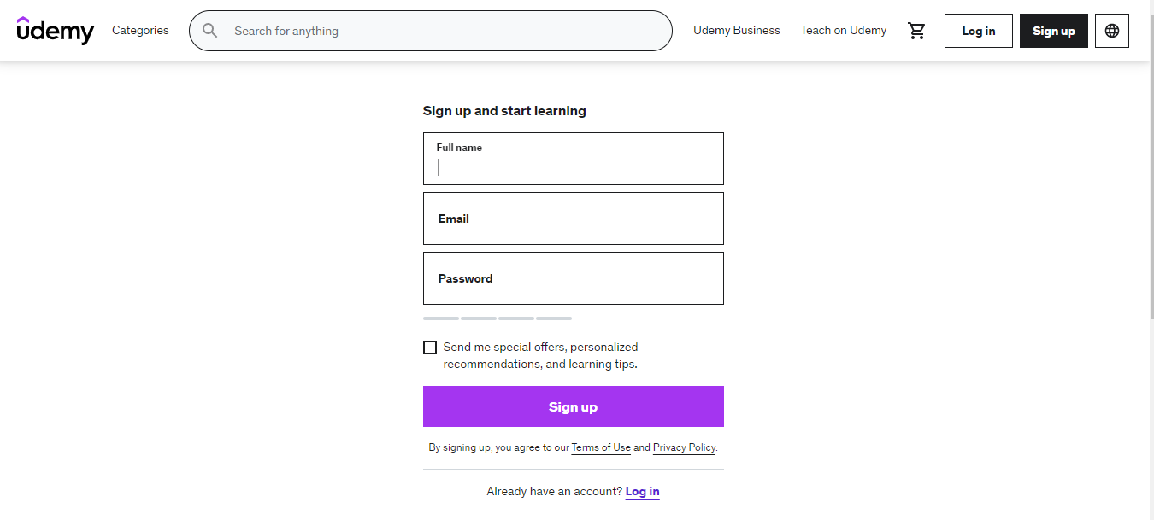

In order to create account on Udemy, learners need to enter the sign-up page visible on the menu bar and once the sign-up page pops up, learners’ full name, email and a unique password must be filled. There is also an option to choose whether to allow Udemy to send emails about the platform’s contents and if learners want to receive and keep up to date with Udemy, they can check the option and if not, they can leave it behind. Before clicking the Sign-up button, if learners already have the existing account on the platform, they can move to log in page directly from the menu or via the underlined log in text “Already have an account?” text down the page. If there is no existing account, learners can just simply click on the “Sign up” button and the new account would be created afterwards.

Coursera



In order to create account on at Coursera, user must click on “Join for Free” button which a registration form would appear afterwards.

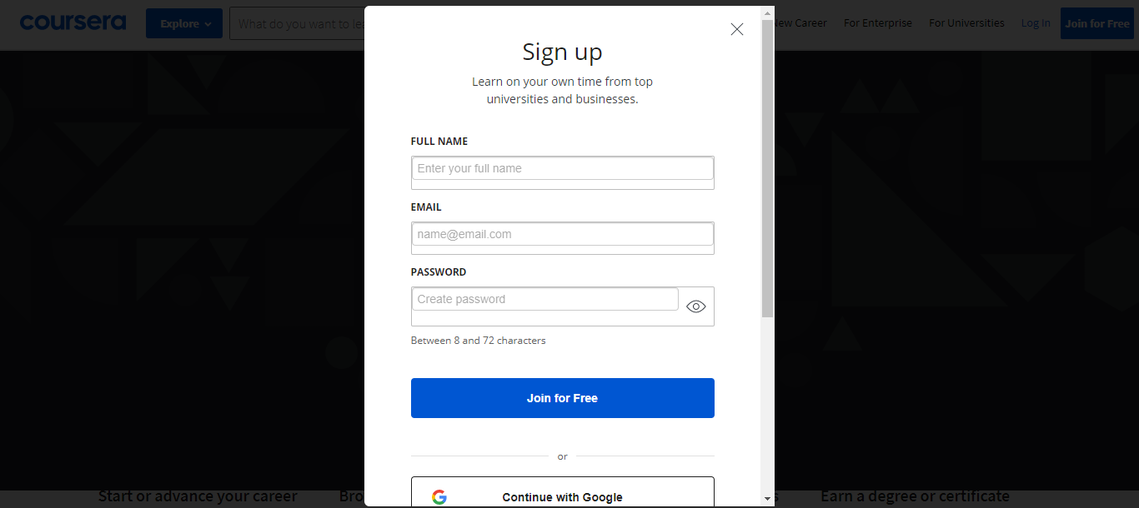



On the registration form, user’s full name, email and a password must be filled or if they wish to create their account with their google or Facebook accounts, they can simply click on “Continue with Google” or “Continue with Facebook” buttons and complete verifications. Otherwise, they have to click on “join for free” button. Clicking on “Join for Free” button means learner agrees with terms and conditions provided by Coursera. There is also an option to sign up with learner’s organization account and if they wish to sign up via that, they can. Before signing up, if they have their Coursera account already existing, they can simply click on Login via the menu tab or the highlighted link under the registration form.

### Login

Udemy

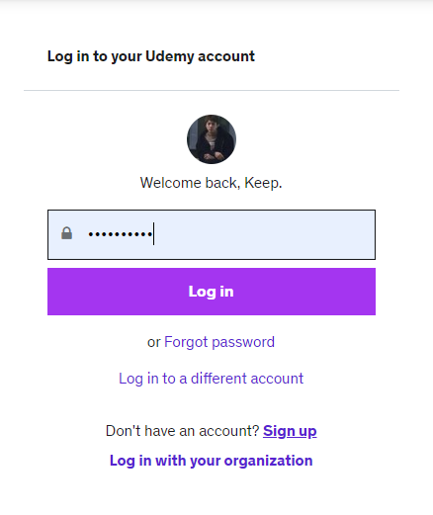

The log in page for Udemy can be entered via the Login button on the menu tab above the page or through registration page. The credentials used during sign up stage must be used to login to the account and then click on Login afterwards. If there are multiple accounts on this platform, learners can simply click on Log-in to different account link to login with another account. Just like from the sign-up page, if users want to log in via their organization account, they can by clicking on the “Log in with your organization” link. If a new visitor entered the login page accidently, they can enter the Sign-Up page to create account via this login page. With that being said, for ordinary users, they have to click on Login button.

Note: For Udemy, if some one has both learner and instructor account, they can have access to both of them once they have logged into learner account.

Coursera

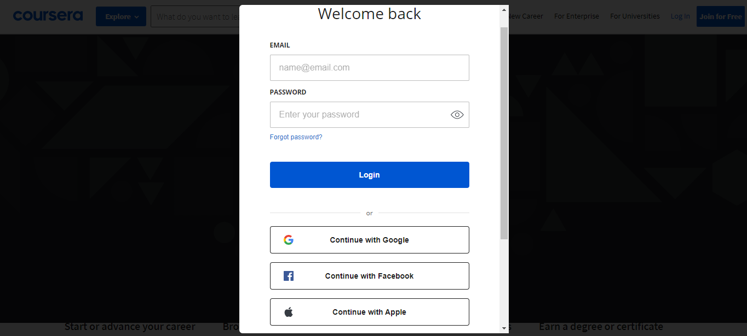

To login to Coursera, email and password of user that were used in sign up stage must be entered and if they have registered via their google or Facebook or organization accounts, they can continue logging in with them and additionally, there is also a direct link to sign up page for confused visitors who accidently entered the login form.

### Instructor registration

Udemy



For instructors to register in the platform, they can simply click on “Teach on Udemy” link which instructors will be directed to a page that consists of tips and methods for instructors to begin their business on Udemy platform.

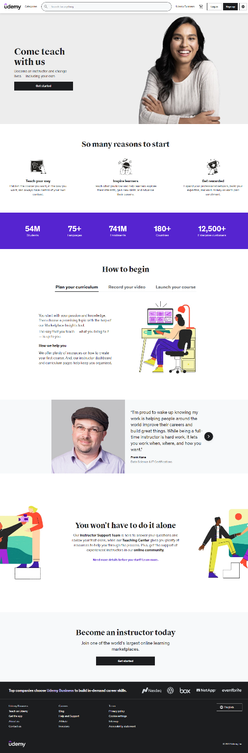

If the instructors have no idea how to start their teaching journey on Udemy, they can watch and apply those tips shown in this page. To create instructor account, they must click on “Get Started” button.

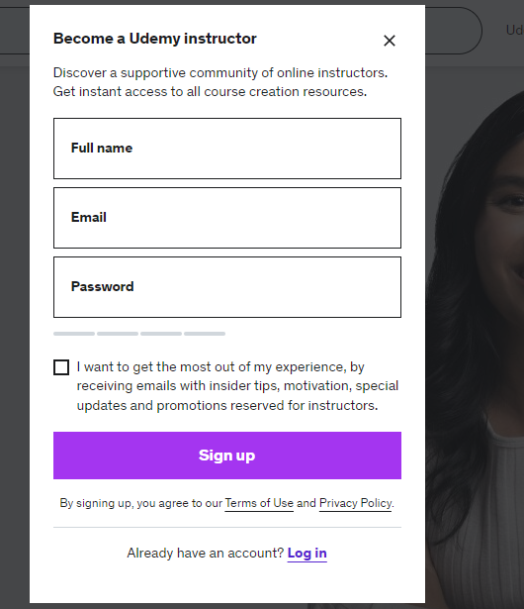

Once clicking on that button, a registration form will appear which instructors have to fill required credentials including their full name, email and password just like in learner registration page. The other contents in this registration form are the same as the learner’s ones and thus, no further explanation would be required here. Once the credentials are filled, the Sign-up button must be clicked. 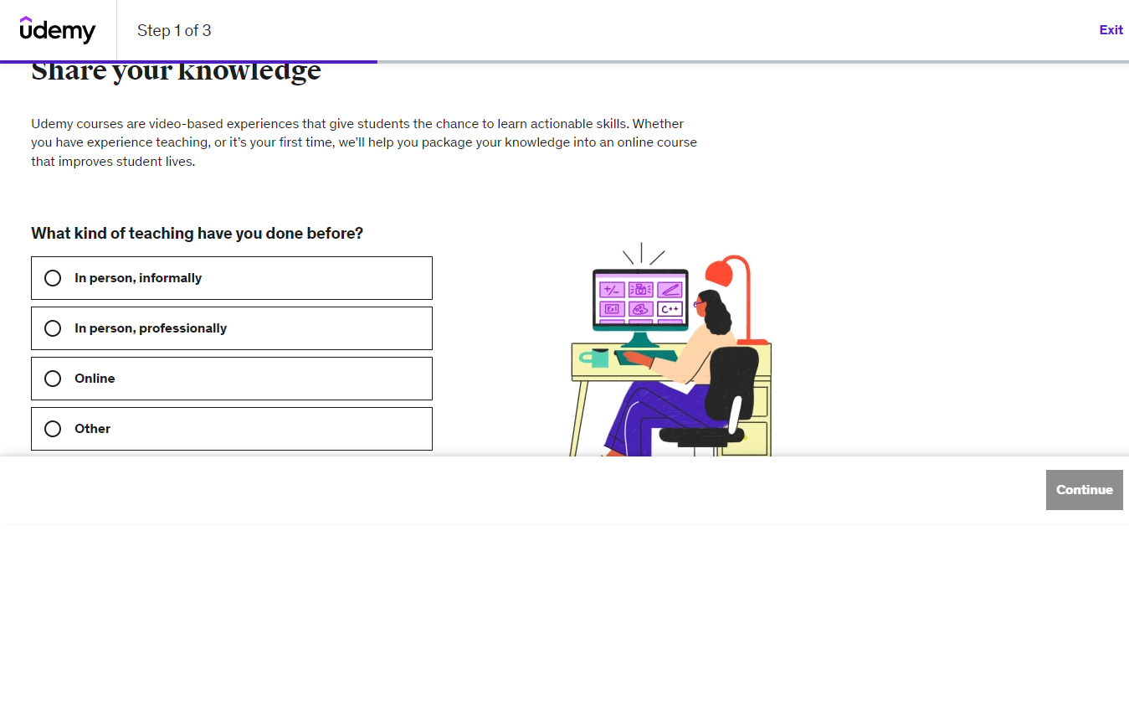

After this, instructors would be directed to the first page that is equivalent to first step of creation of instructor account. Here, they must choose option that fits the kind of teaching they have done prior. In this page, there are two things to take note considering for usability, which are the inclusion of Exit button and Continue button for users to easily exist the registration progress if they have second thoughts and proceed if they want to go further.

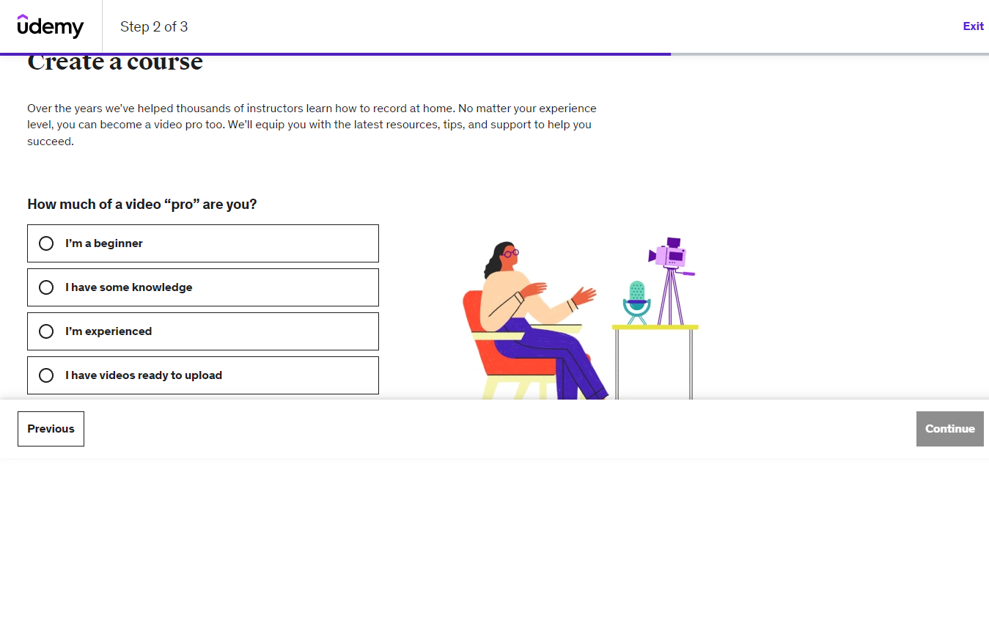

On the second step, instructor must choose their experience in video editing. Also in this page, usability consideration for users can be seen with the provision of “Previous” button that would take user back to step 1 page to change anything there if they have messed up.

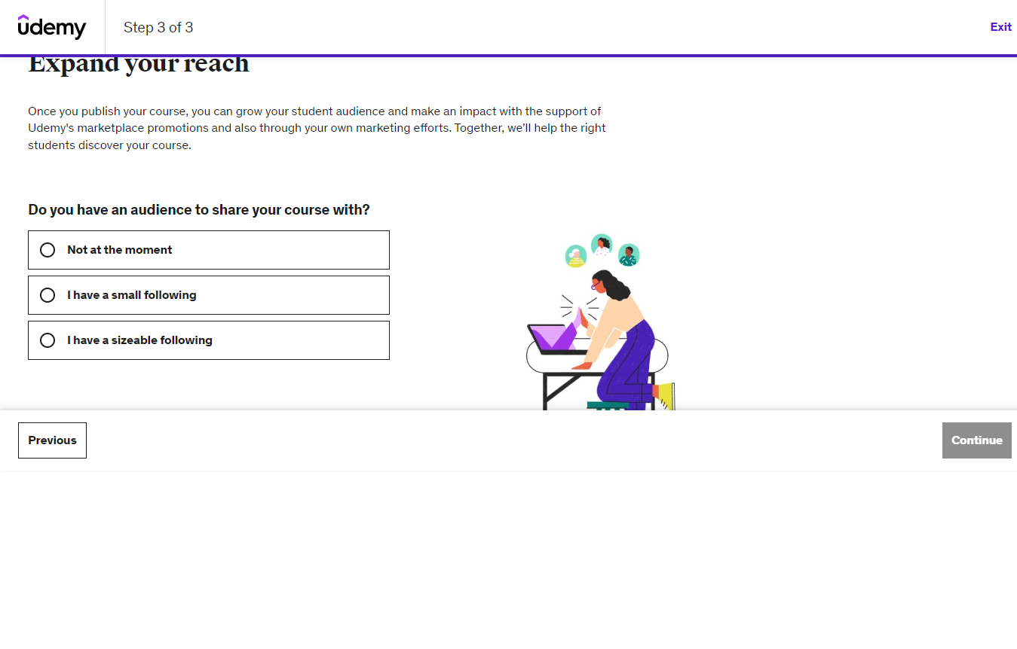

On this step 3 page, they have to choose whether they have existing audience or not by choosing one of the 3 options that fits them the most. After clicking on the “Continue” button below, the instructor registration has completed and the instructors can start teaching journey on Udemy.

Coursera

Apparently, there is no page of registration for instructors in Coursera but to become one on the platform, they must either already be a professor or part of a university or institute that is already a partner of Coursera or a lecturer who had experience of teaching at a college or university level since Coursera itself had not made agreements with freelance instructors. Therefore, under this topic, information of Registration for instructors at Coursera cannot be provided.

### Instructor dashboard

Udemy

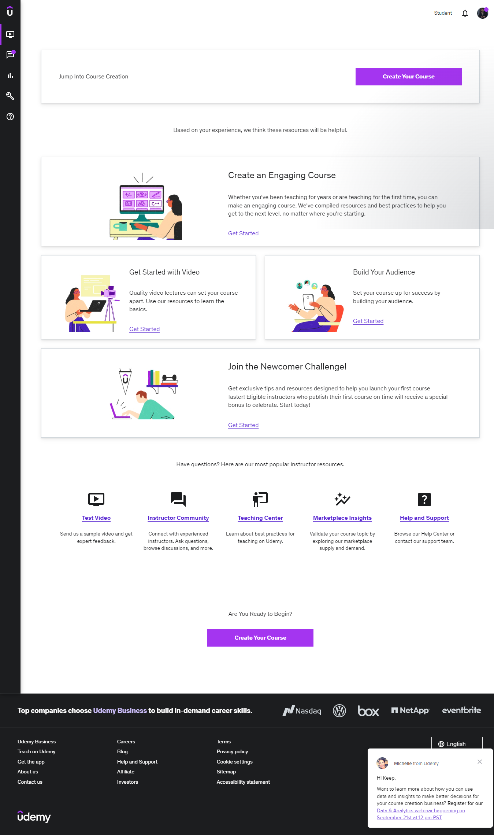

After logging in as an instructor, the first page they would land on is the course page that includes area for creating courses; areas that provide tips and ideas to upload video lectures, build learner audience, create an engaging course and actually launch the course and area of instructor resources consisting of video testing, instructor community, teaching centre that would provide advice on how to teach at Udemy, market place insights that provide information on most demanding topics on Udemy and help and support. Once the instructor is ready to create a course, they can simply click on “Create Your Course” button.

Course creation

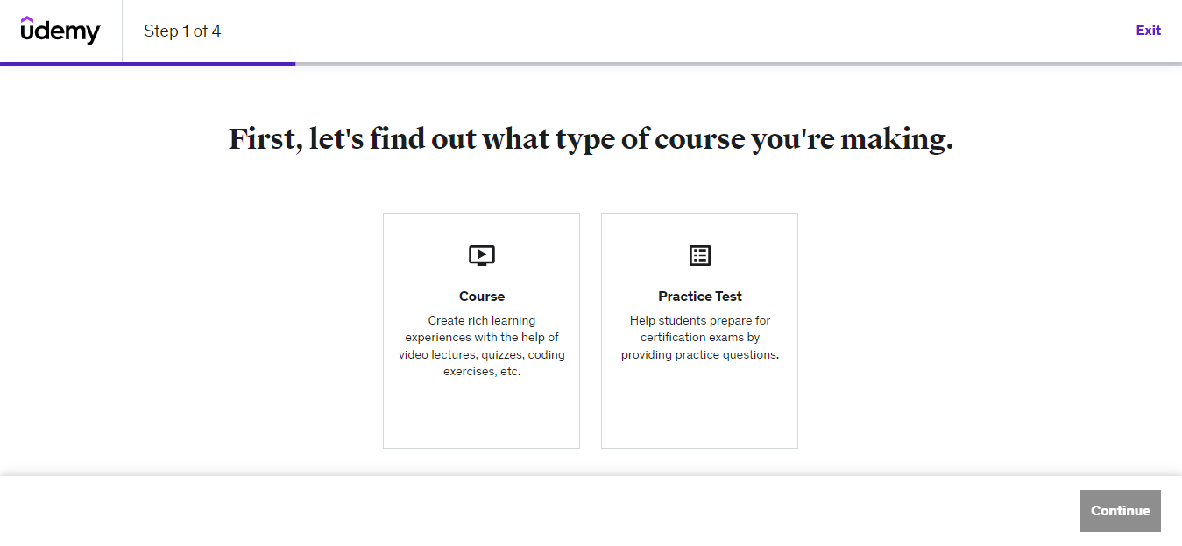

This is the page instructors will land on after clicking on the “Create Your Course” button and is the first step of creating a course. Here, they must choose whether they are going to upload the entire course of just the practice test with a bunch of questions.

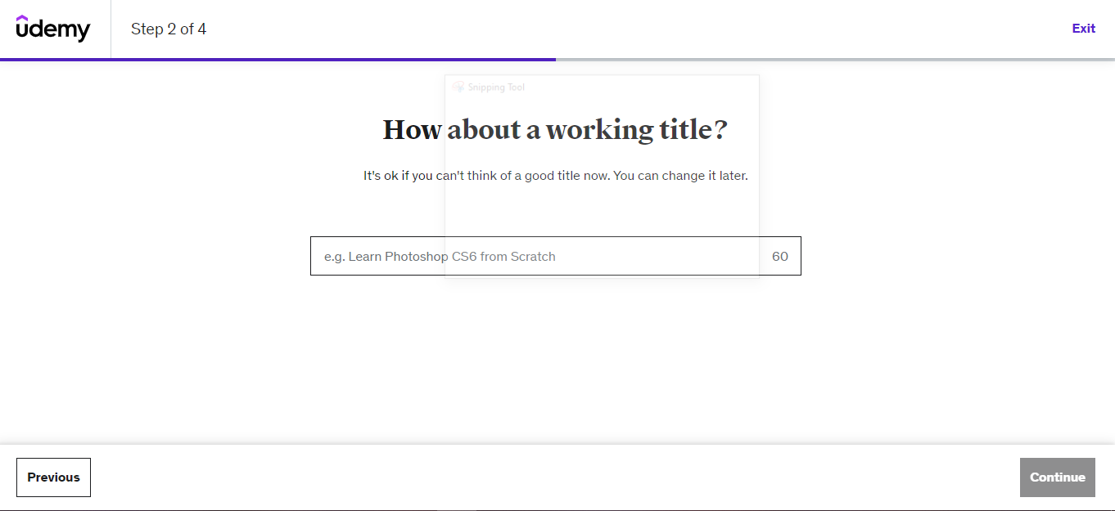

If instructors chose “Course”, this is the page they would be seeing which is about naming the course title. If they don’t have any idea for course title, they can change it later.

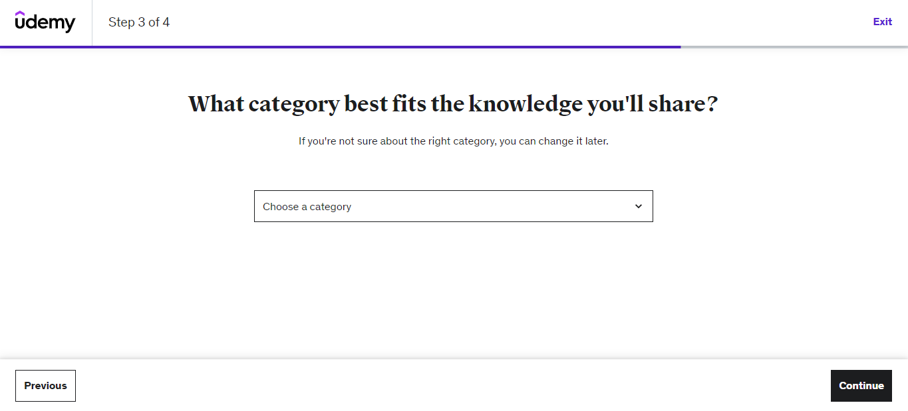

The next step is about choosing the category for the course.

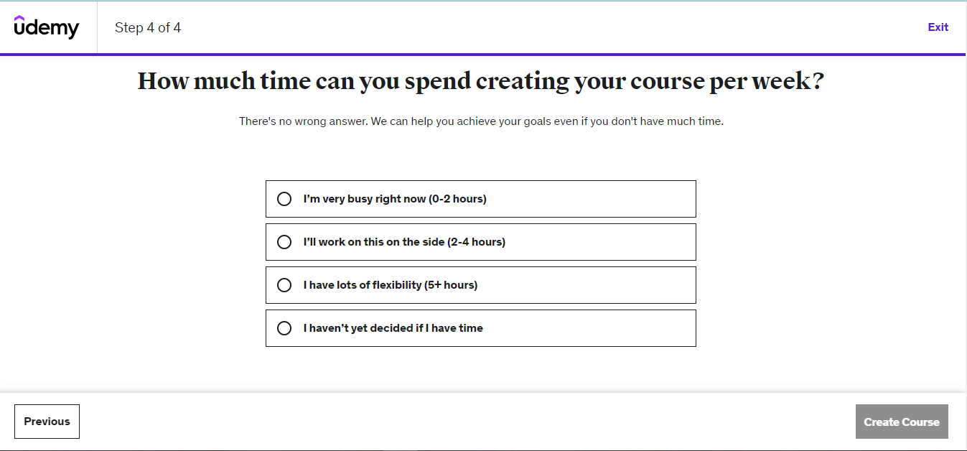

In this step, instructors have to choose the amount of time they can spend while creating their course in each week.

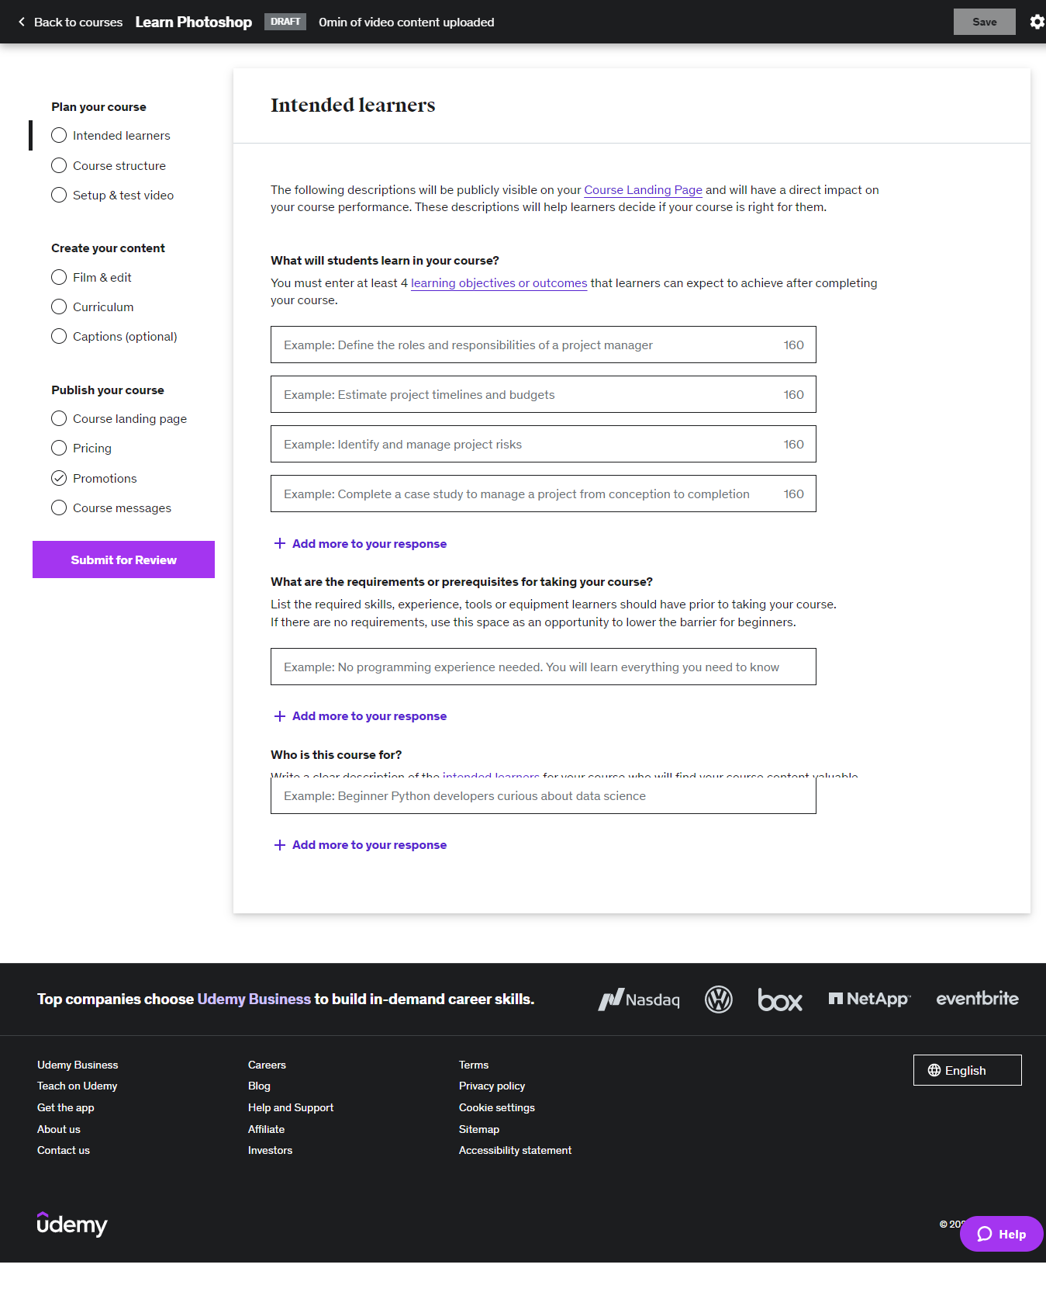

This is the step of setting up descriptions for the course. Here, instructors must describe at least 4 learning objectives and outcomes (which they can add more if they want to) highlighting what learners would learn from this course and what they can expect to achieve after completing this course. Then, requirements such as tools, skill set, experiences or equipment that learners must have before taking this course must be demonstrated. And lastly, the targeted audience for this course must be described. After filling all of these descriptions, save button on the top of the page must be clicked.

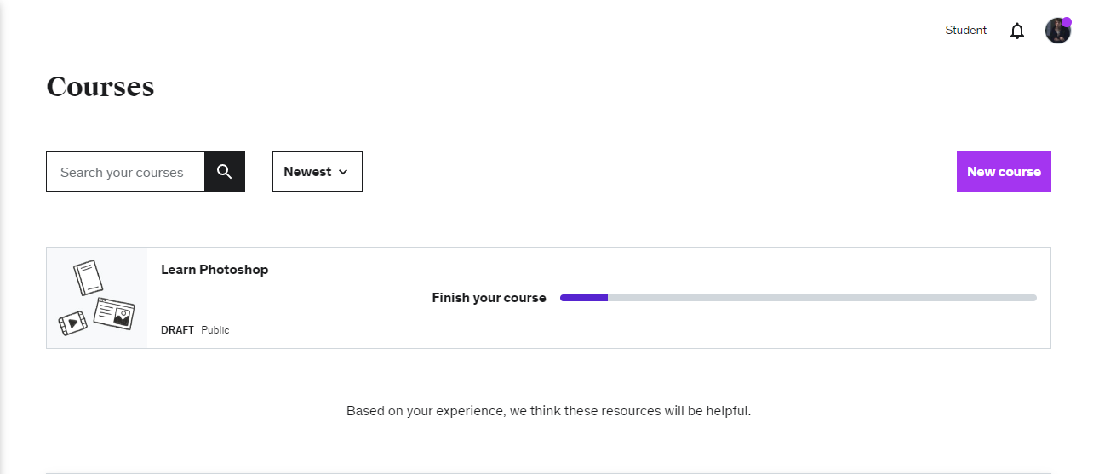

After saving the course and going back to the courses page, instructors will see the courses they have just created. For usability purposes, it can be seen that Udemy has put a search box and filter that would filter out the courses that instructors have created. Even better, to show instructors the status and progress of their course, there is a status showing “Public” which conveys the course can be seen by everyone on Udemy and a measurement bar showing the progress of the course.

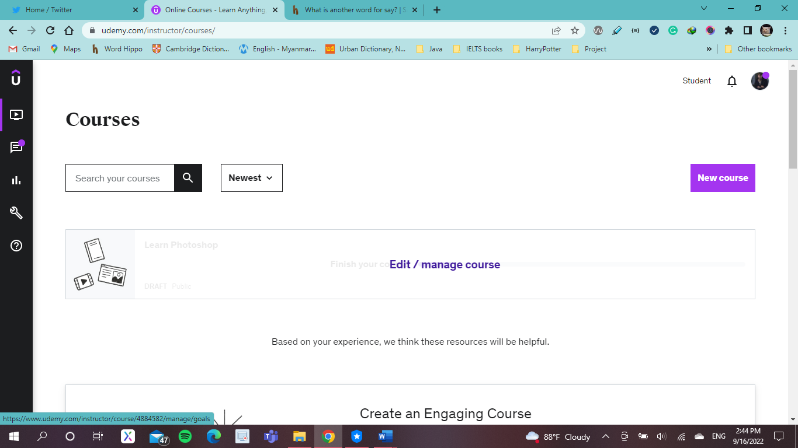

Hovering on the course will allow the instructor to Edit and manage the course and clicking on it would direct the instructor to editing page of the course as follows.

Course editing

Course Structure

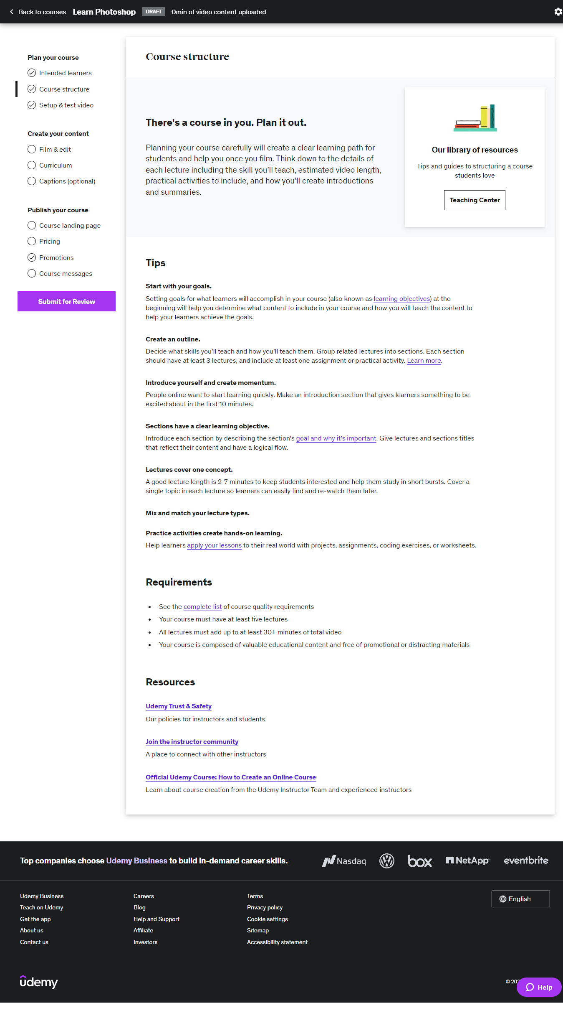

There is a navigation bar to navigate through the pages the editing process and the current page shown in the picture above is the course structure page under “Plan your course” section and here, instructor will see the advices and ideas Udemy give to structure the course plan.

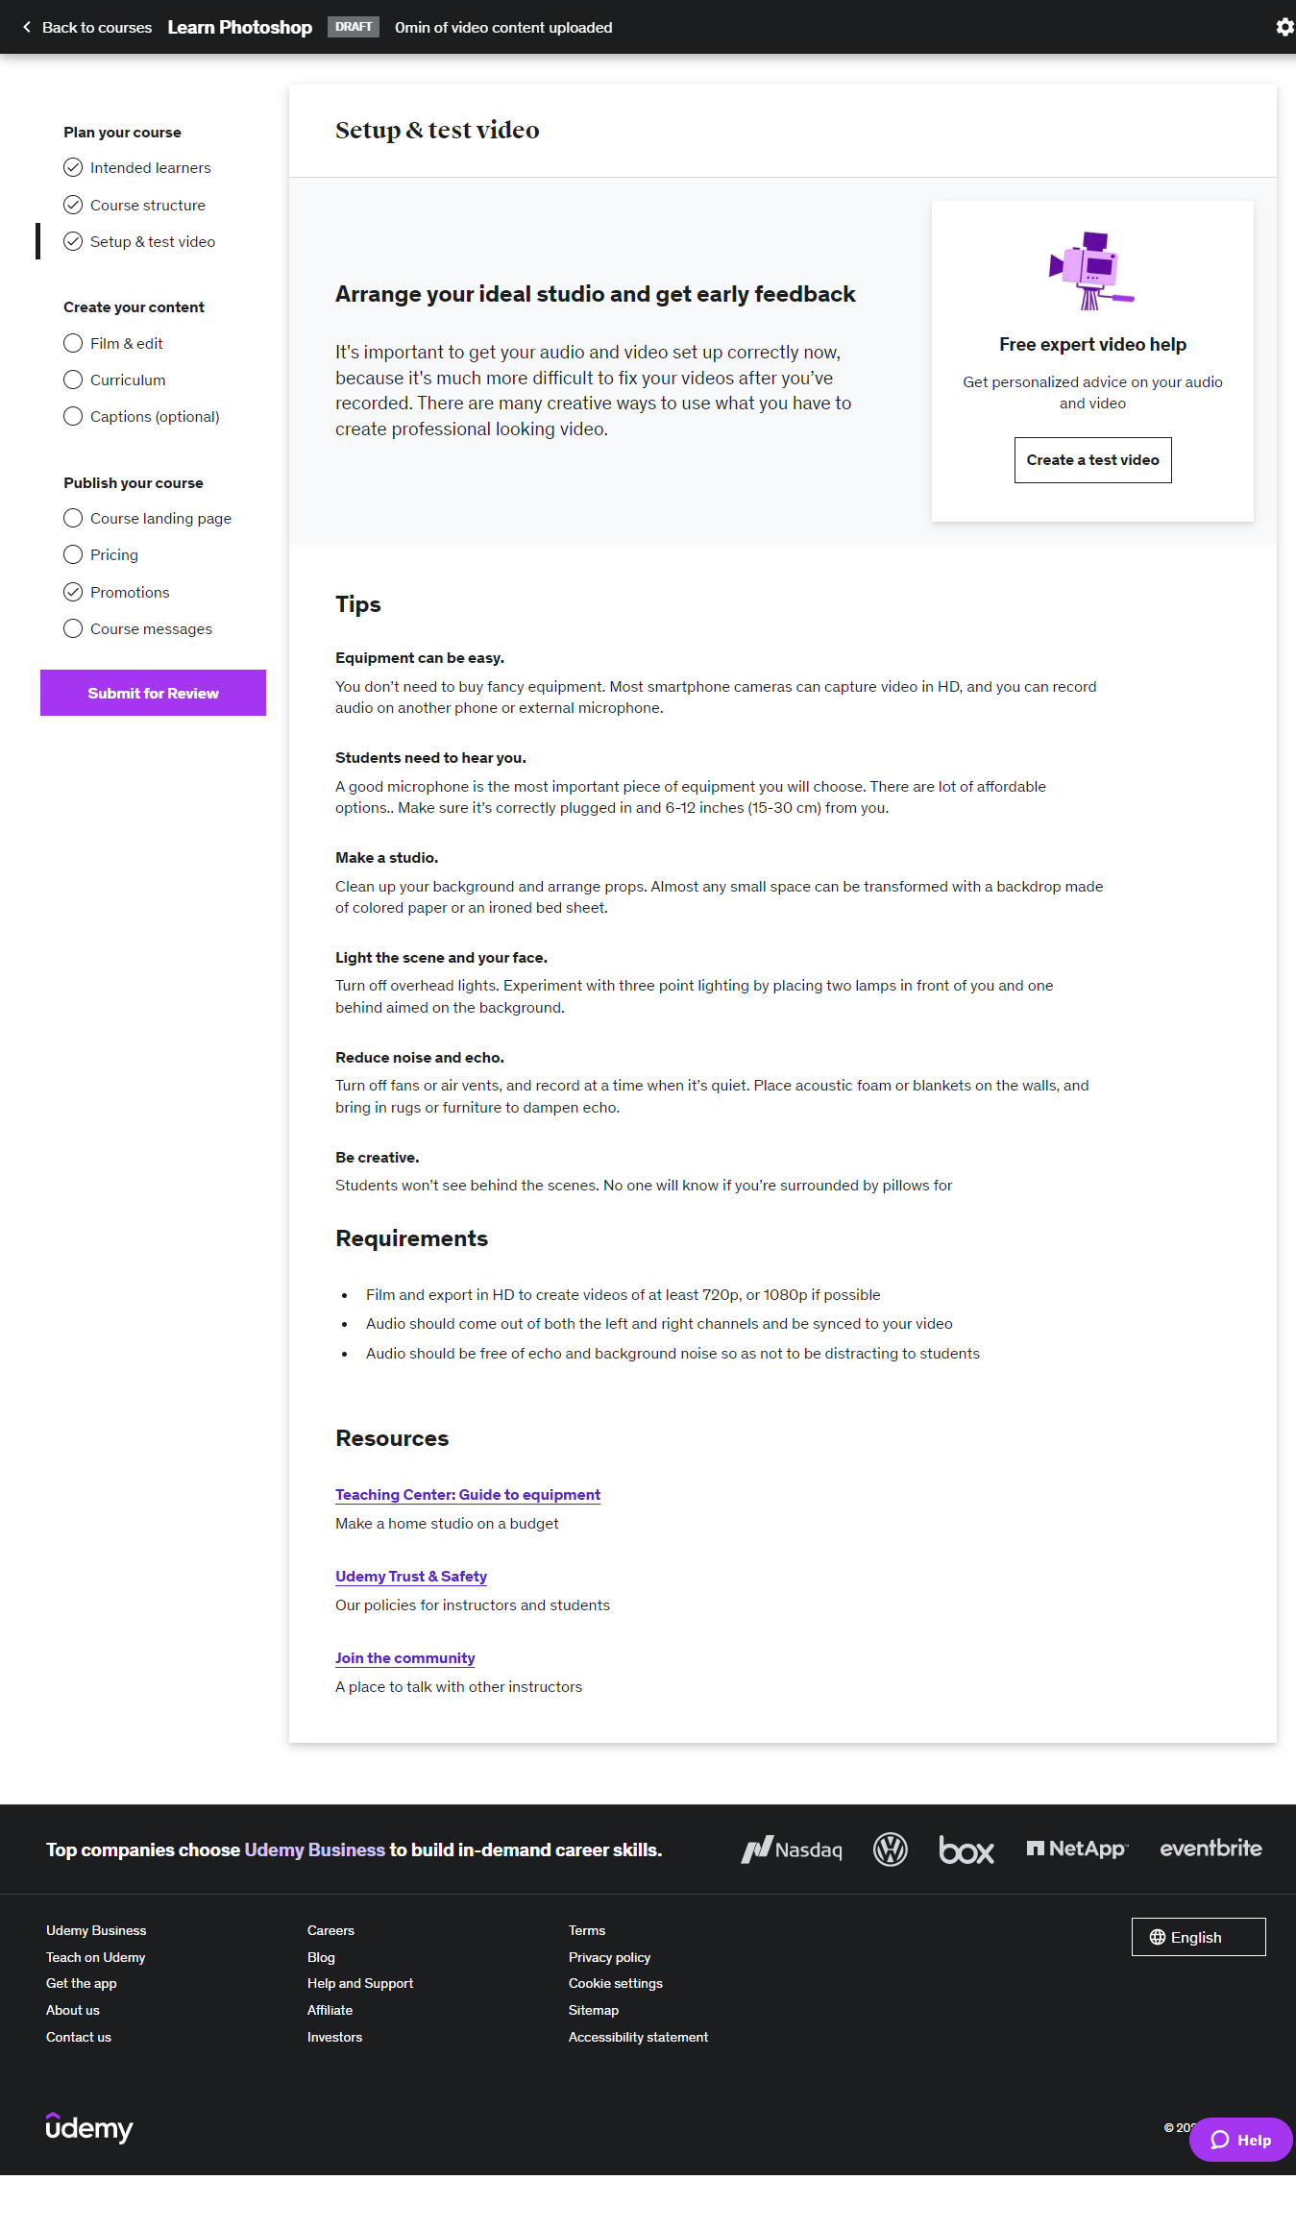

This is the page that provides information and tips to instructors about setting up and testing the video. Instructors can apply the tips provided here to plan their video courses efficiently.

Film and edit

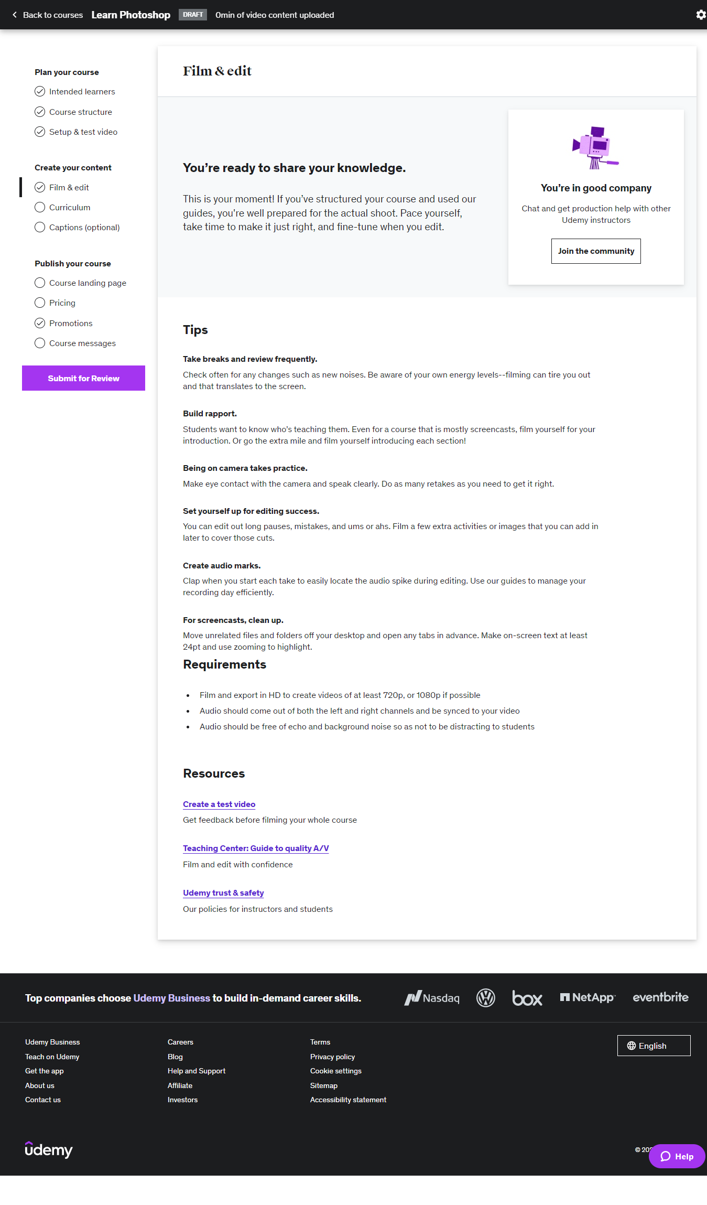

This is the first page under “Create your content” section of course editing and contains Udemy’s provisions of tips and ideas on filming and editing video lectures.

Curriculum

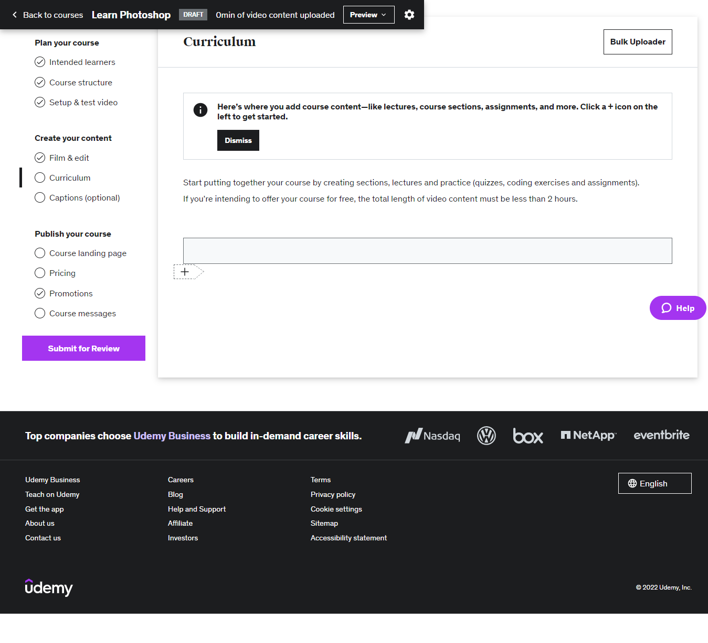

This is the page for creating curriculums for the course and here, instructors can upload course contents through sections, lectures, quizzes and videos. To upload a new section, they have to click on the “+” sign circled in the figure above.

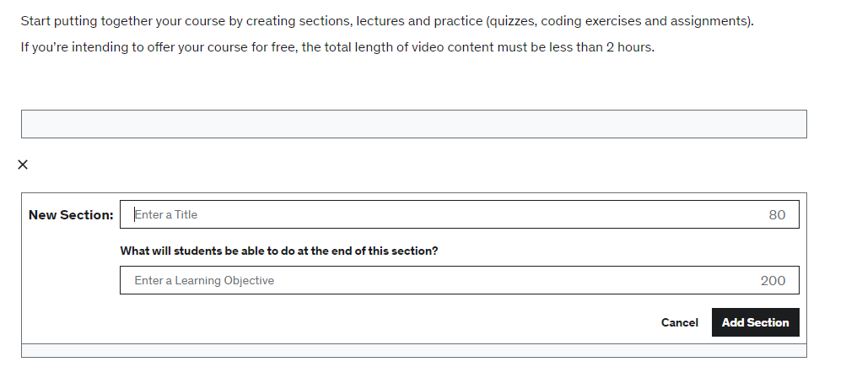

Once it is clicked on, a box will appear for instructor to put section title and fill up the learning objective of that particular section. Once they have finished giving title and objective out, they can simply click on “Add Section” button and a new section will be created.

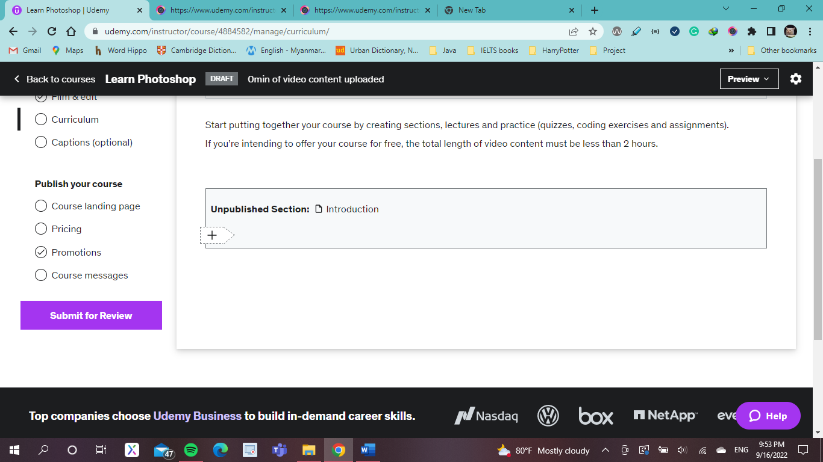

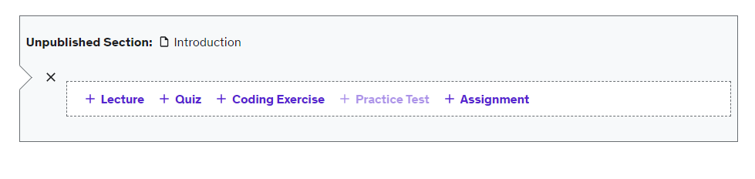

Contents to the section can be added by clicking on the “+” sign just like mentioned above and options for content types will appear which the instructor can choose which type of contents they want to put into this particular section.

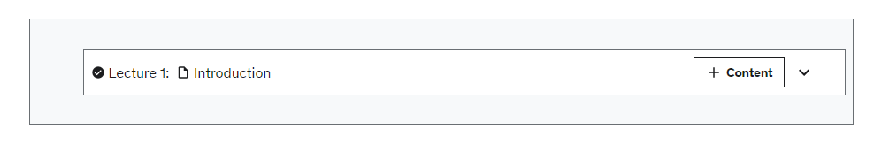

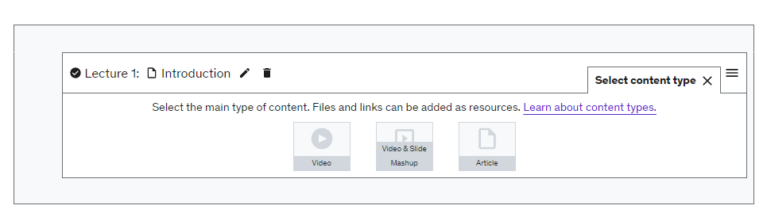

If instructors have chosen the lecture option, they can upload videos with options to video types: simple video, mashup of video and slide or just an article.

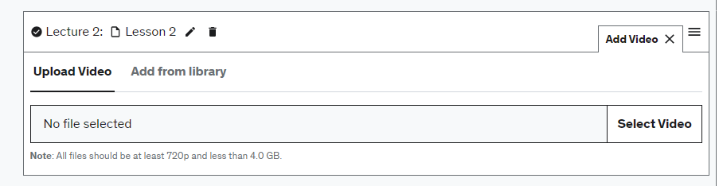

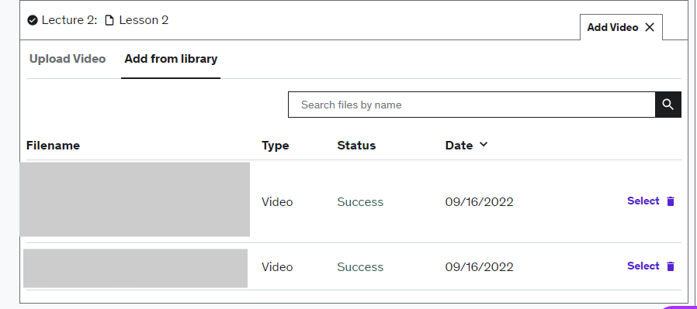

The figure above is what would appear after choosing the video option and instructor can upload lecture videos, they have in their devices by simply clicking on Select Video button or by uploading the video they have already uploaded on Udemy.

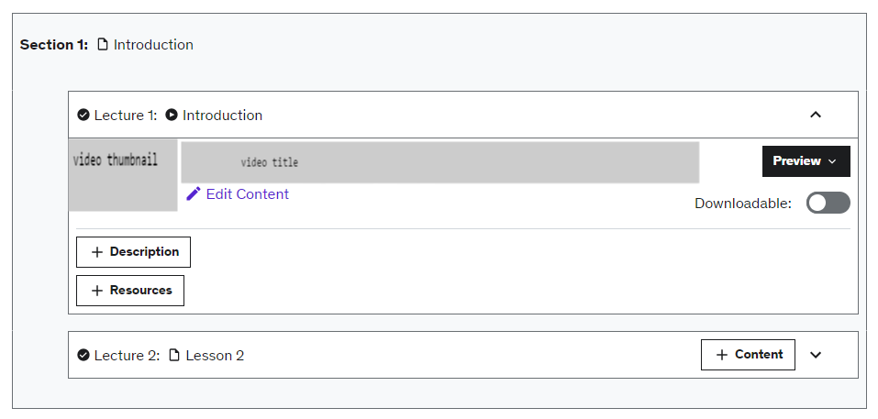

This is what the instructor would see after uploading the video content. They can edit the video if they want to by clicking on “Edit Content” word and Udemy will allow them to replace the video with another one. There is also option to choose whether the instructors would allow the learners to download the content or not. Under the video content, they can add descriptions of this particular content and additional resources as shown below:

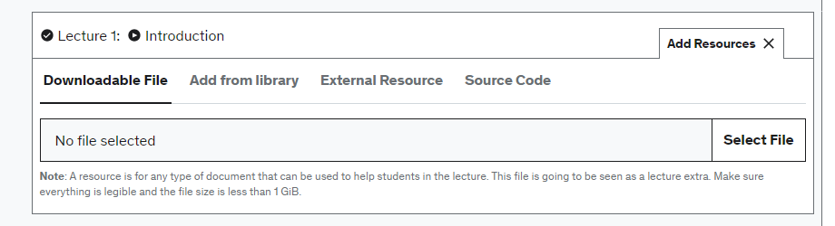

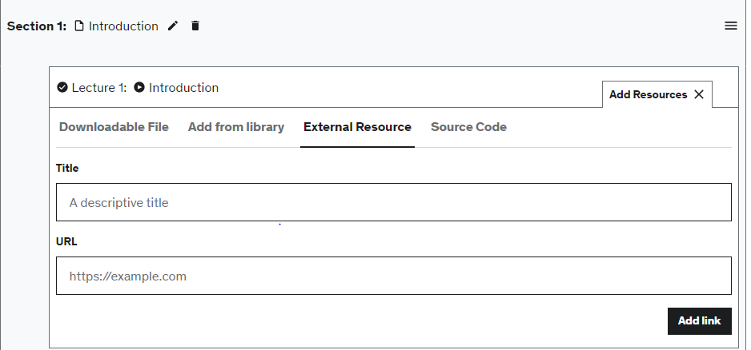

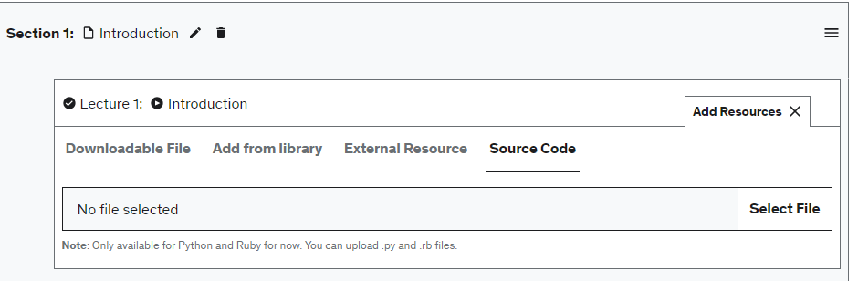

They can choose whether they want to upload downloadable file from their device or add existing content from Udemy library or from External Resource by giving out link or the source code for programming courses.

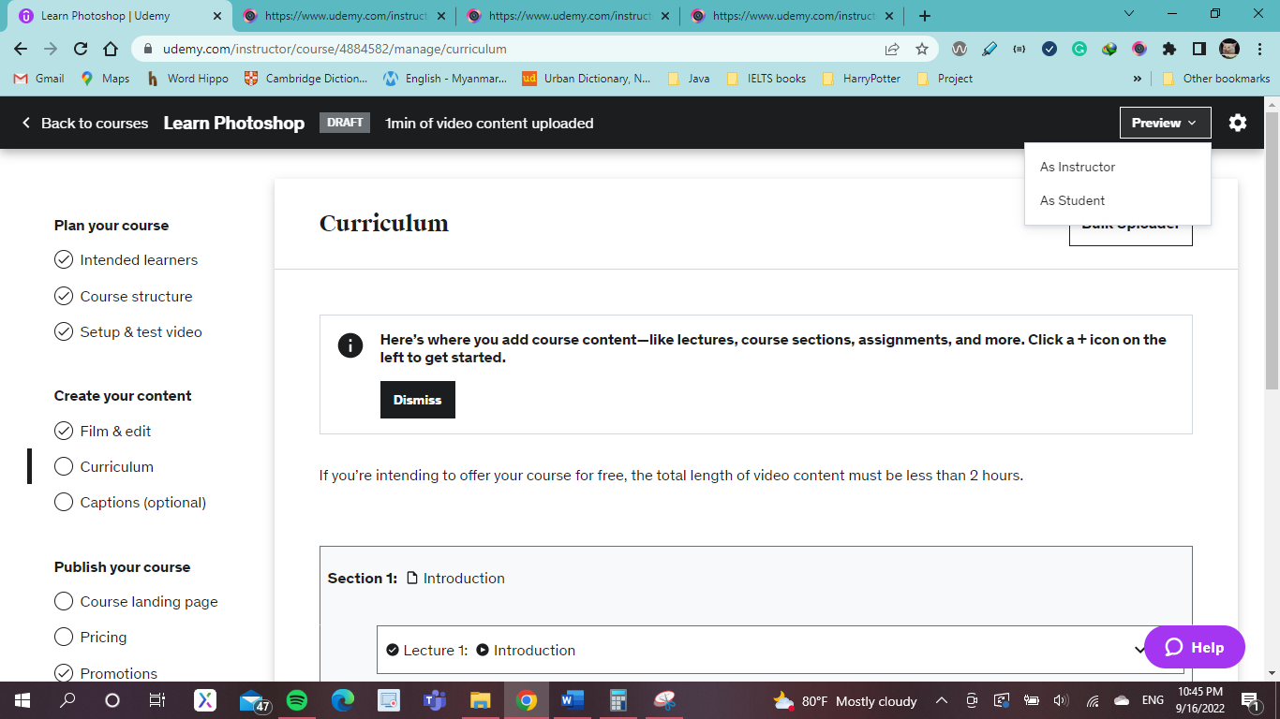

Udemy also provides preview for both instructors and learners which will show two different views of how the course contents will be visible on both instructor and learner side.

Learner and Instructor preview

Instructor and learner previews are basically the same here.

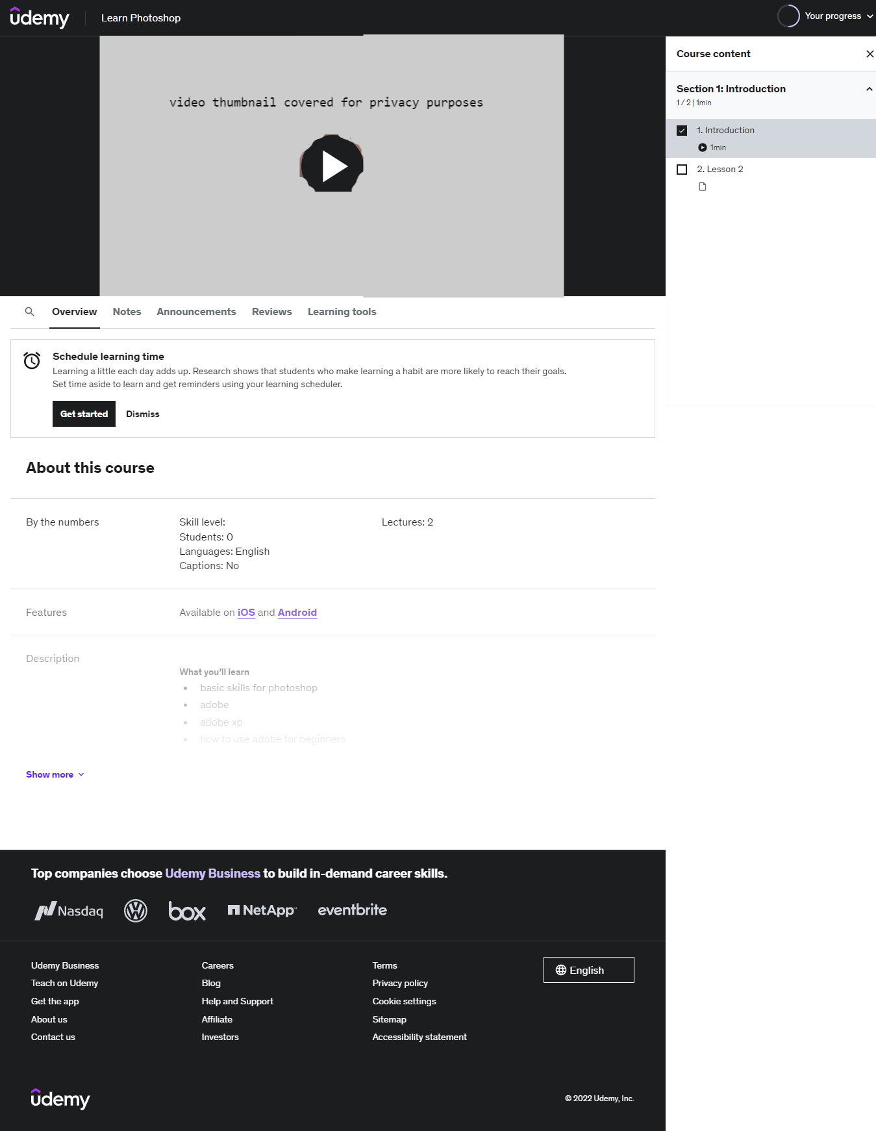

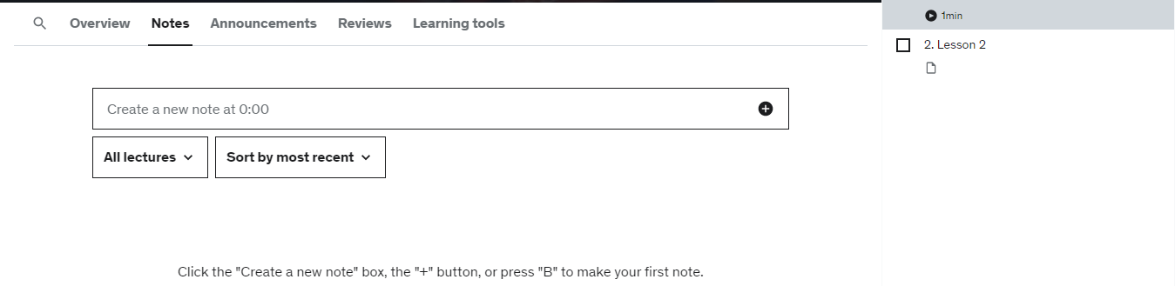

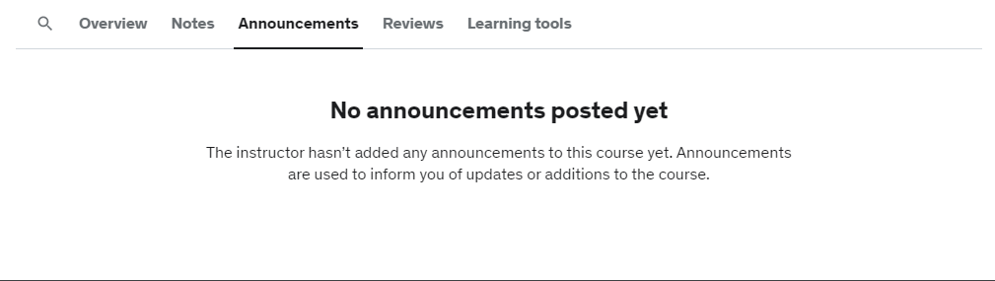

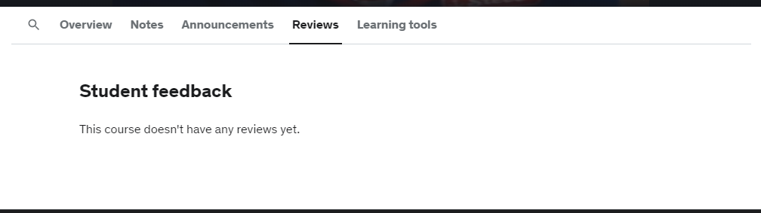

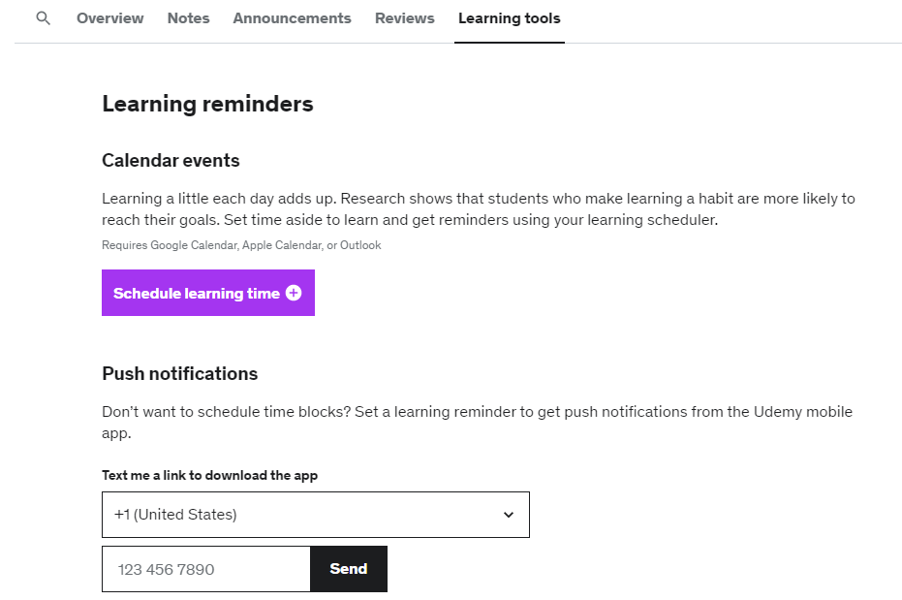

The above figures are the preview from learner’s side and here, 4 sections are provided: overview that will show the description and details of the course, notes: where learners can take notes on specific time duration of the video, Announcements: where learners can see any announcement instructor made on this particular course, Reviews: where learner can see review on this particular lecture from other students and Learning tools: which are provided by Udemy and contains calendar events that will help learners in scheduling their learning and notification pushers which will notify them learning schedules via their mobile phones. Beside of the content video, there is a list of course contents which the learner can navigate through each of them.

Captions adding

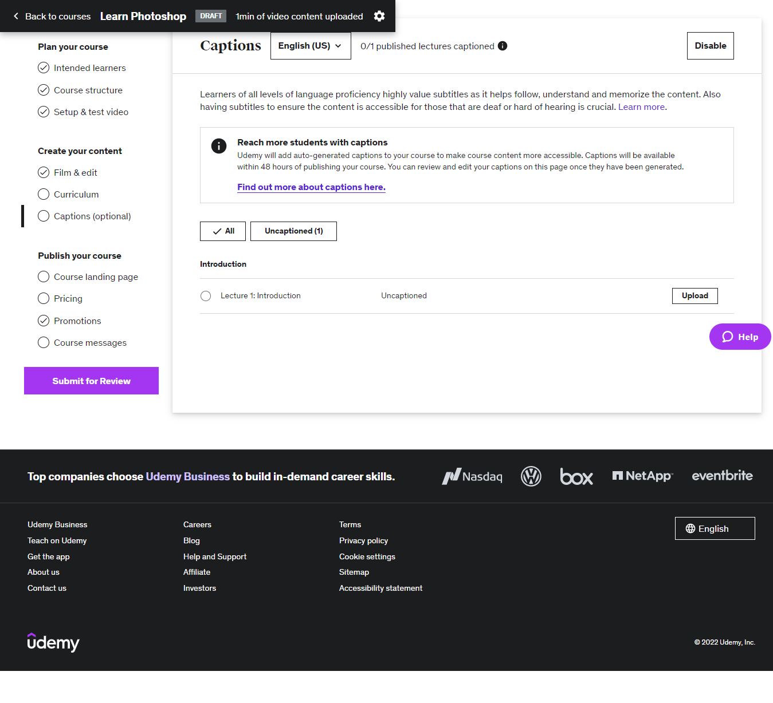

This is the page for uploading subtitles for uploaded video lectures. Instructors are given with two options to provide captions to their audience: they can either upload the captions by themselves using the VTT extended files or wait for 48 hours for Udemy to add auto-generated captions to the videos in their courses.

Course landing page

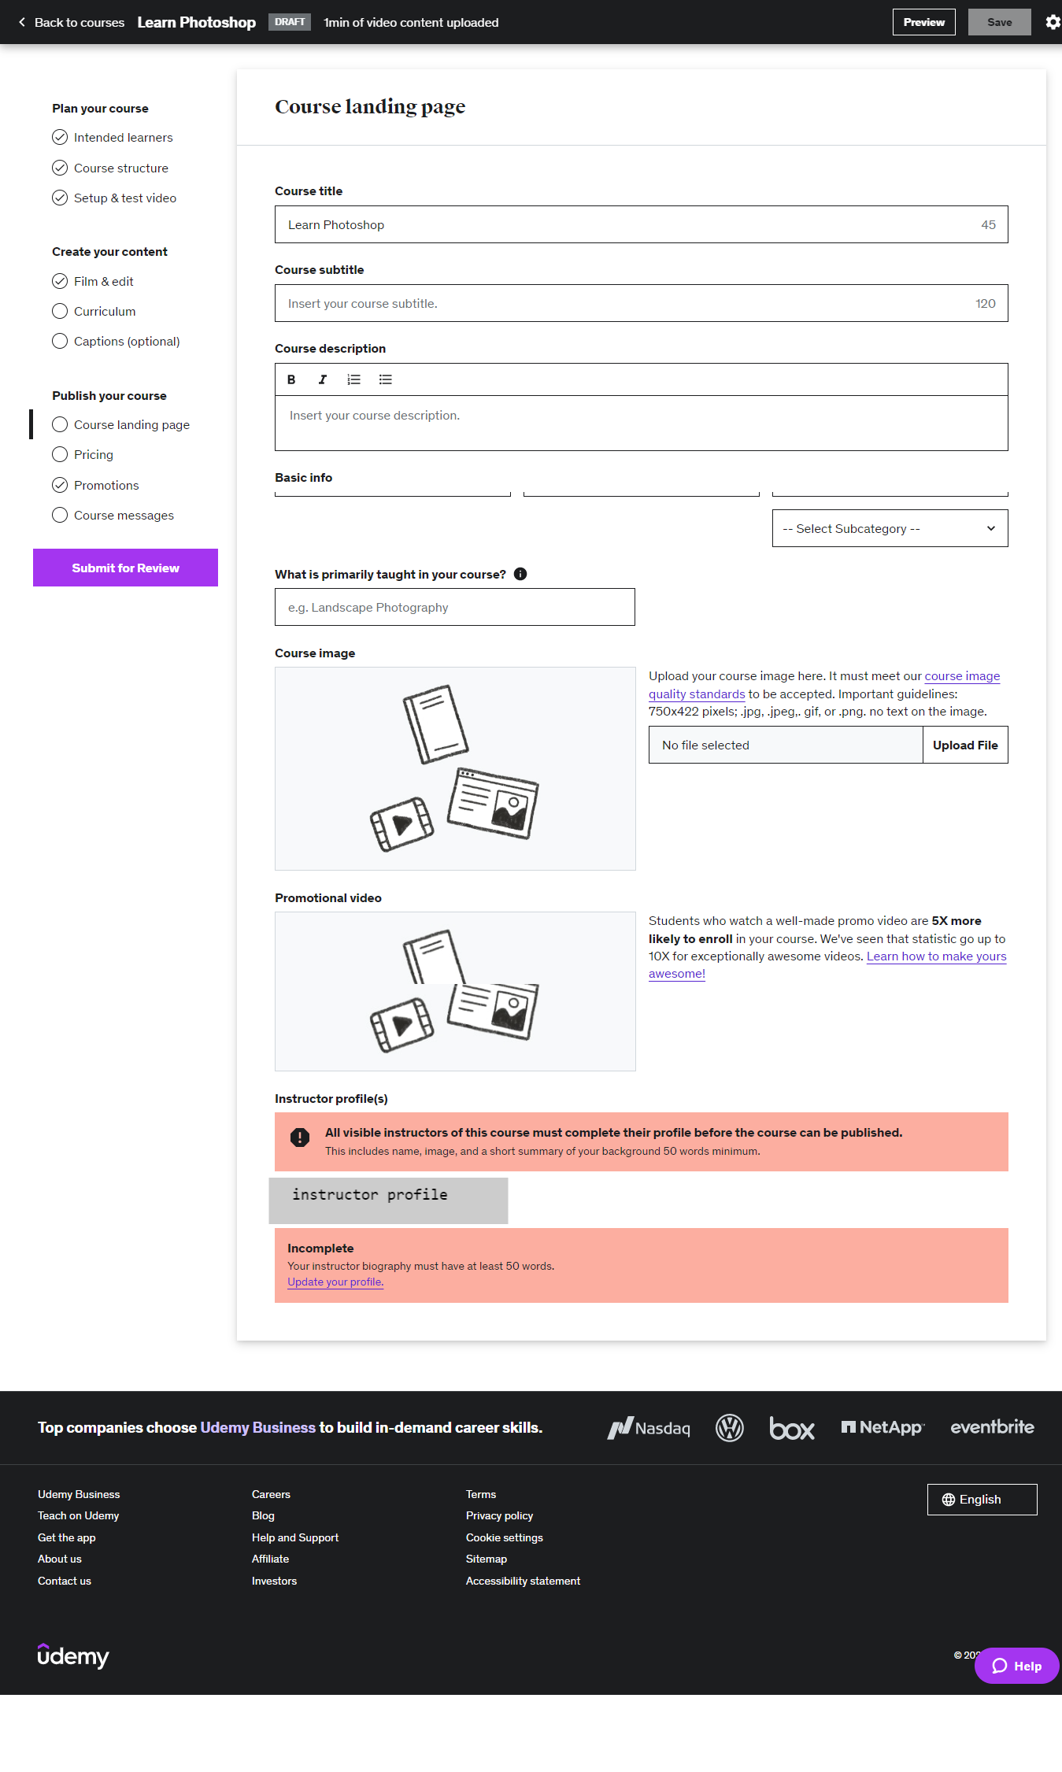

This is another page for adding description for the created course. Here, instructors can modify the course title, course description that they have mentioned during creation stage as well as add subtitle for the course, edit basic information such as language, level, course category etc., elaborate what they would be primarily teaching in this course, upload the thumbnail picture for the course and add promotional video. They can also update their profile and biography here if they want to.

Pricing

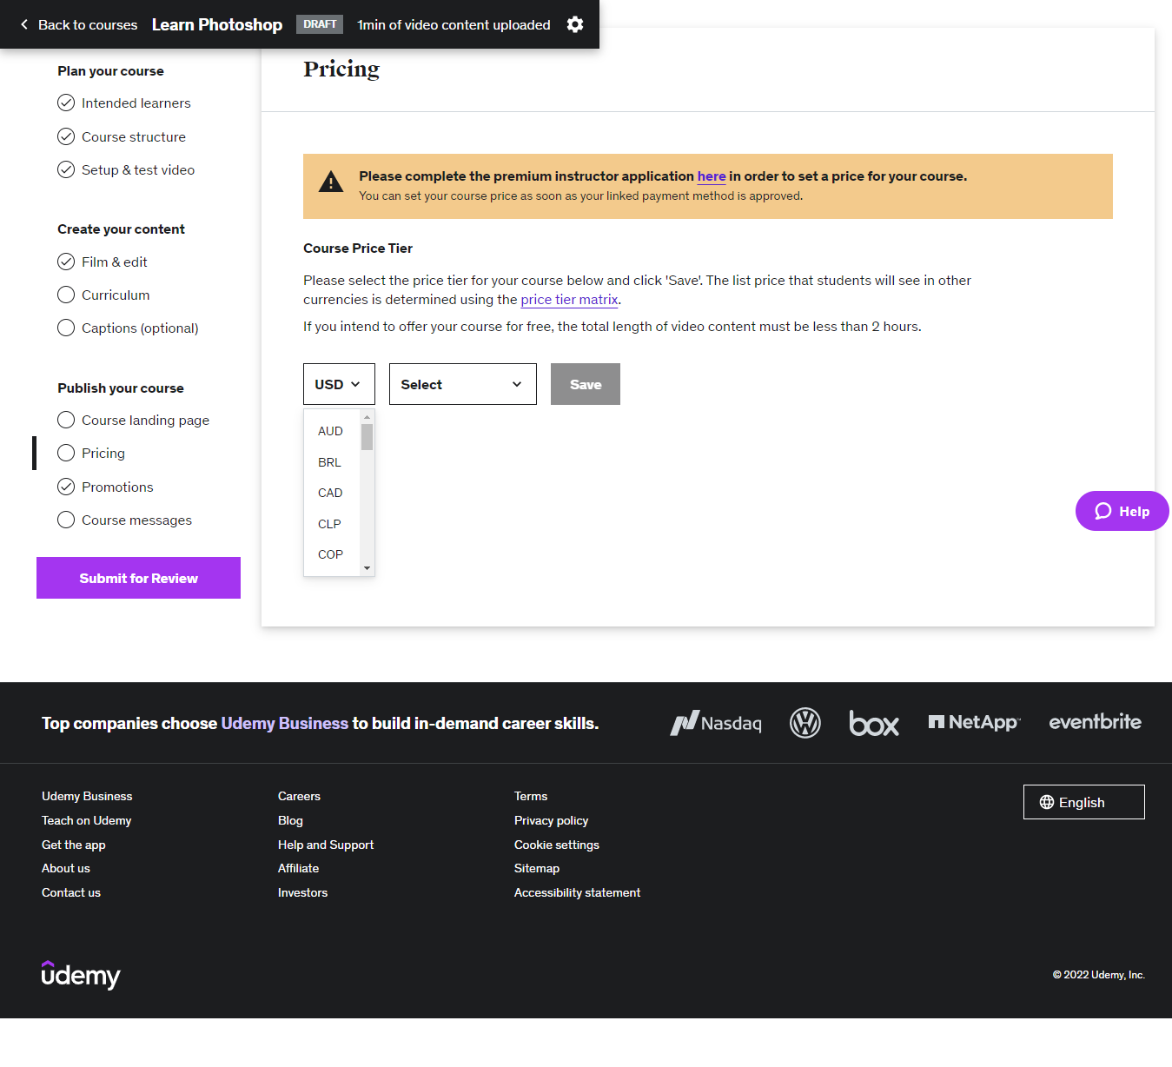

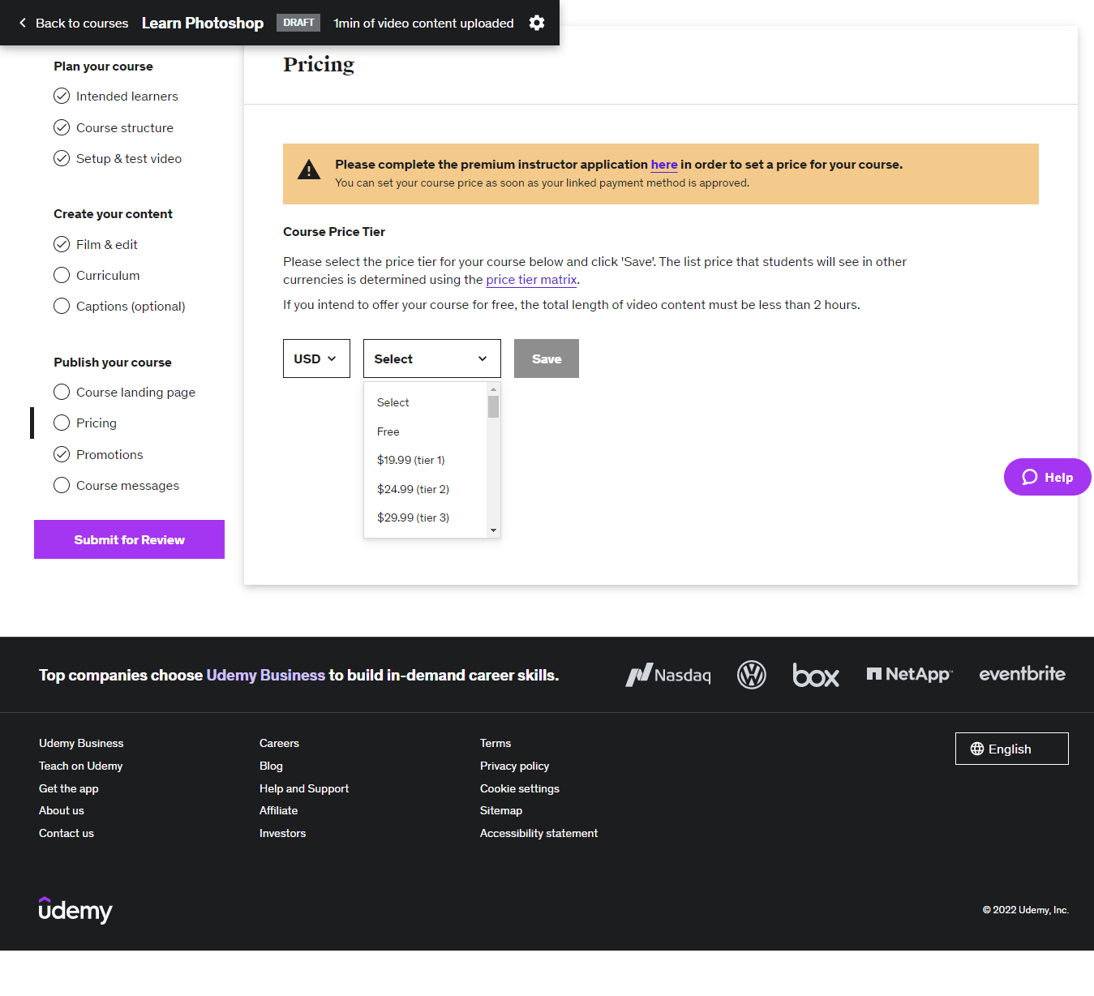

This is the page for instructors to set the price for the course. Here, they can choose the currency and price range they will be taking.

Promotions

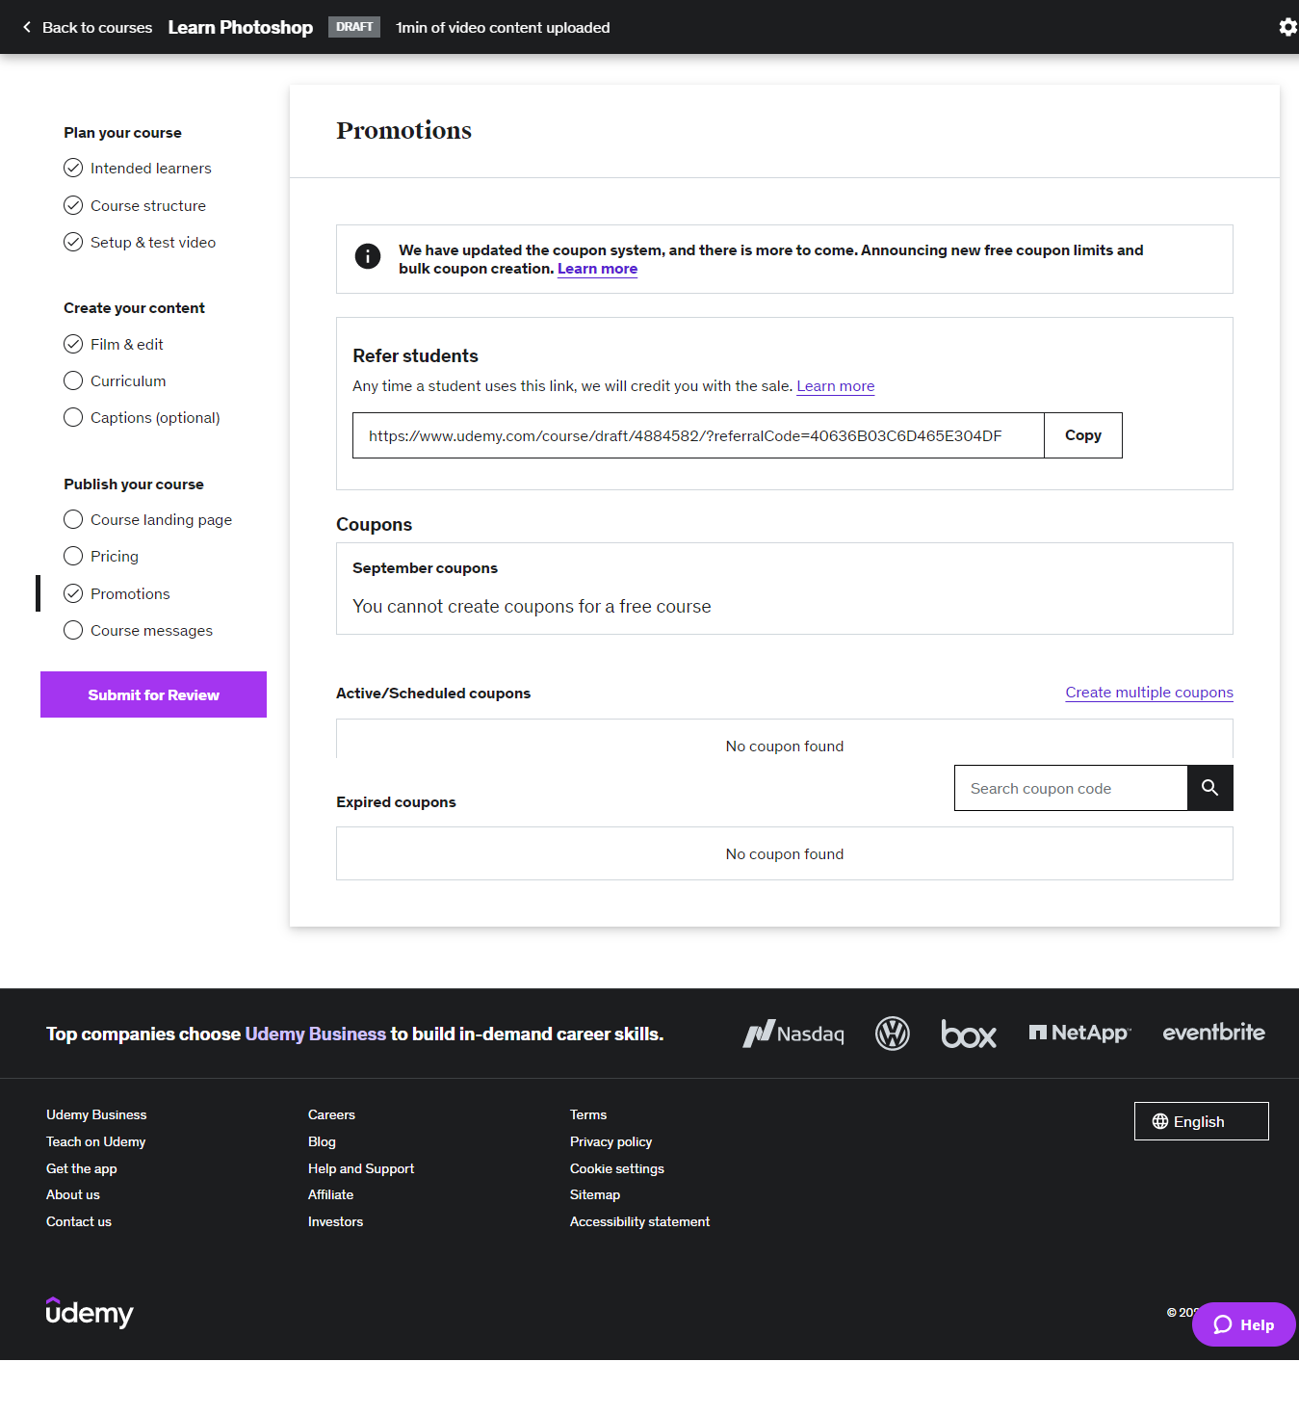

This is the page for instructors to set up promotions for their courses. The page contains promotional link which learners can click on and purchase the course and once they do it, regardless of the place they click on it, instructors will be credited and Coupons instructors will offer to learners to reduce the cost, which will be activated if the course is a paid course.

Course messages

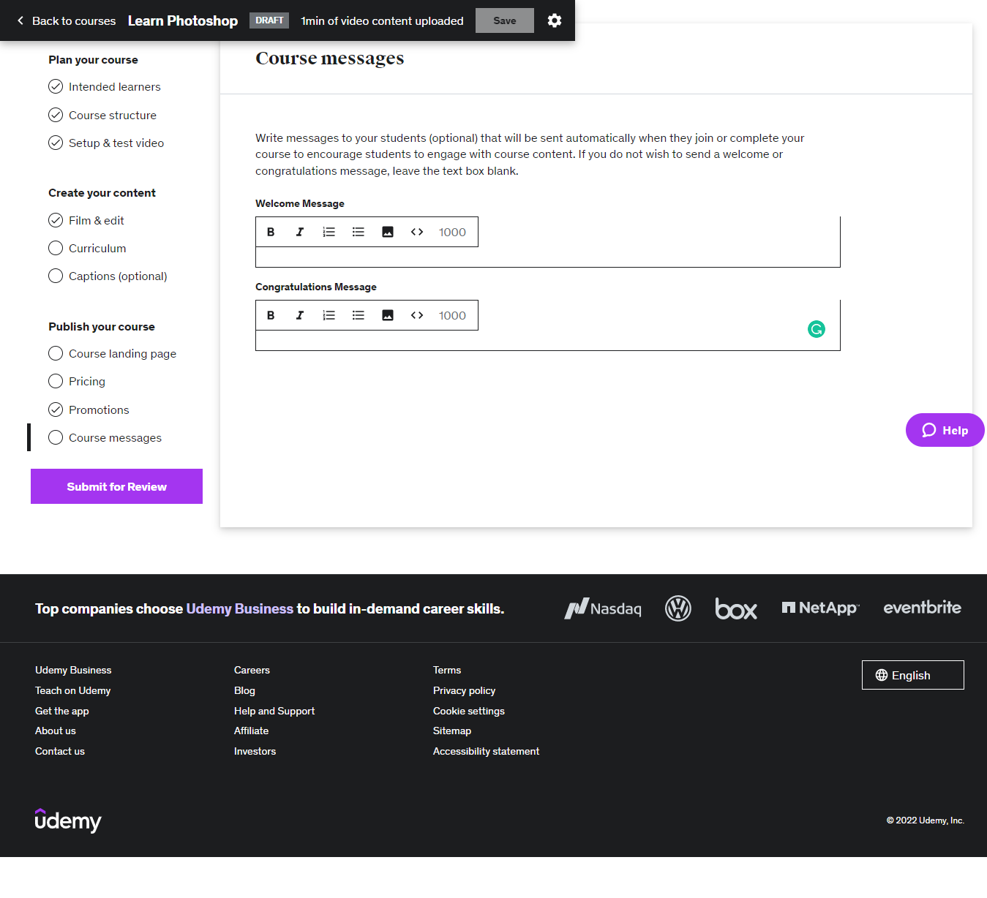

In this page, instructors can set welcome messages which will be sent to learners once they purchased the course and Congratulations message once they have completed the course.

After setting up everything for the course, instructors have to click on “Submit for Review” button to send the initial proposal of the course to Udemy who will analyse the course and make decision to publish the course.

Teacher dashboard navigation bar

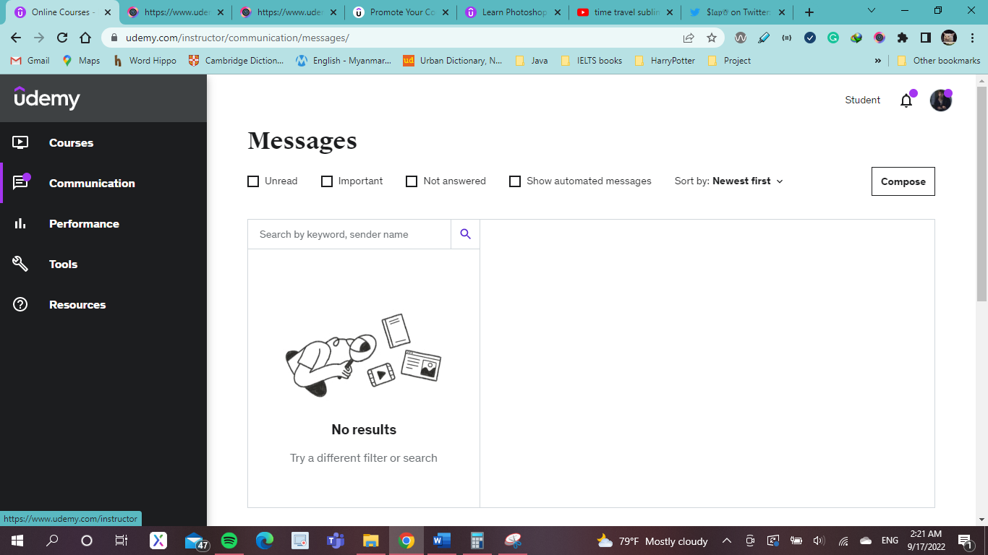

Going back to the teacher dashboard, navigation bar has links to Courses page which has discussed earlier, Communication which will be discussed next, performances, tools and resources

Communication

Question and Answer

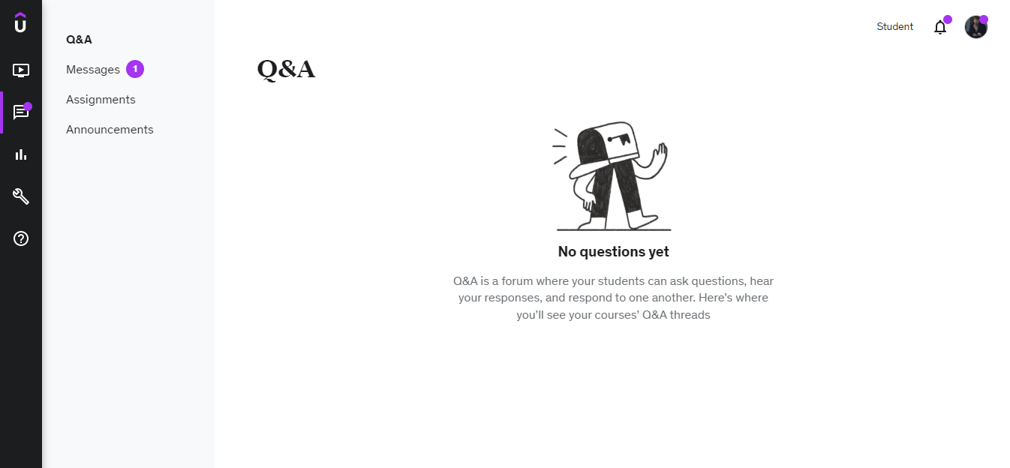

This is the first page of communication and here, instructors will see the questions asked by their learners.

Messages

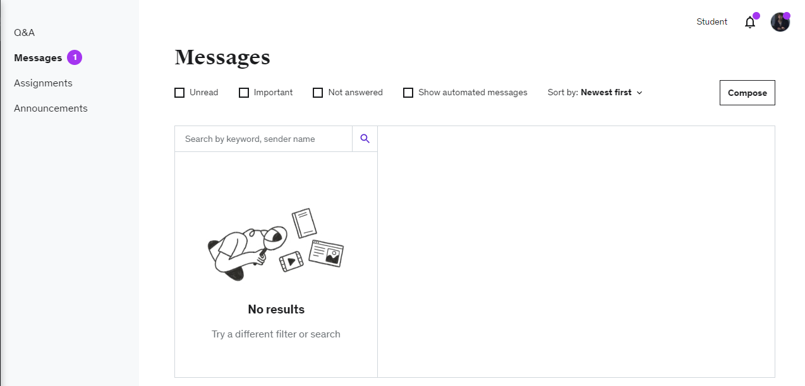

This is the page that shows instructors the messages they are getting either from Udemy itself or their learners. For the usability purposes, it can be seen that there are options to filter the messages based on their importance, read or unread, answered or not and the time received.

Assignments

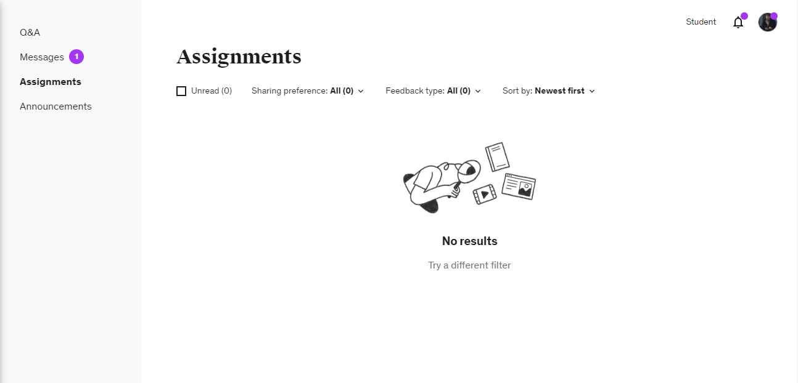

This is the page of showing the assignments instructors have given out in their courses, which can be filtered as unread ones, public or instructor only ones, feedback types i.e., instructors only, students only, instructors and students and all, and the newest and oldest ones.

Announcements

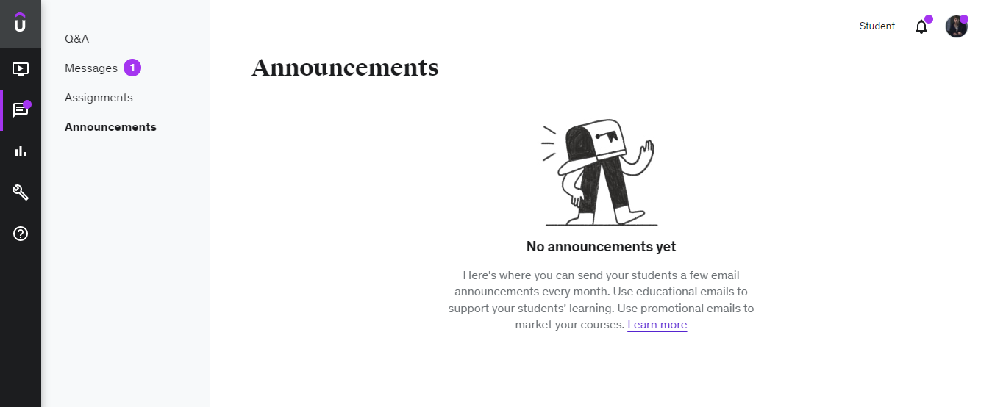

In this page, instructors can see the announcements they have made which include two types: the ones they send to their learners via email to support their learning and the promotional ones via email.

Performances

Performances section has 5 sub sections that instructors can navigate thorough to get analysis of performances on their students and their courses. The detail for each of them will be elaborated as follows:

Overview

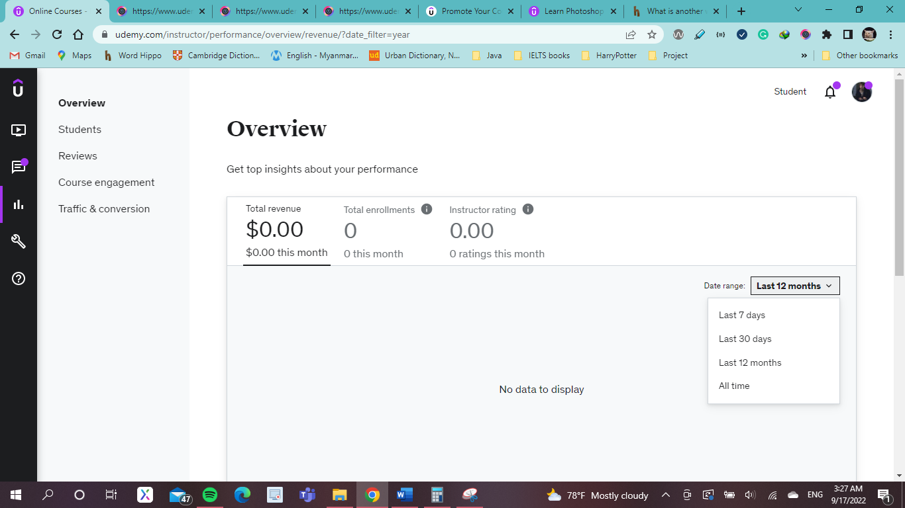

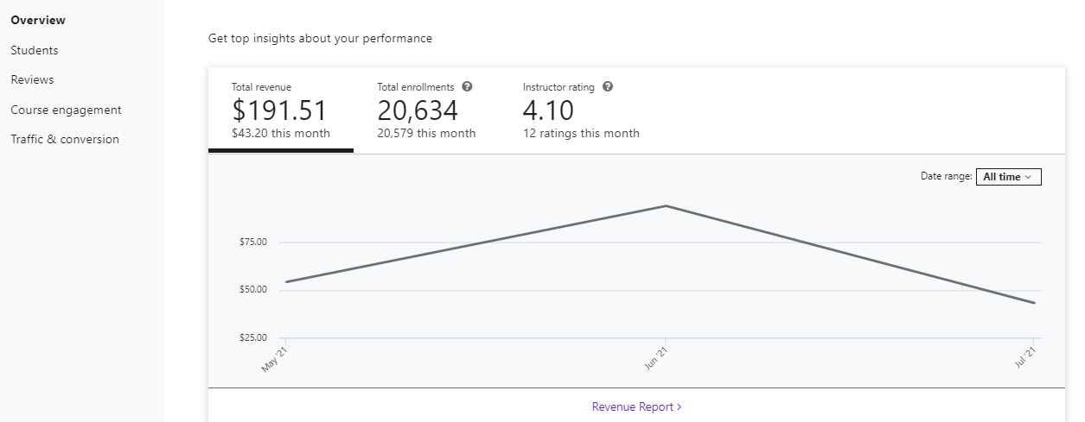

(Udemy, n.d.)

This is the page called Overview and is the first page instructor would land on once they enter the performances section. Here, Udemy will show them their total monthly revenue, total enrolments of students they receive per month and the number of ratings they receive within a month. With consideration to usability purposes, it can be seen that Udemy put a filter for instructors to help them filter out the results based on time period. The second figure from two pictures above is from Udemy’s official site and was fetched to show what the overview page with actual information in it would look like.

Students

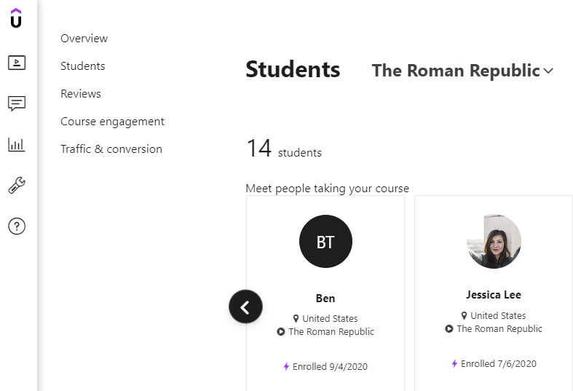

This is the student page of Performances section and here, instructors will see the total of enrolled students they have in all of their courses combined including the published and unpublished ones which will help them get to know more about their audience such as their educational interests and their market reach in Udemy. This will help them in making future plans for their courses and make improvements in the existing ones. The above shown figure was fetched from google since the author of this project don’t have any students in their Udemy instructor account and hence nothing to show. However, it is claimed on Udemy page that instructors can filter a particular course to see the number of students there specifically and thus a perk to usability. By clicking on the student profile avatar, instructors can go to student’s profile to see further information about them.

(Udemy, n.d.)

Course engagement

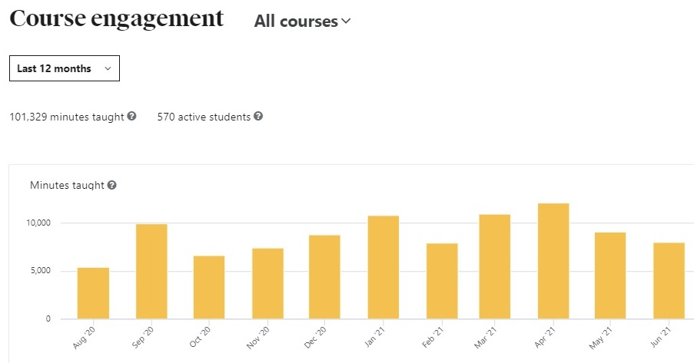

This is also a page gotten from Udemy’s official site in order to show what the page look like with the information in it. This is what the course engagement page would look like when the instructor land on it. In this page, first of all, minutes taught by instructors and number of active students are shown at the top of the page. For usability purposes again, there is a date range filter which will filter out the time period and based on it, the minutes taught in the graph is the total minutes of lectures that learners have generally viewed for all courses. The active students refer to the number of students who have started the lecture during the filtered time period and the graph shows the statistics of course engagement per month or day selected in the date range filter. In addition, instructors can also filter out the courses to see engagement statistics on each course.

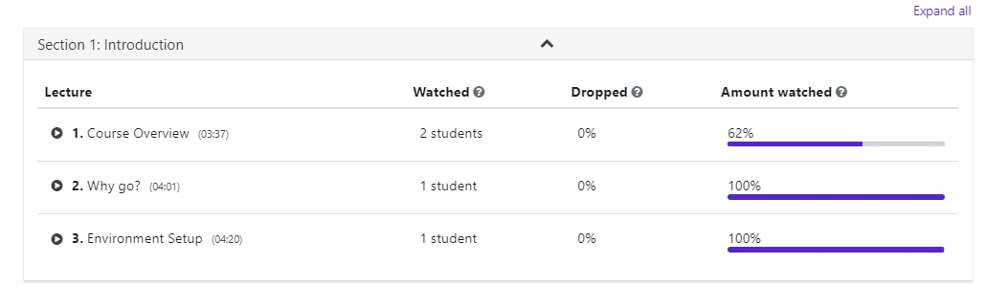

This is claimed to be the table instructors will see at the bottom of this page. Apparently, the lecture column shows the title of lectures in each section of a course along with their duration, watched column shows the number of students that have watched those lectures for more than 15 minutes, the dropped column shows the percentage of people who stopped watching the video within 15 seconds and the amount watched column shows the average percentage of people who have completed watching the lectures.

(Udemy, n.d.)

Traffic and conversion

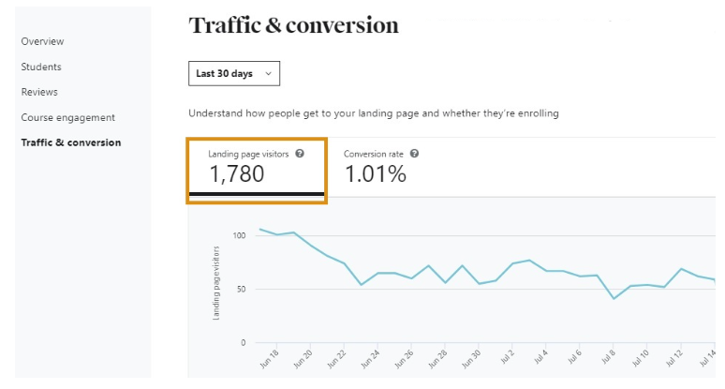

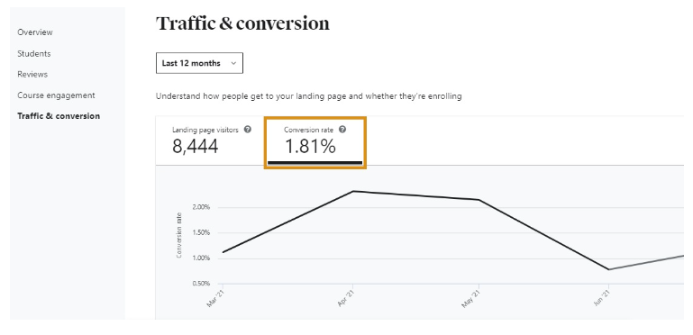

This is also the picture of this particular page from Udemy since the actual one that is used in testing don’t have any data to show the further information. This is the page of providing instructors with analytics of detailed insights on how learners are discovering their courses and their demands. First of all, the data can be filtered based on time period such as within last 7 or 30 days using the date range filter. The landing page visitors refers to people who visit the course landing page more than once during the filtered time period. The conversion rate represents the division of enrolment numbers by visitor number in order to sort out the rate of actual landing visitors. The graphs below the statuses shows the statistical analysis of landing page visitors (for first figure) and that of Conversion rate (for second figure) based on the date range instructor have chosen.

(Udemy, n.d.)

Tools

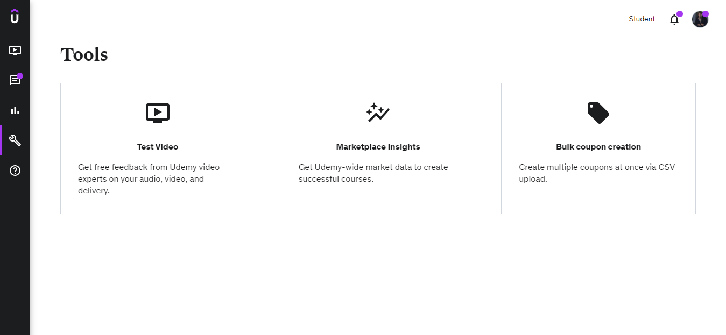

This is the Tools section of instructor dashboard and consist of 3 subsections: Testing videos, marketplace insights and bulk coupon creation. Since all three of them use advanced technologies and would not be necessary for this Educally project which is a mere college student project, no further explanations for them will be discussed but rather the summaries. First of all, “Test Video” section will be about instructor uploading a test video that is going to be used in the lecture containing 1-3 minutes of duration along with description on what languages they are going to use in it, required feedbacks for it, what they are filming in this video, the equipment they are using and so on. “Market place insights” will be about Udemy providing information on market insights of the particular topics that instructors are interested in. Here, Instructor need to choose the topic they are interested in and Udemy will generate the statistics on student demands number of courses on Udemy, estimated monthly revenues, search volumes on that topic, enrolment rates and existing courses of that topic on Udemy. Lastly, “Bulk coupon creation” is about instructors uploading csv files of coupons they will provide to their learners along with their information.

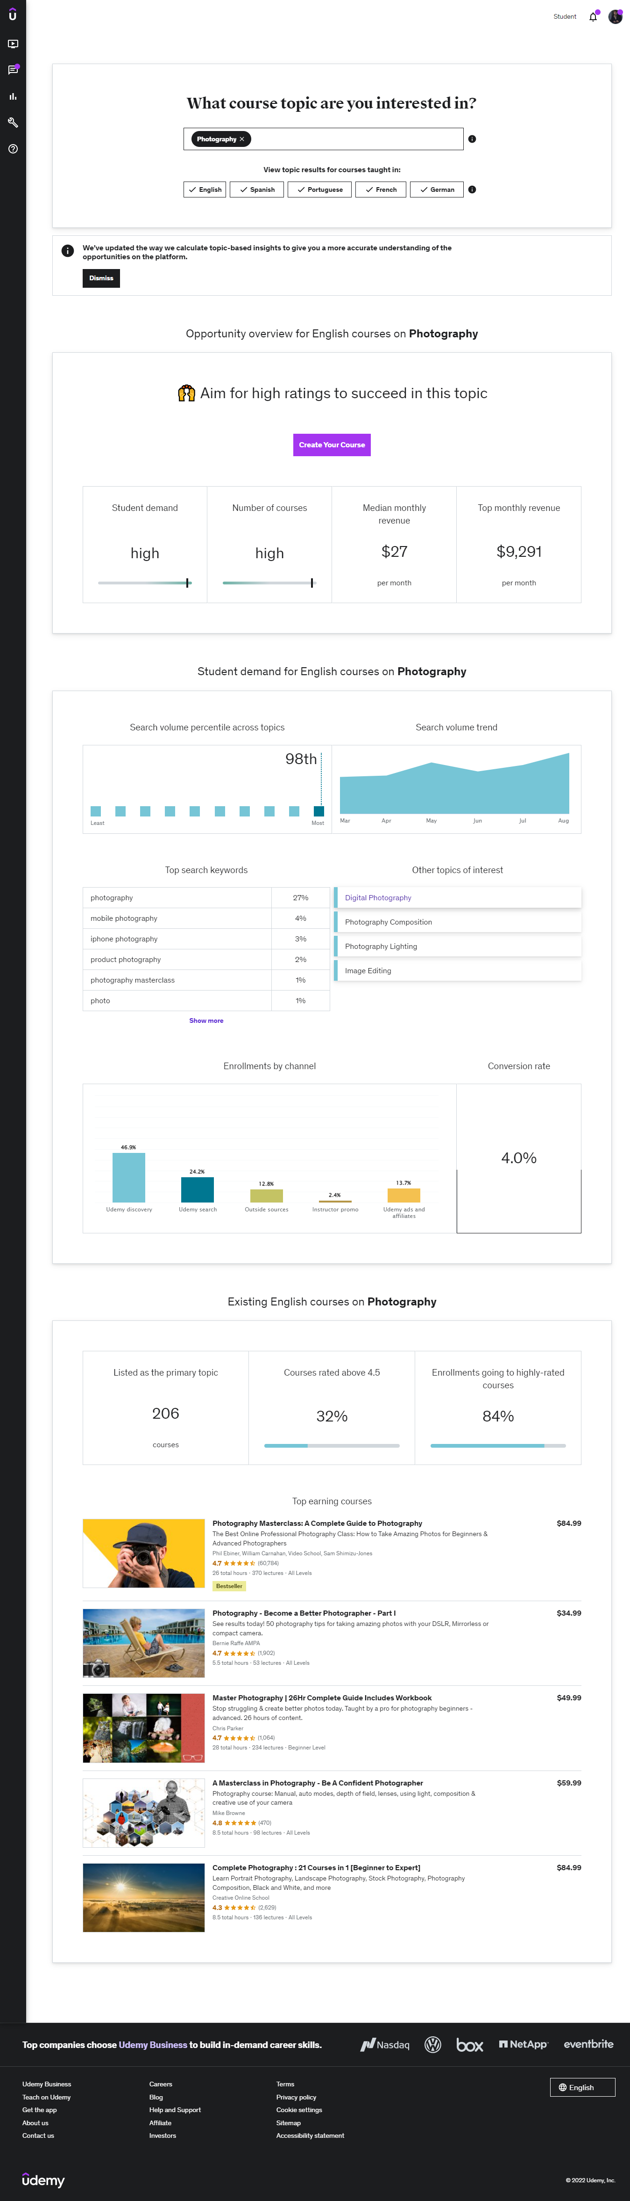

(Market place insights)

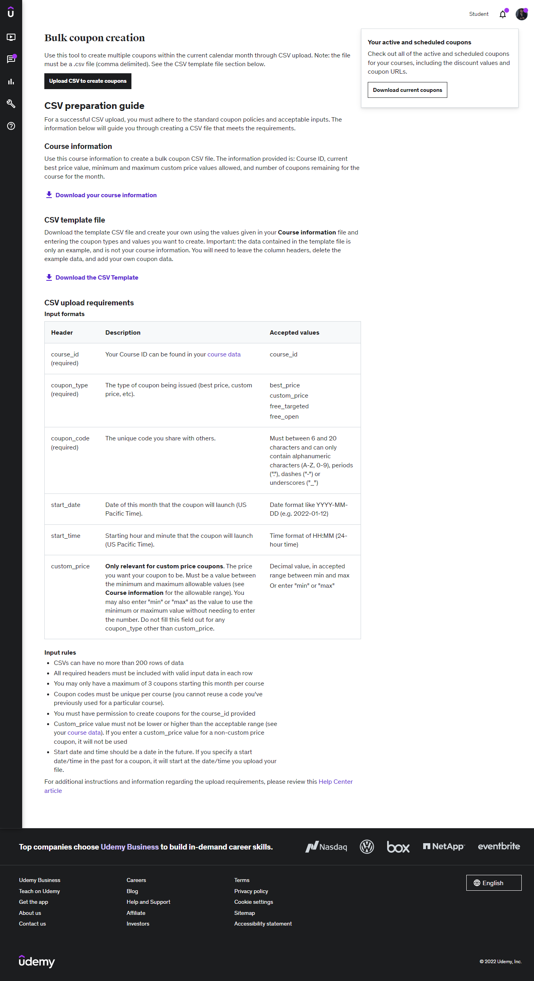

(Bulk Coupons)

Coursera

Since there is no instructor registration available for usual visitors or freelance instructors, it is impossible to observe the instructor dashboard for product research.

### Course landing page and purchasing system

Udemy

Landing page

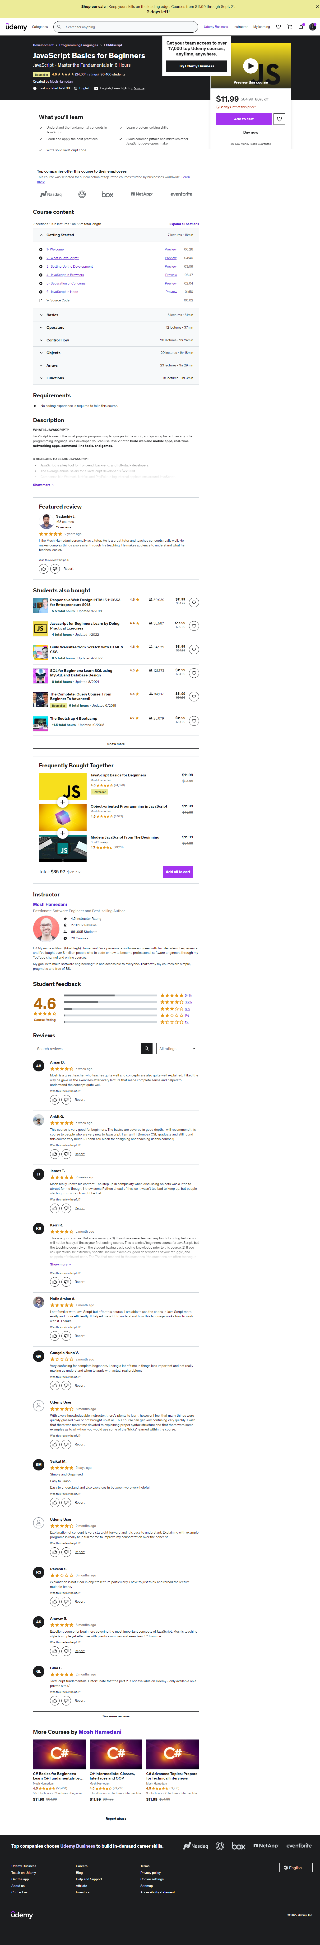

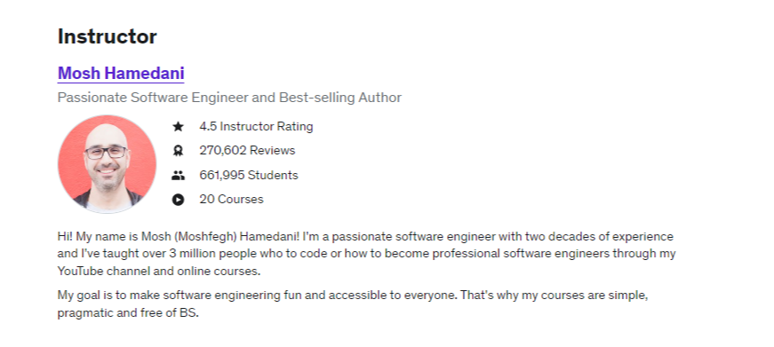

Reference: <https://www.udemy.com/course/javascript-basics-for-beginners/>

After searching and choosing the course, this is the page learners would land on. Here, the detail of the course such as the rating, number of students, price, learning objectives and outcomes, contents contained in the course, requirements and descriptions are provided as well as the instructor’s information and student reviews. The information provided here will help learners decide if this is what they are looking for and whether they should purchase this course. Here, they can either click on the “heart” button to bookmark this course if they don’t intend to purchase it at the moment or click on “Add cart” to temporarily keep it while still looking for other courses to purchase or click on “Buy now” if they have decided to purchase it.

Preview



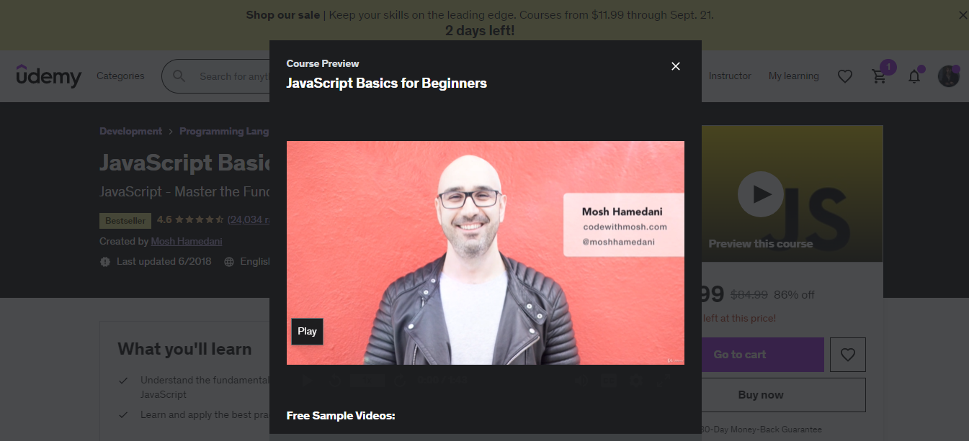

The preview video of the course is available by clicking on the play button on the “Preview this course” video. There, the instructor will explain everything the learner need to know about this course, the summary detail and what the learning outcomes are.

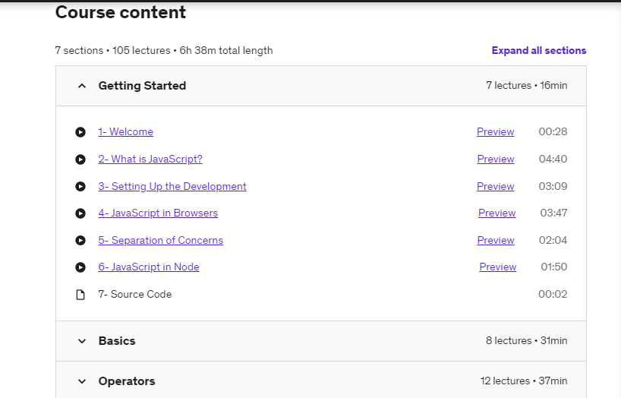

The preview of each chapter (if provided) will also be available under Course content section so that learner can know what the summary of what they will be learning in each chapter.

Wishlist

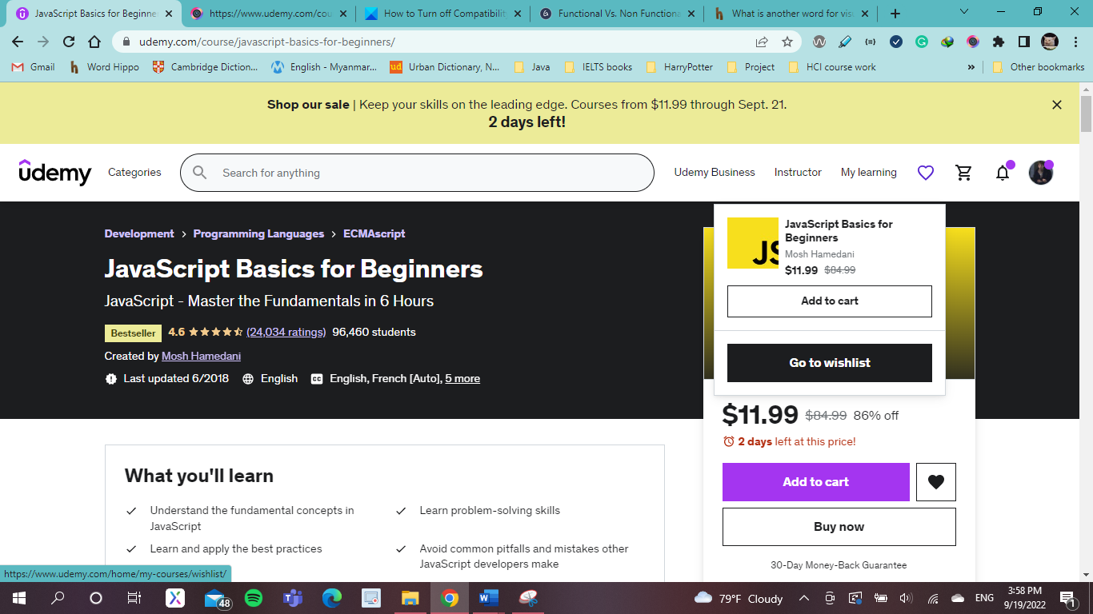

Once clicking on the heart button, the notification pops up indicating the course has been bookmarked in the wish list library with “Add to cart” and “Go to wish list” options provided to let users choose whether they want to put it into the cart or view in the wish list.

Add to cart



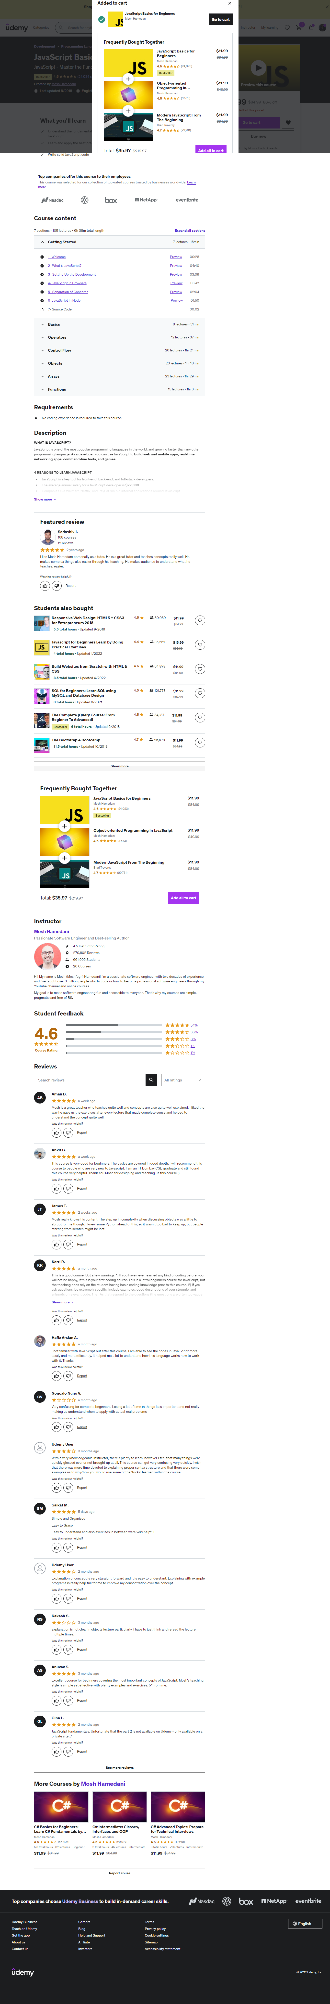

Once the “add to cart” button is clicked, a pop up appears claiming the course has been added to cart with a bunch of recommended courses shown to help learner know what other courses they can purchase next after completing the purchased course.

Checkout process

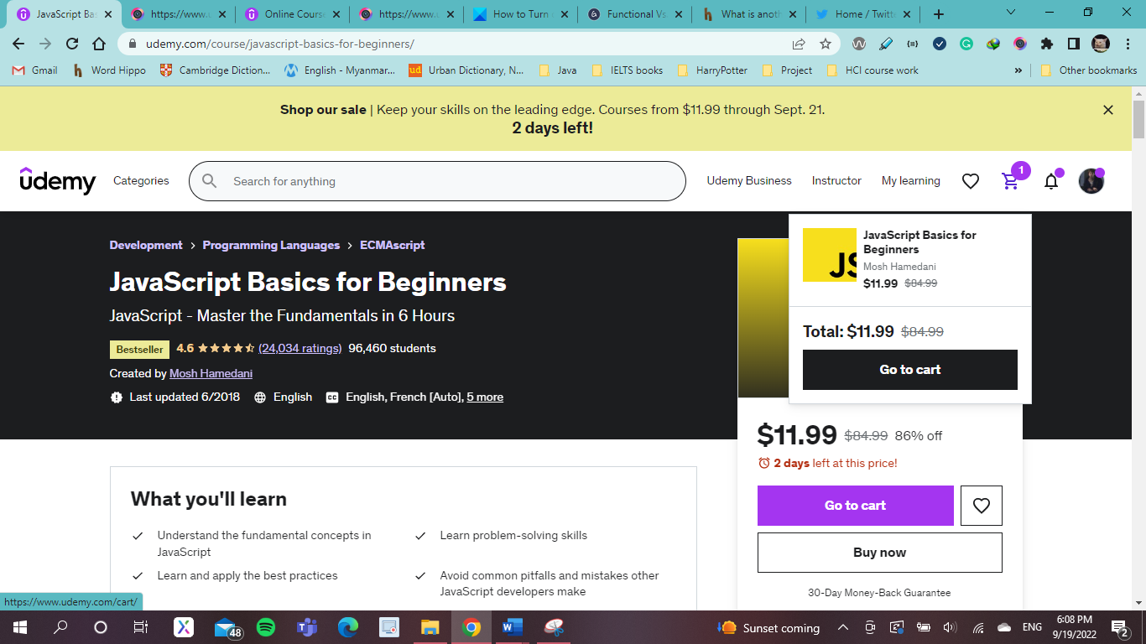

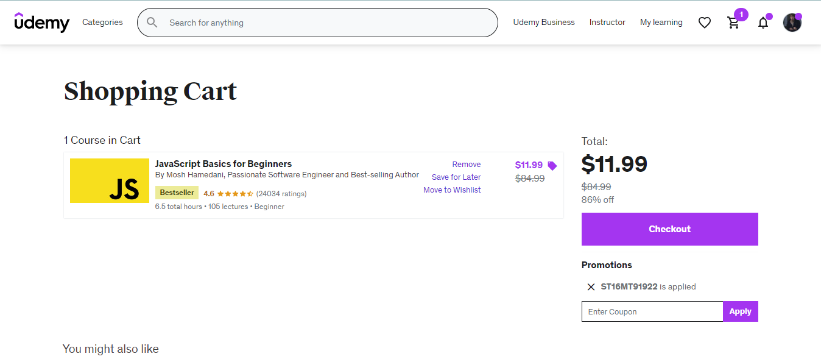

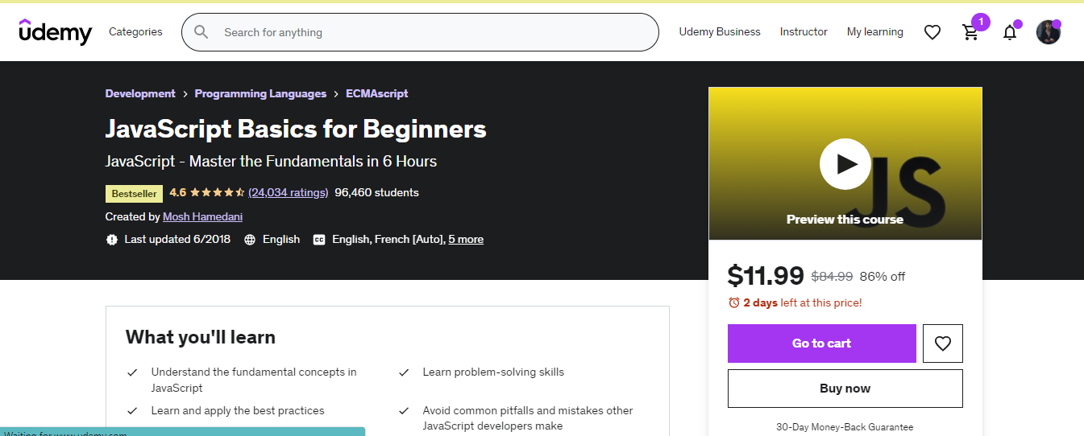

The checkout function can be done by clicking on the “Check out” button via cart page which is directed by either clicking on the cart button on the navigation bar or by “Go to cart” button in the pop up of “Add to cart” or by clicking on the “Buy now” button on course page. Either way, they will be directed to Check out page as below:

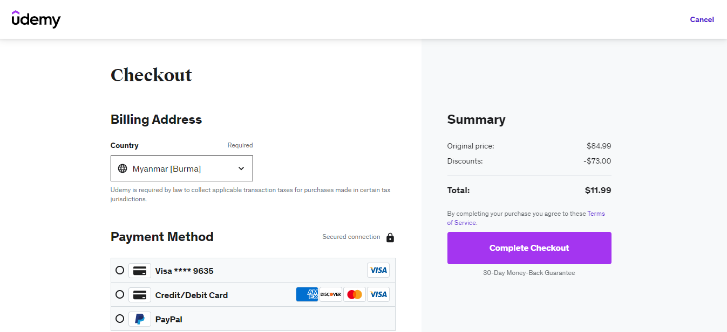

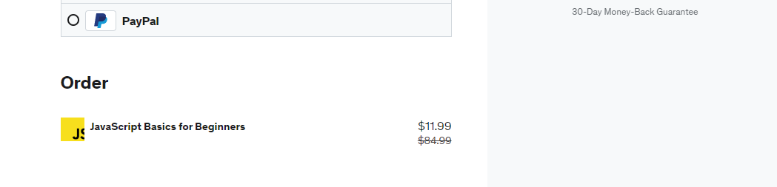

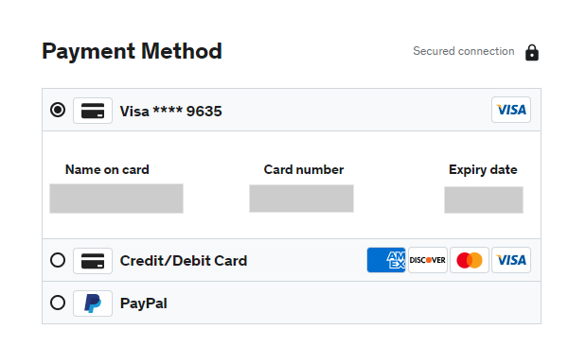

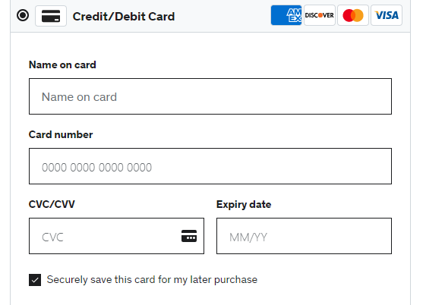

3 Options for payment method are provided i.e., learners can pay with visa card, credit card or pay pal by filling up the required credentials. On the right-hand side, the price of the course and the amount of discount the learner got (if there is any) is shown along with the total cost below. After clicking on the “Complete Checkout” button, the purchasing process is completed.

Coursera

Course landing page

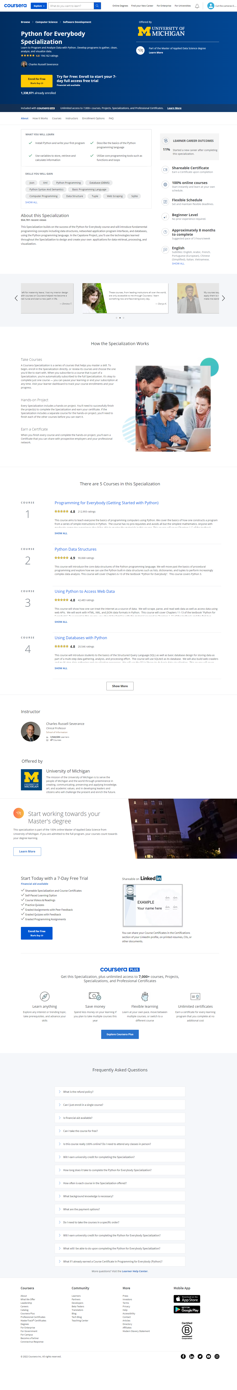





Once the course was found and selected, this is the landing page learners would land on for this particular course. The above pictures show the selected type of course is a specialization program that contains a series of courses to master learner’s skill in a particular field. Here, Coursera provides general information about the program such as what this program is about, learning outcomes, number of enrolled students, professor information, summary of featured courses, learner reviews and ratings, contents contained in this program. With this information provided, learners can know what they will be getting after completing this program and if they should enrol this.

Enrolling in the program/course

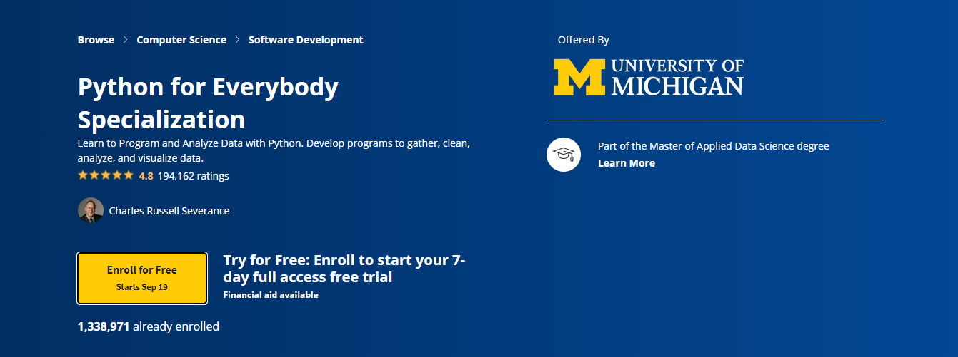

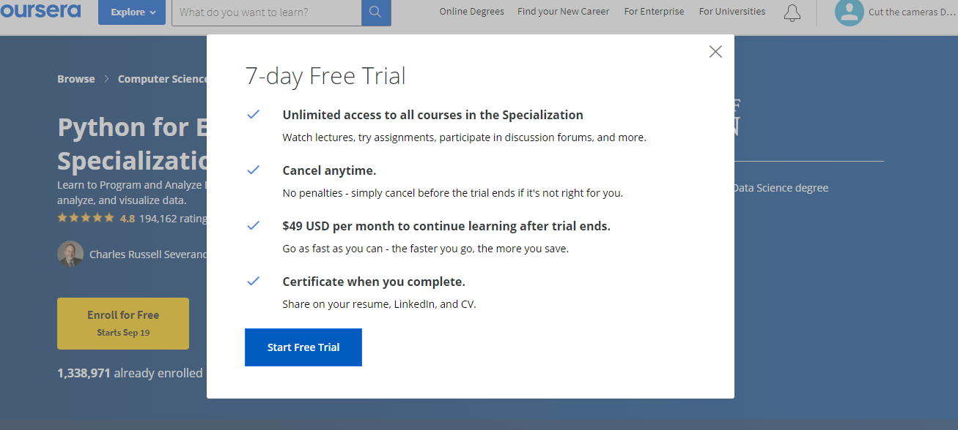

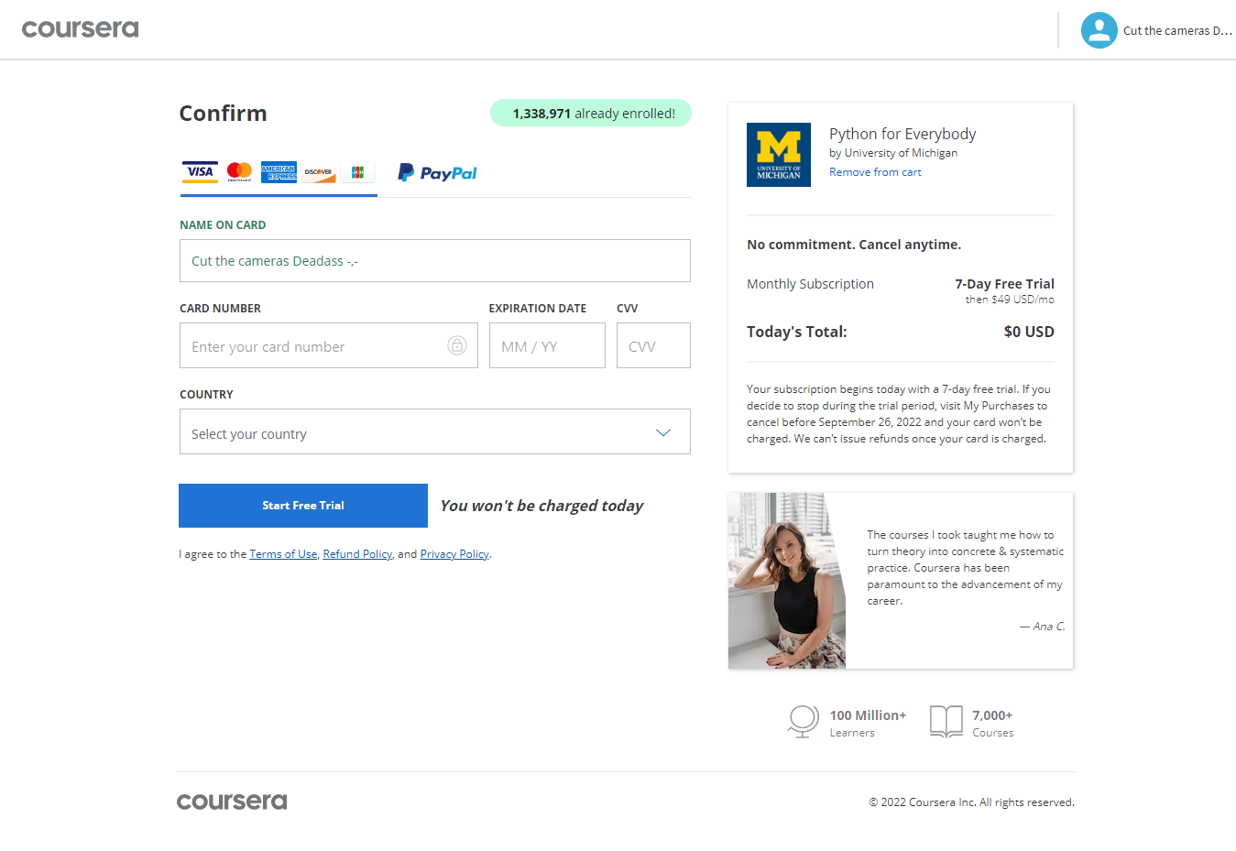

It is mentioned in the biography of Coursera, new students are given access to courses for free after signing up for 7 days but afterwards would be charged monthly. The above pictures show the freshly new signed up student trying to enrol the course and here, they are given 7 days free trial and to enrol, they must take the trial. In paying for subscriptions, 2 options for payment are provided and users can choose one that is convenient for them. Here, in the last one of above figures, on the left-hand side, the information of program user is enrolling can be seen with the total cost while on the right-hand side, user have to fill up required credit card credentials to activate the trial and as Coursera has promised, users would not be charged for 7 days but after passing 7 days, subscription fees would be taken from their credit card monthly.

(Bowden, 2021)

### Course detail

Udemy

If a learner had purchased a course from Udemy, they will see the following contents and pages when they enter the course.

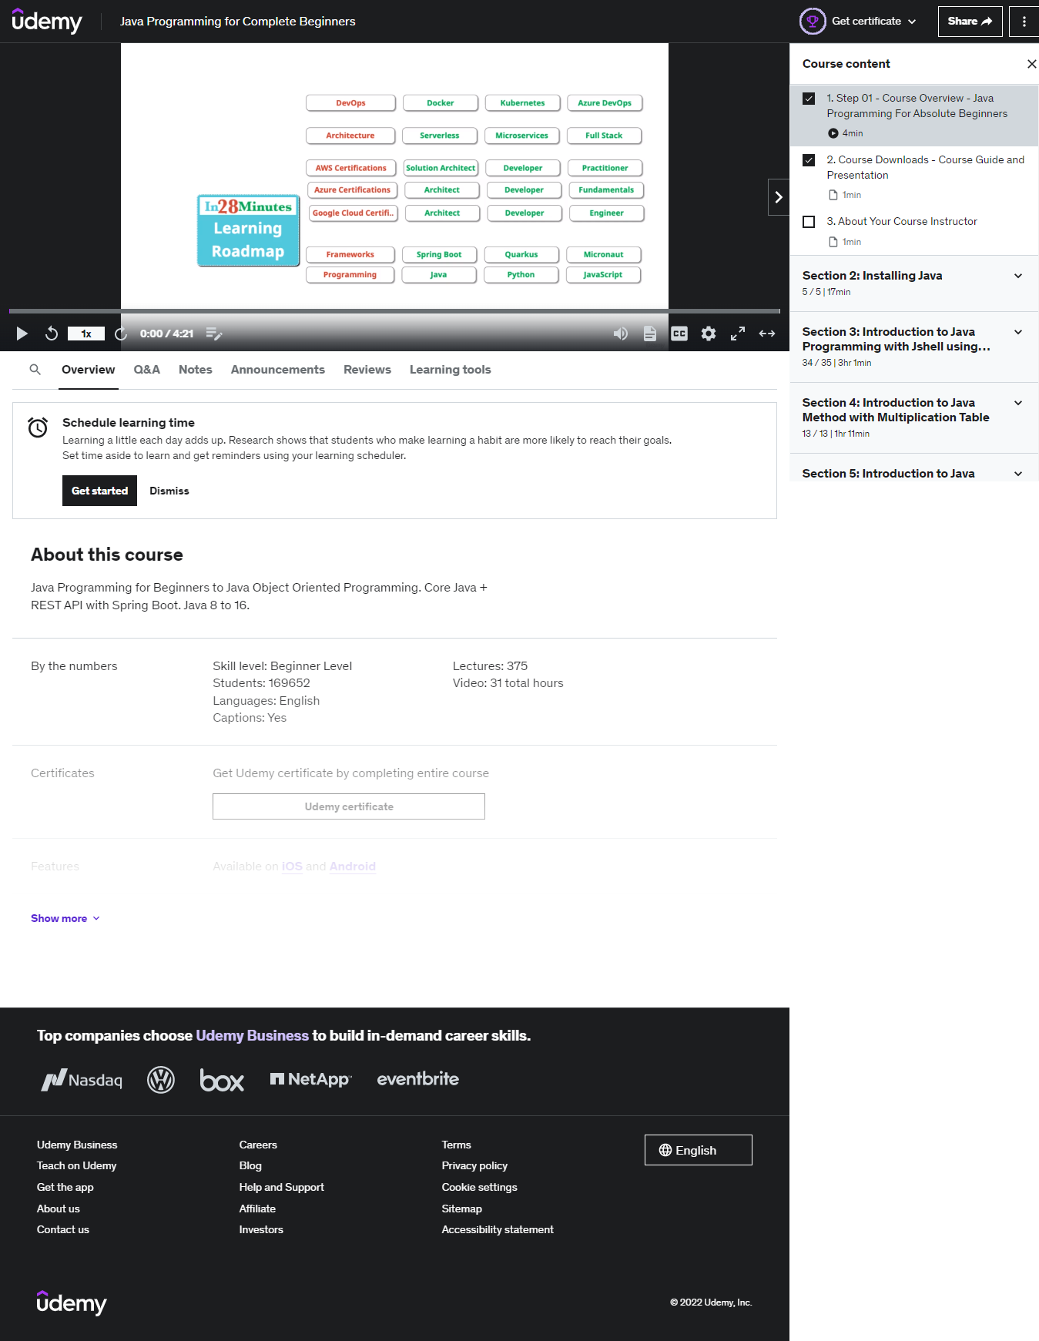

First of all, this is the landing page learners would see once they enter the course and here, they will see the first lecture video on the top and beside it is the navigation to the other lecture videos. Below the video, they will see the navigation tab staring Overview, Q&A, Notes, Announcements, Reviews and Learning tools which each of them will be discussed afterwards.

Lecture video

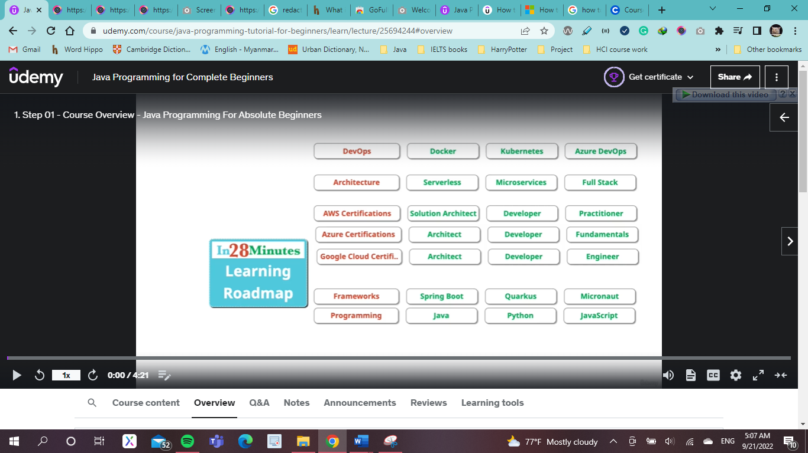

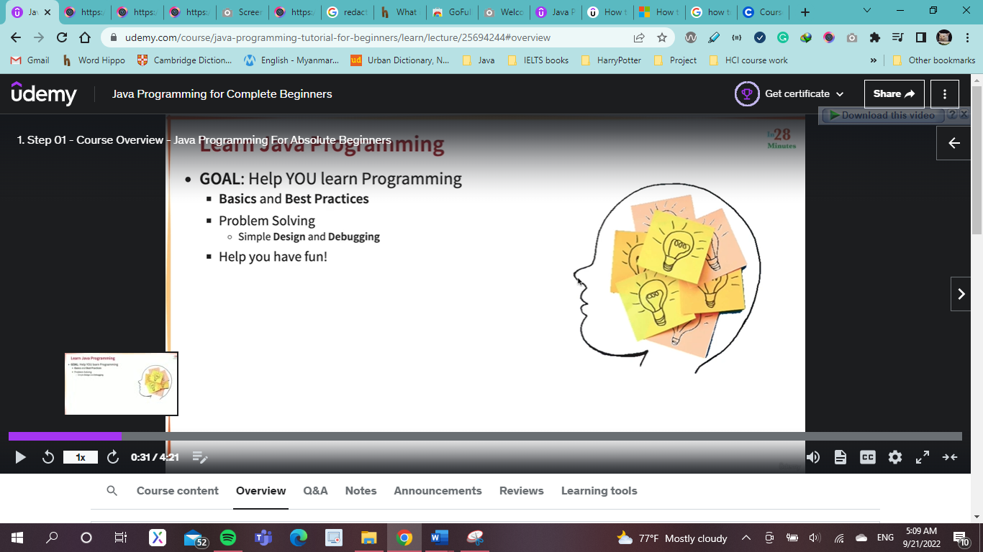

Forward and rewind by moving the cursor around

This is the lecture video and here, learners are provided with a bunch of control functions to adjust their viewing experience. First of all, learners can forward and rewind the time of the video by moving the cursor around the time frame so that they can review or move forward to the part they want to see.

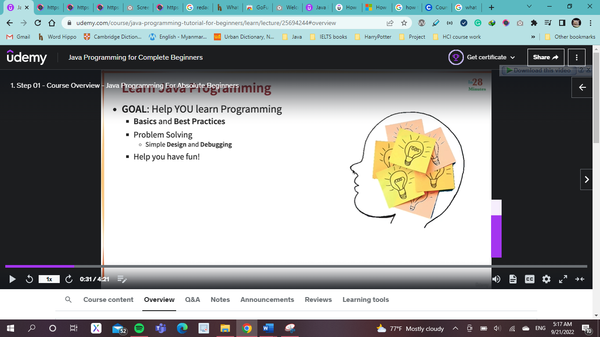 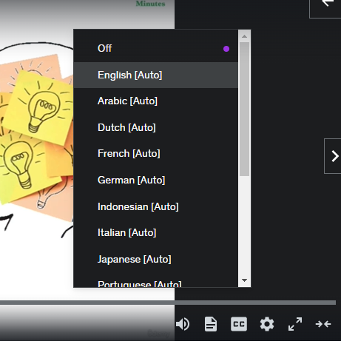

To adjust the volume, they can move the cursor around on the

Overview

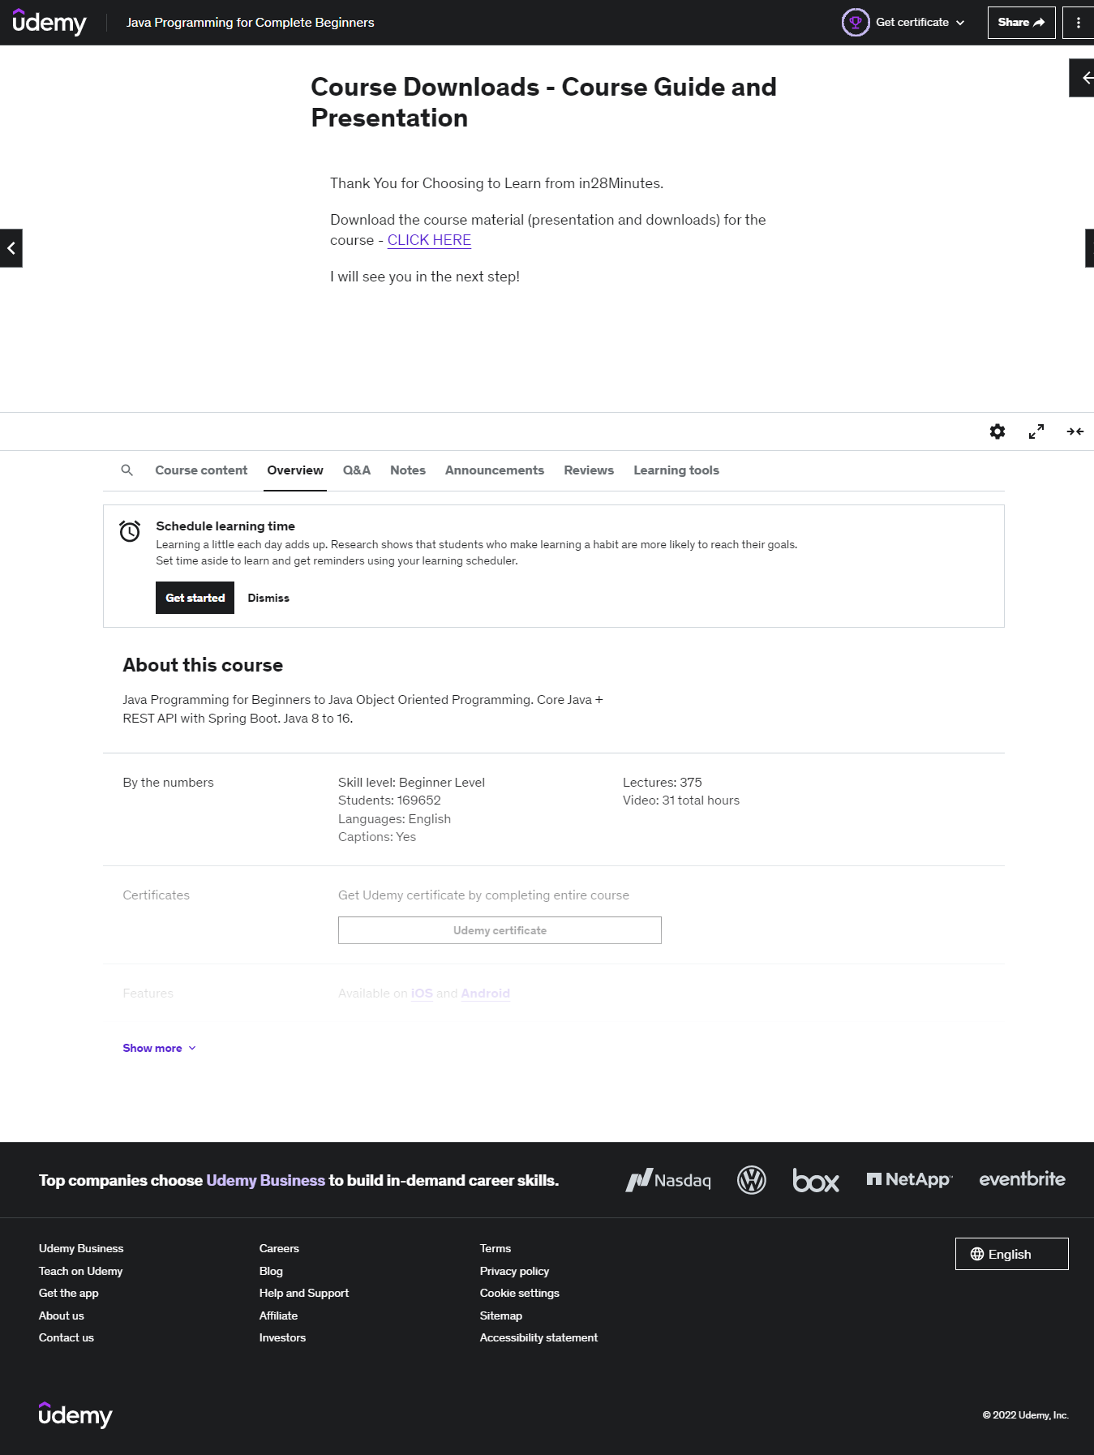

This is the overview of the course where learner can see the details of the entire course and all the descriptions here are the same in other lectures of the course.

Q&A tab

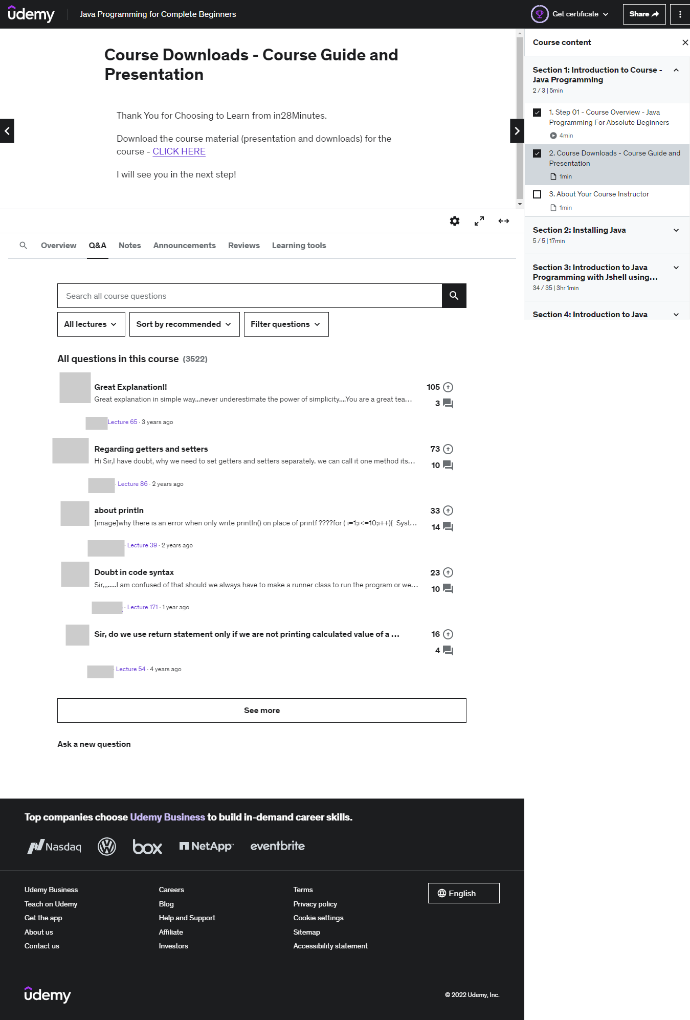

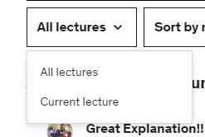 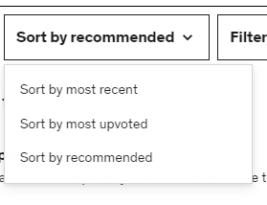 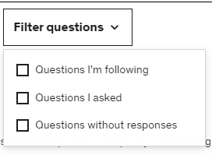

This is the Q&A tab and here, learners can see the questions and answers of other students for both current lecture or for the entire course. By filtering the questions for all lectures and current lecture; sorting the questions based on numbers of interaction and filtering the questions with a set of criteria provided, learners can see sort out the questions and answers which saves time and effort while looking for what they want.

Notes

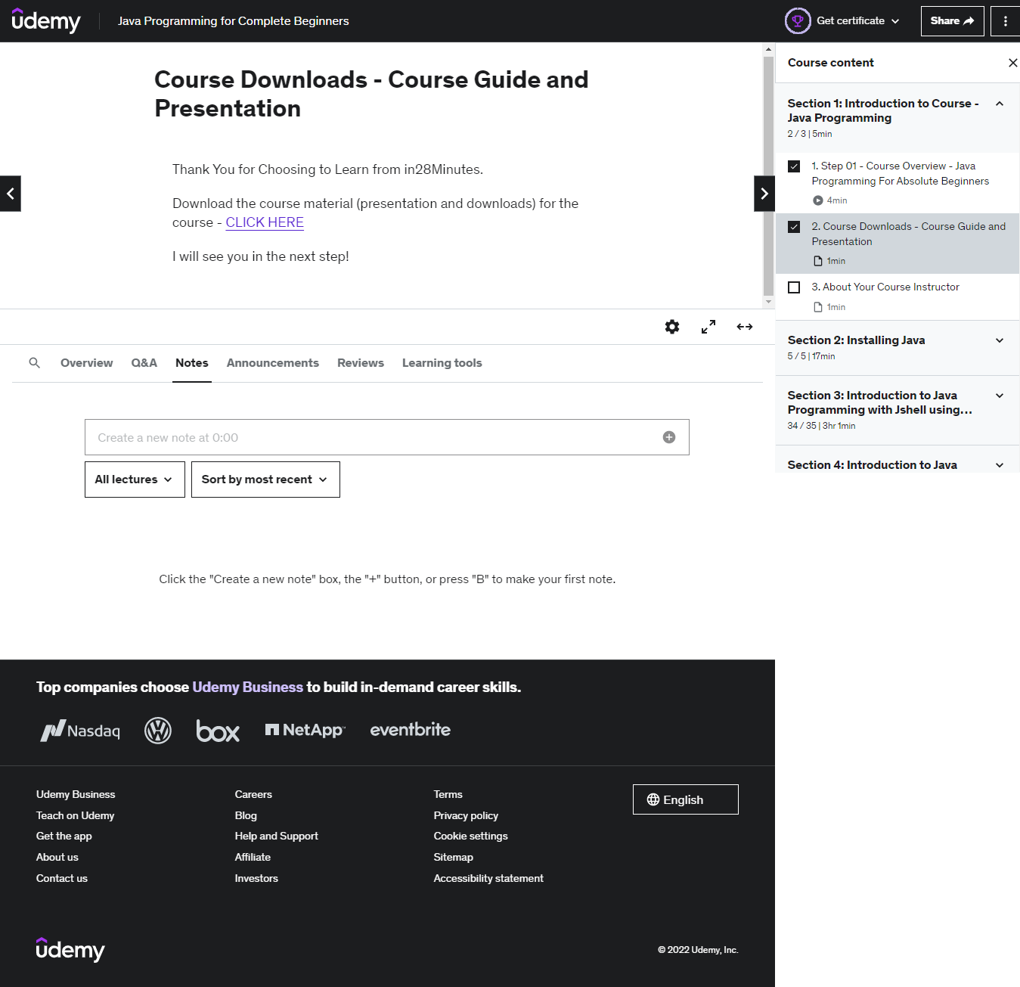

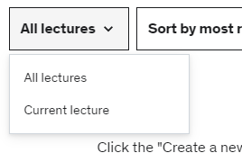 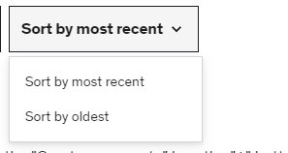

Under this Notes tab, learners can note down notes for the specific moment of the video with the timespan which will be recorded so that they can come to the lecture again and review it later. Here, by sorting down the notes for current and all lectures and from latest to newest ones, it will save time of learners trying to find the notes they are looking for and this will help them focus on their learning processes.

Announcement

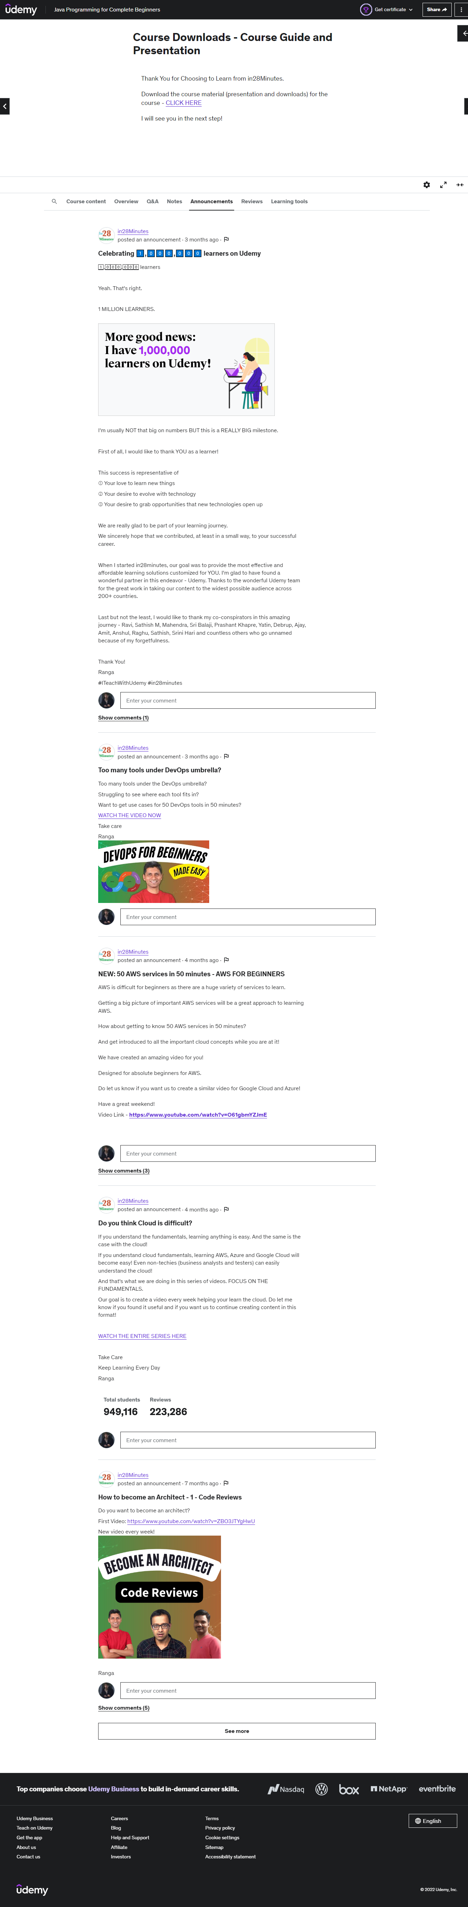

This is the announcement tab and here, learners will see any announcement instructors had made which is concerned with the entire course and here, learners are provided with the comment box under each announcement for them to comment their opinions over the announcement. The contents under this tab would be the same for all lectures in this course.

Reviews

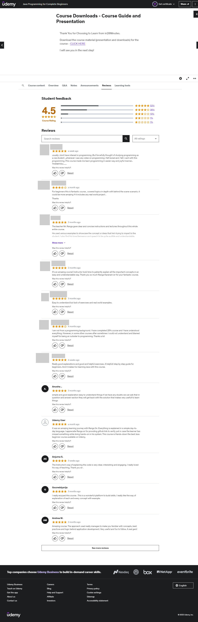

 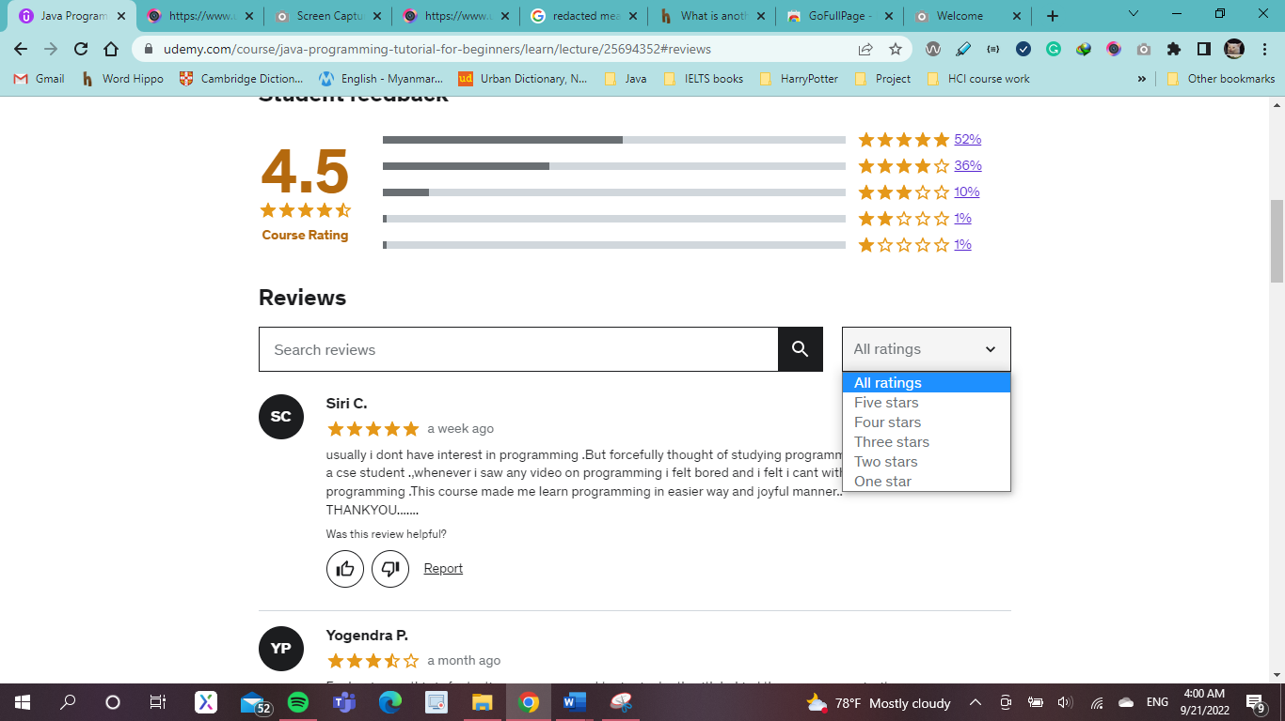

This is the review page concerned with the entire course and here, learners will be able to give feedbacks for this course and also see the rating and feedbacks given by various learners. There are like and disklike buttons provided for each review of other users which learners can interact with them to show their reaction on those reviews. Search box and Filtering function and also provided here so that learners can filter out the reviews based on the ratings and search for the desired reviews.

Learning tools

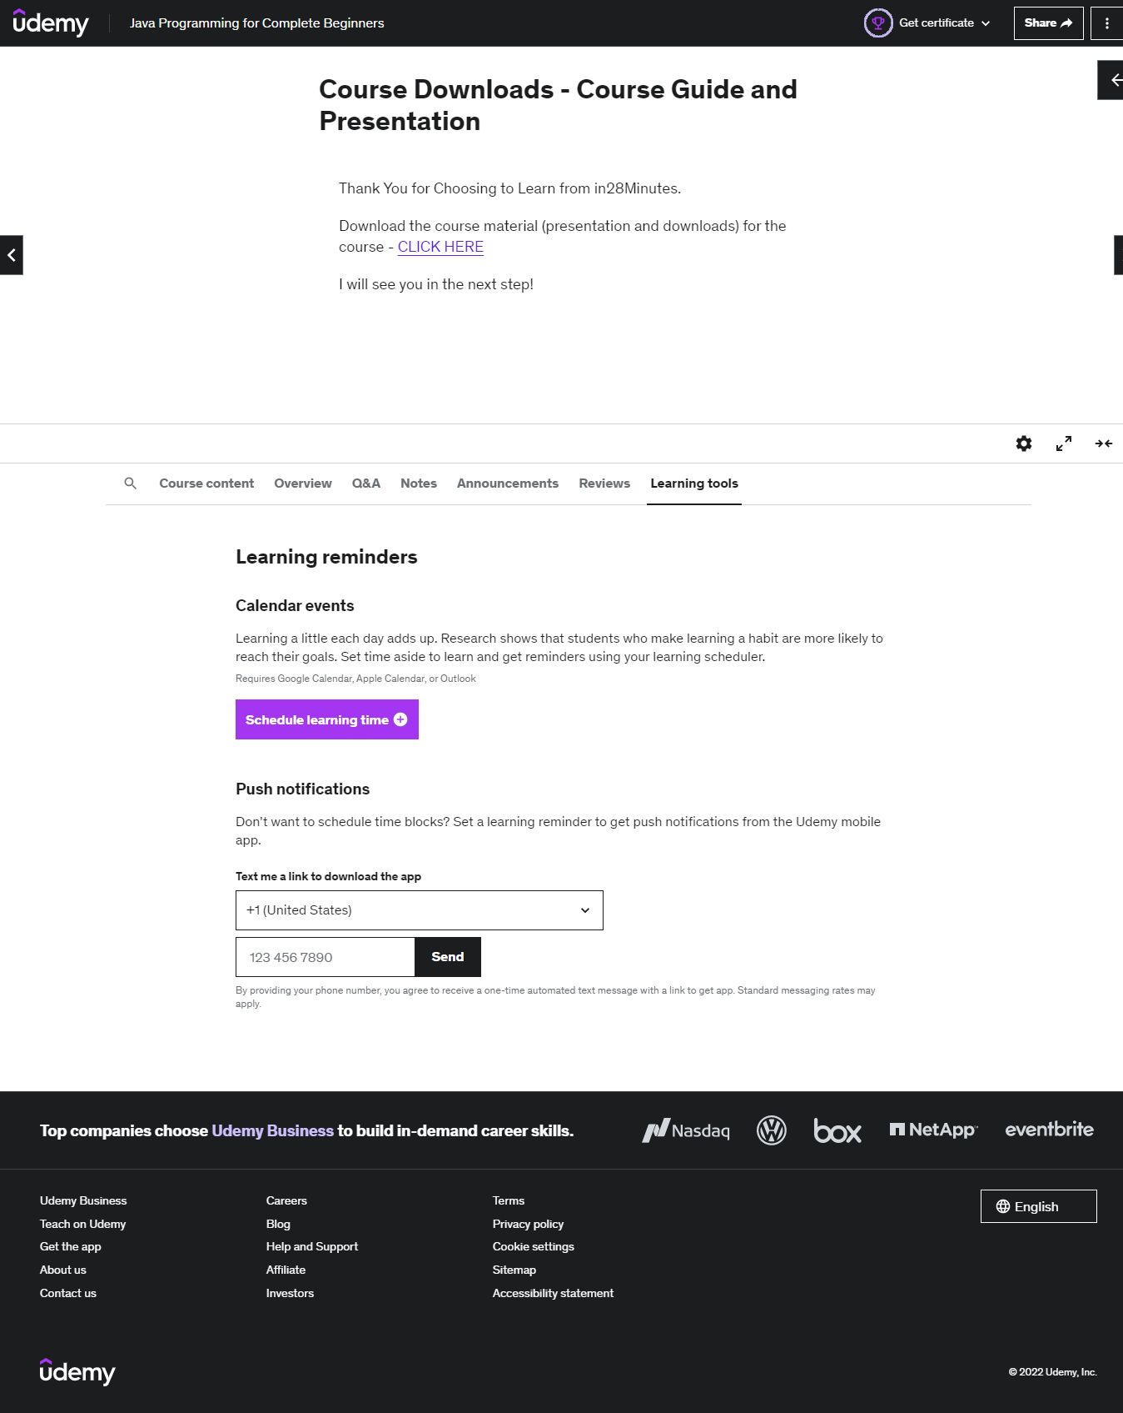

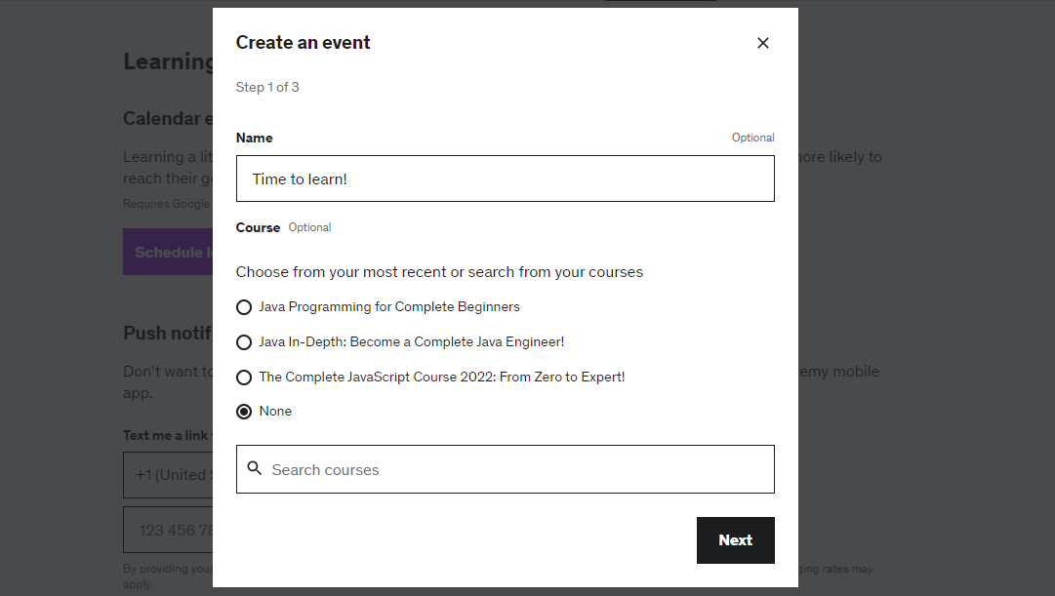

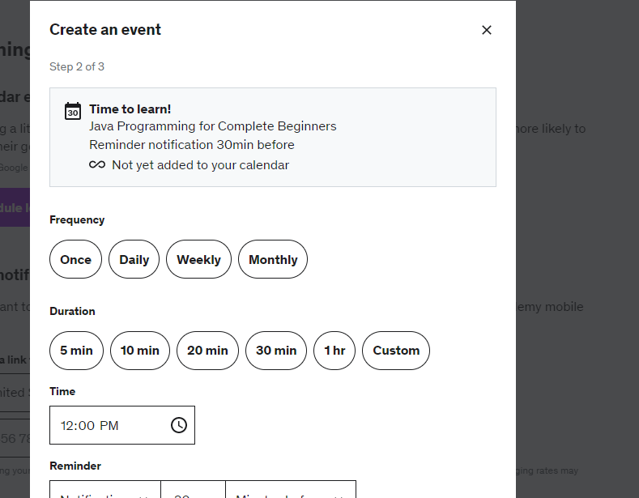

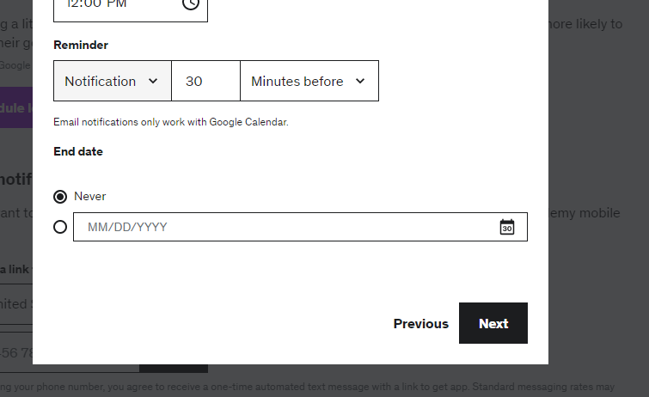

In this learning tool page, learners will be able to set a schedule for their learning and to do so, first of all, they need to choose and search for the course they have purchased to set learning schedule for. Then they need to set frequency, duration and time period they want to get remined of and afterwards, they need to choose how many minutes, days or hours they want to be remined before their learning event and the type of notification they want to receive i.e., notification on their Udemy account or email. Then, they need to choose end date of the event.

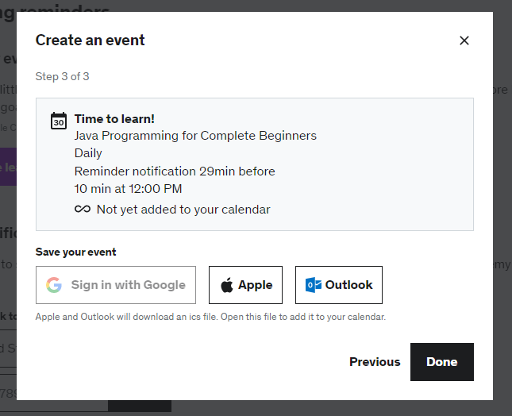

Finally, learner need to choose the platform they want to save their event in and after it, the event creation process is done.

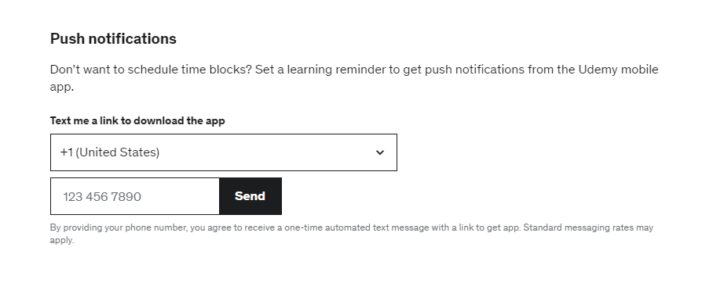

If learners do not want to miss their learning schedules while they are not on the internet or on their Udemy account, they can also choose to get notification on their Udemy mobile app by filling up their mobile phone numbers which they will receive their notification message on their mobile phone message.

(Udemy, n.d.)

Coursera

# Legal, Social, Ethical and Professional Issues and Considerations

## Legal Issues that can happen at Educally

# Requirements

## Analysis of requirements

In this project there are of….

## Comparison of systems

For some projects there may be similar existing systems. This would be a good place to identify these, compare them and elicit requirements from them.

## Requirements elicitation

Perhaps you have conducted some actual research with questionnaires and interviews and such like (having obtained research ethics clearance of course). This would be a good place to discuss this.

## Functional requirements

A clear statement of functional requirements is the starting point for your design. Without this you will look foolish.

## Non-functional requirements

Clear statement of non-functional requirements. It may be an idea here to refer back to your earlier LSEPi section as compliance is likely to (and should) be an important aspect here.

# Design

Describe your approach to design. If perhaps you are using UML use-case notation then the line between requirements and design starts to blur (Šilingas & Butleris, 2015). Other UML notation is however part of the design process, but perhaps overlaps with testing.

# Prototype

Describe your approach to creating your first (and second and third) prototype(s).

## Review of technology

If you need to review technologies this is perhaps the place to do it. Perhaps you need a data base, in which case state what database engines have you considered, which have you decided to use and for what reason. Perhaps you need an app, in which case you could, for example, state which development frameworks are available, compare and contrast all, select 3 for detailed comparison, choose one and state why you have made this choice.

# Reflection

Wrap the whole thing up with some conclusions. A reflective approach is increasingly popular but many students struggle with introducing a critical personal perspective (Day, 2013).

# Bibliography

Day, T., 2013. *Success in Academic Writing.* s.l.:Palgrave.

Portocarrero, J. M. et al., 2014. Autonomic Wireless Sensor Networks: A Systematic Literature Review. *Journal of Sensors.*

Rudestam, K. E. & Newton, R. R., 2007. *Surviving Your Dissertation: A Comprehensive Guide to Content and Process.* 3rd ed. s.l.:SAGE.

Šilingas, D. & Butleris, R., 2015. Towards implementing a framework for modeling software requirements in MagicDraw UML. *Information Technology and Control,* 38(2).

# Appendices